Web-Based Evaluations

User Manual

Class CPSC 488 Section 02

Group Number: 2

Revised: 4/22/2023

Originally Created: 4/25/2022

Tanuj Rane [txr1029@sru.edu](mailto:txr1029@sru.edu), ranetanuj@gmail.com

Dalton Stenzel [drs1030@sru.edu](mailto:drs1030@sru.edu), daltonrstenzel@gmail.com

Logan Racer [lsr1006@sru.edu](mailto:lsr1006@sru.edu), loganracer27@gmail.com

Anthony Cinicola [ajc1033@sru.edu](mailto:ajc1033@sru.edu)

Duncan Lawrence [dal1017@sru.edu](mailto:dal1017@sru.edu) duncanlawrence2000@gmail.com

J Abbigail Rowe [jhr1002@sru.edu](mailto:jhr1002@sru.edu) jakerowe@protonmail.com

Revised By:

Mike Elias [mwe1002@sru.edu](mailto:mwe1002@sru.edu)

Revised By:

Ari Hilsher [cgh1004@sru.edu](mailto:cgh1004@sru.edu)

Frank Nkurunziza [fxn1001@sru.edu](mailto:fxn1001@sru.edu)

Chris Thornton [cpt1003@sru.edu](mailto:cpt1003@sru.edu)

Table of Contents

Login 2

Logging In 2

First Time Login 2

Password Recovery 2

Home, Account, & Logout Navigation Bar Options 2

SuperSuperUser Abilities 2

Manage Companies 2

Editing a Company 2

Deactivate Company 2

Manage Users 2

Company SuperUser (Admin) Abilities 2

Manage Roles 2

View Roles in Greater Detail 2

Editing Roles 2

Deactivating and Reactivating Roles 2

Manage Users 2

Viewing the Users 2

Editing Users 2

Deleting Users 2

Evaluator Admin Abilities 2

Evaluations Form Navigation Bar Options 2

Uploading a New Evaluation 2

Viewing an Evaluation Form 2

Downloading an Evaluation Analysis 2

Deactivating Evaluation Forms 2

Manage Groups 2

Adding Groups 2

View Groups 2

Editing a Group 2

Adding a User to Group 2

Searching a User to Add to Group 2

Moving a User to a Group 2

Editing an Evaluator of a Group 2

Deleting a Group 2

Chart Generation and Analysis 2

Archived Groups 2

User Abilities 2

Evaluation 2

Evaluator Abilities 2

Evaluation Groups 2

Testing………………………………………………………………………………………………………………………………………………………………………………………………………………… 38

# Login

## Logging In

This program is designed to allow different types of users to be able to access evaluations in some form depending on certain rules and situations. Upon completing setup, after reading the installation manual, and running the program class “WebBasedEvaluationsApplications.java”, the user can either “Login” or “Reset Password” at the “localhost:8080/login” URL. In order to login, a user must provide an appropriate email address and password into the respective boxes on the webpage.

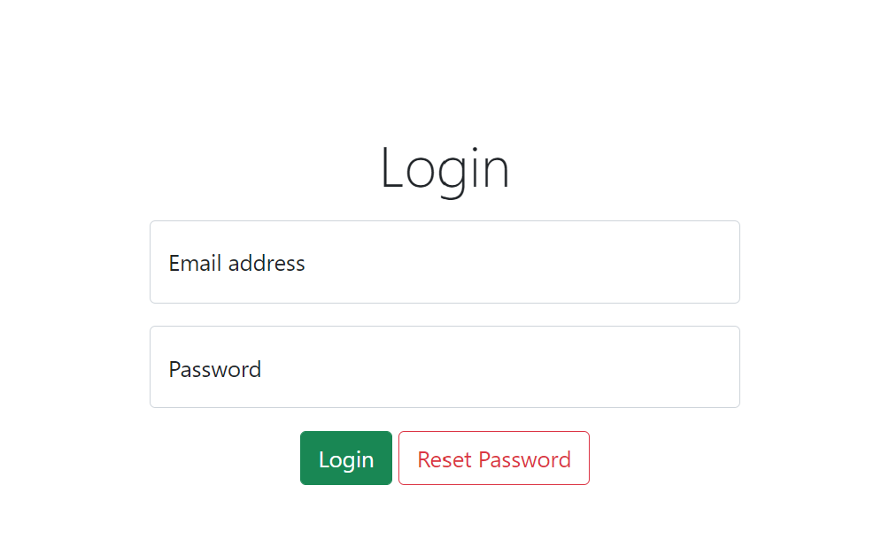

*Figure 1 - Default View*

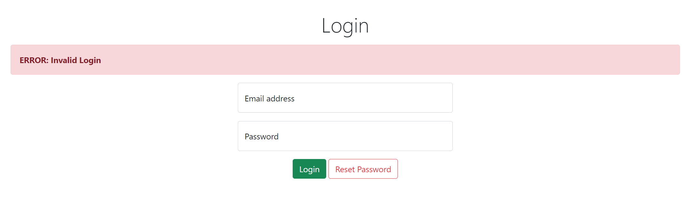

*Figure 2 - View upon entering incorrect credentials*

## First Time Login

New users will be prompted with a window in order to reset their password upon logging in. The user must provide their old password in addition to a password of their own, where it must be retyped in the “Reenter Password” box. After this is completed, they can click “Update User &Return to Login”. If the update was successful, then the user will be taken back to the login screen.

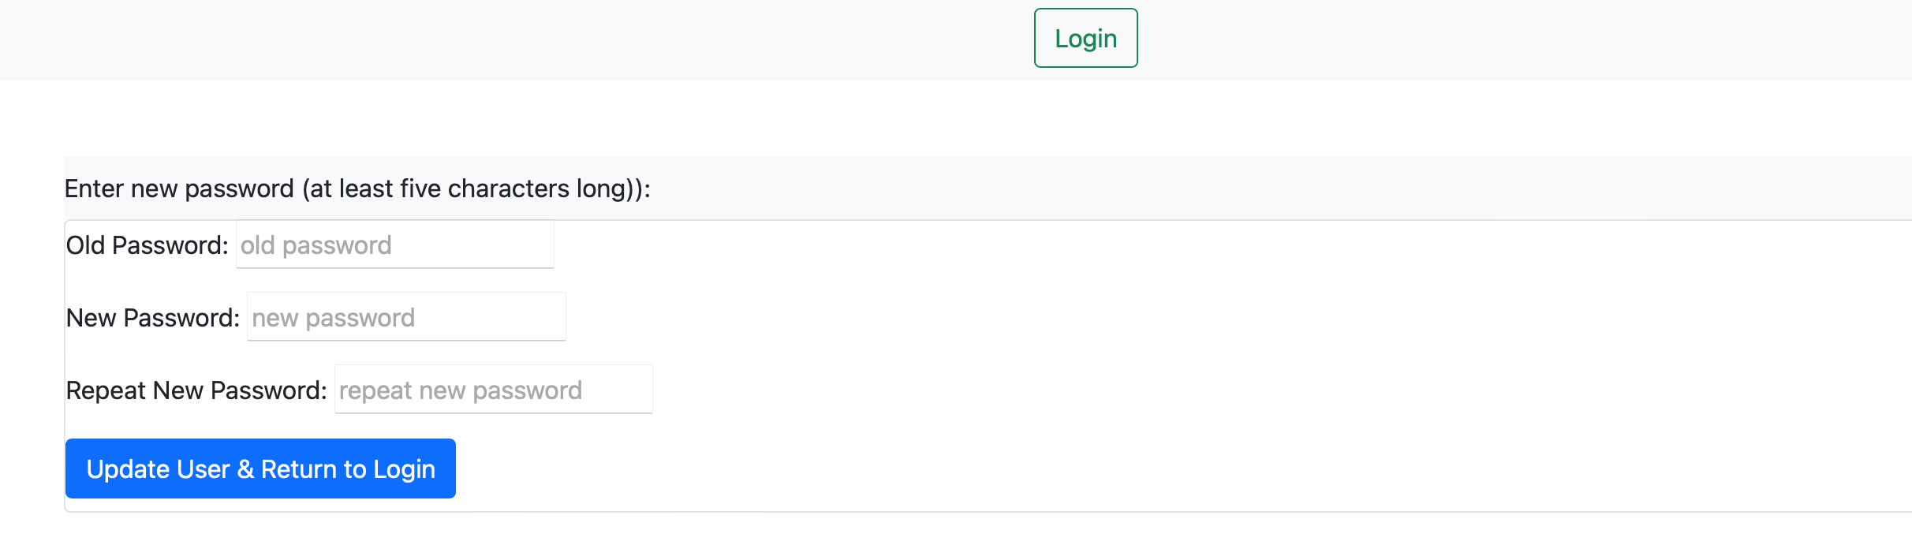

*Figure 3 - Default View*

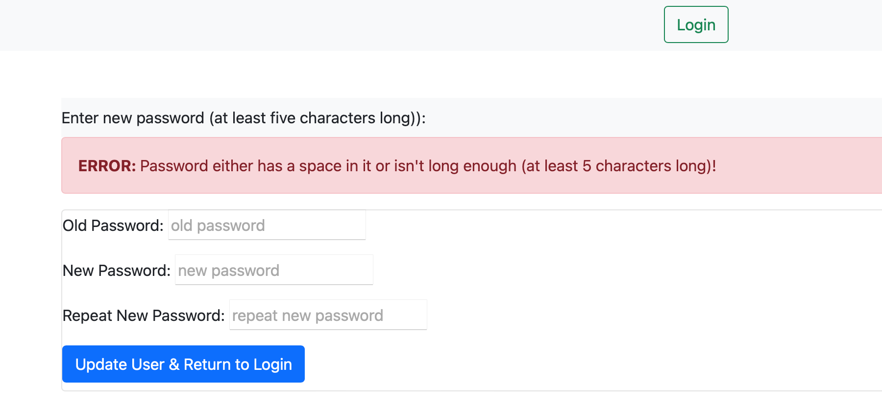

*Figure 4 - View upon providing an inappropriate password and clicking “Update User”*

## Password Recovery

Clicking on “Reset Password” instead of attempting to login will display a page where the user can enter in an email in order to try and receive a link for resetting their password. Upon entering an email address that is a part of the database of users, an email will be sent by an address called [spring.web.eval@gmail.com](mailto:spring.web.eval@gmail.com). The email will have “Password Reset” for the subject of the mail, while a link will be provided in the body to reset the user’s password. Entering in an email address that does not have an account associated with it will notify the user that an email failed to be sent.

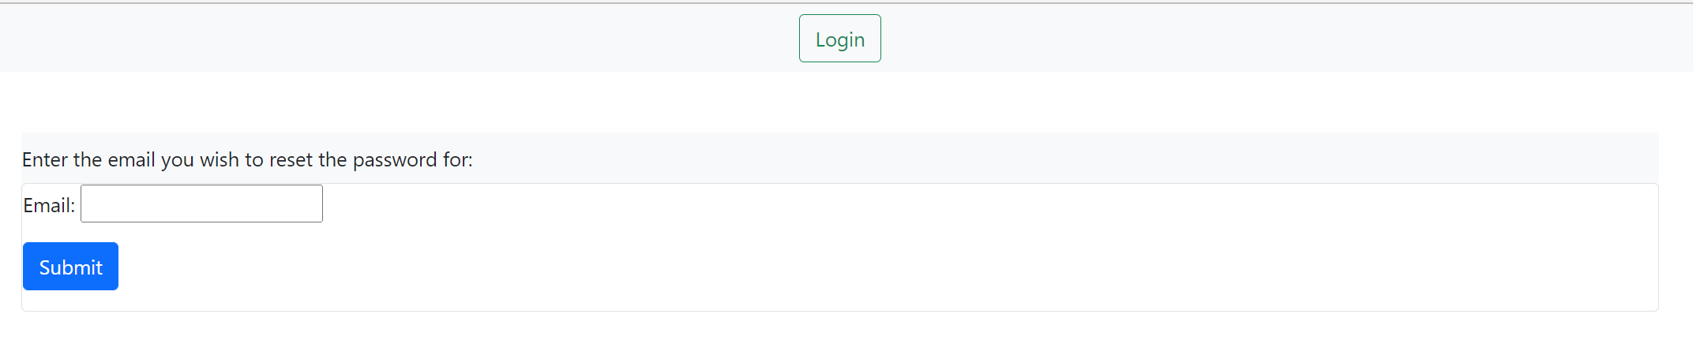

*Figure 5 - Default view*

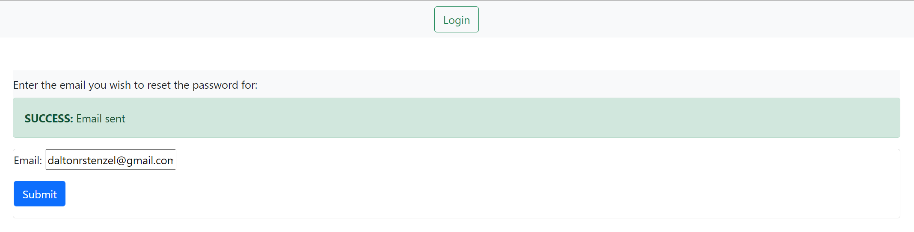

*Figure 6 - View upon entering an email address present in the database*

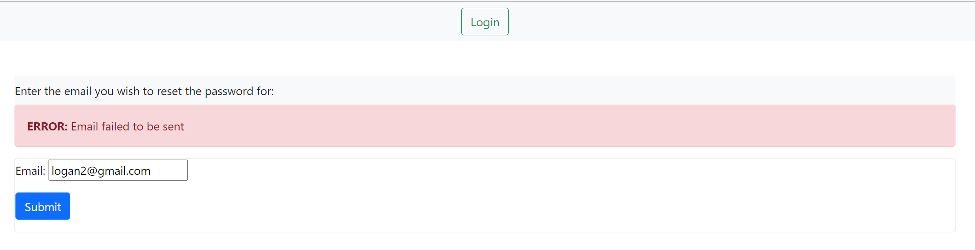

*Figure 7 - View after entering an email that does not exist in the database*

Once an email gets sent, it is very likely for it to end up in the “Spam” box of the user’s email service. Be sure to check the spam folder. Upon receiving and email with the title “Password Reset”, open it to reveal the body message mentioning the 10-minute time limit in order to use the link as well as the link itself.

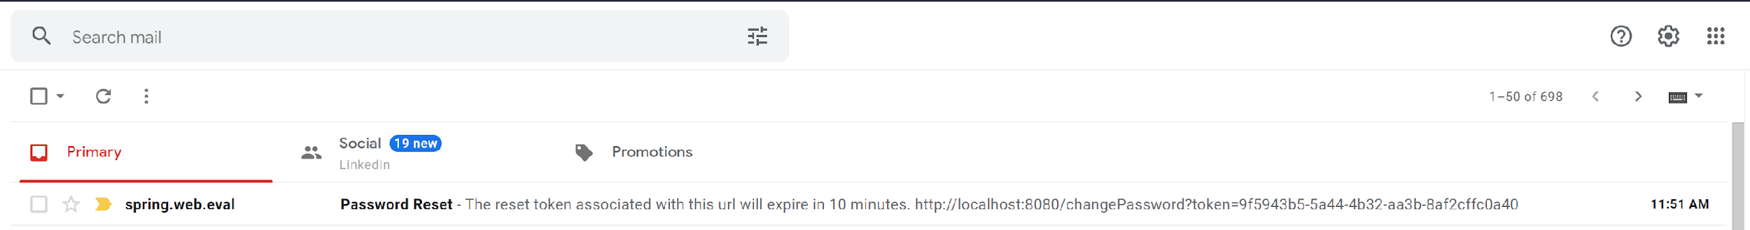

*Figure 8 - View of email inbox with reset email*

After clicking on the link provided in the email, the user will be taken to a webpage where two text boxes are provided. The webpage is the same as the “First Time Log In” section’s page. The text boxes must be exactly the same in order to have the password saved. The newly inputted password will be automatically encrypted and saved to the database upon clicking the submit button. A successful password change will redirect the user to the login screen.

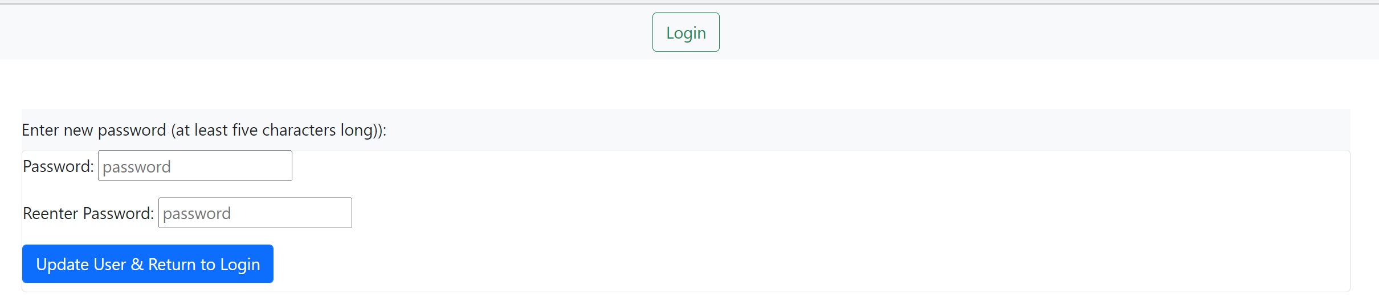

*Figure 9 - Default view*

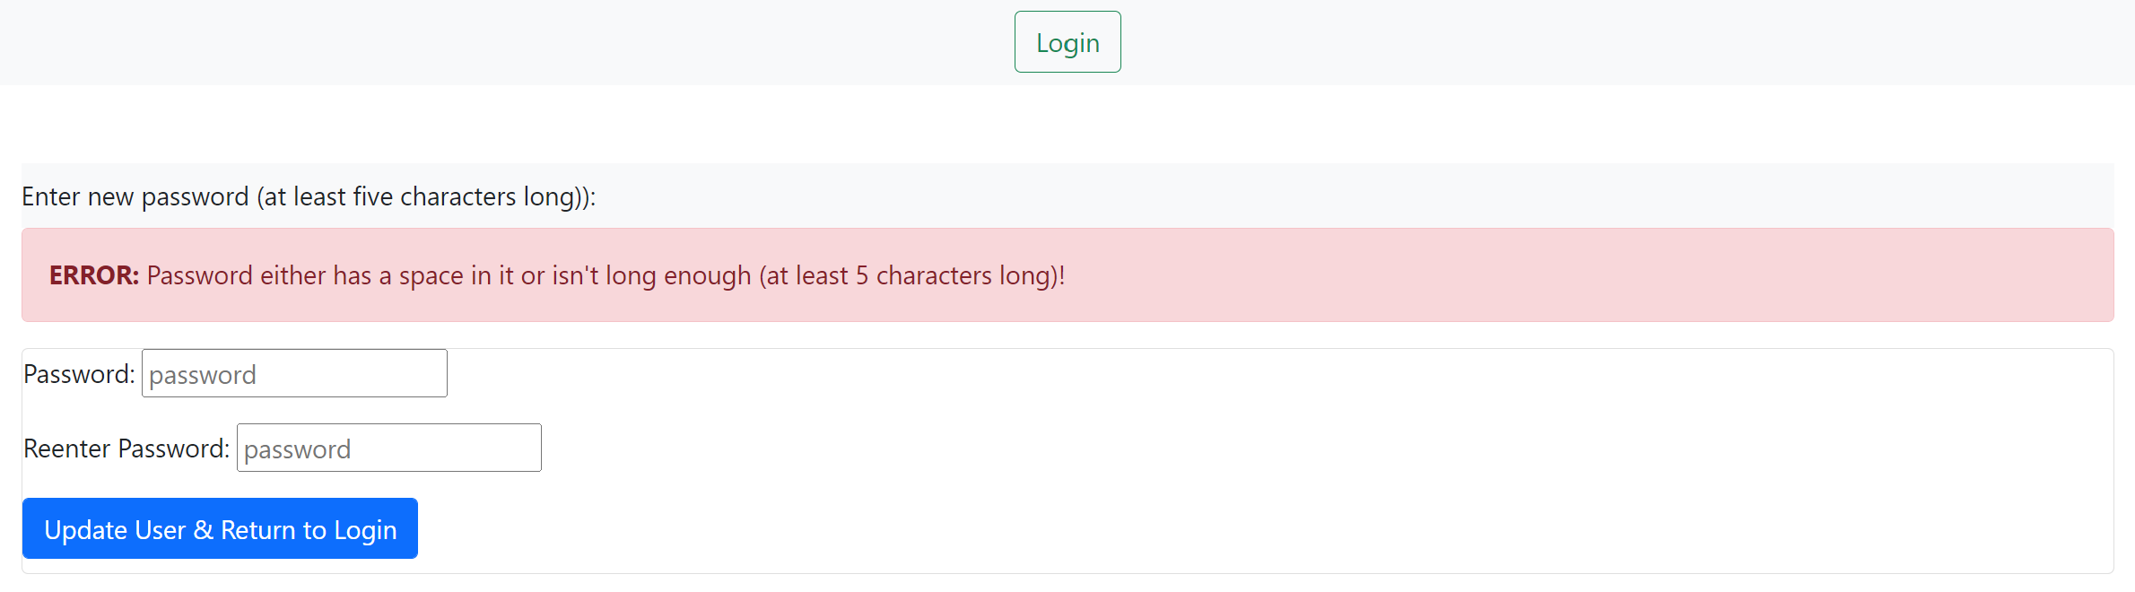

*Figure 10 - View upon failing to have the two text boxes’ content match*

## Home, Account, & Logout Navigation Bar Options

Upon logging in, all users should see a Home button in the navigation bar, being the far left-most button. This button will take the user to the exact page they see upon logging in.

All users have access to an My Account button on the navigation bar, which is located on most screens and it will grant the logged in user access to change their first/last/suffix name, email, and password. This editing ability does offer protection against changing an email to an already-taken email so that no two or more people can have the same email by making adjustments to the emails from here.

All users will also have access to the Logout button. It will logout the currently logged in user.

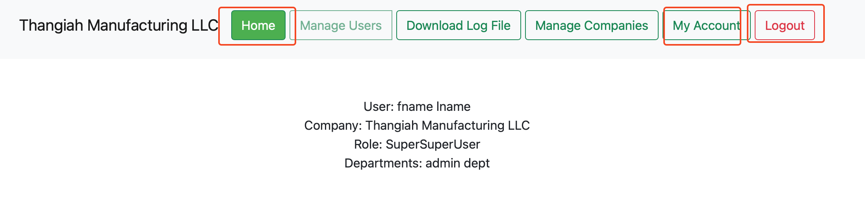

*Figure 11 - The three buttons, noted with a red perimeter, are commonly shared with all roles. The other buttons will vary depending on permissions of the user, this user is a global admin.*

# SuperSuperUser Abilities

Upon logging in, at “localhost:8080/login” or “localhost:8080/”, there are a few choices to do based on what “role” or privileges the user has. The SuperSuperUser’s main purpose is to manage the companies and create admins for each respective one.

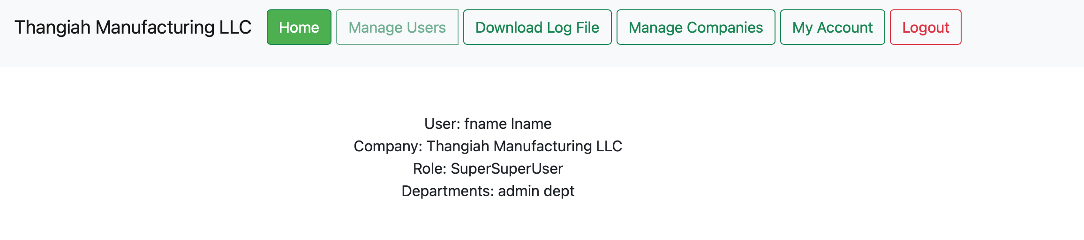

*Figure 12 - The homepage shows the company the current user is a part of, the role of the user, and the departments the user is a part of.*

Note that the SuperSuperUser must upload companies before they can manage users.

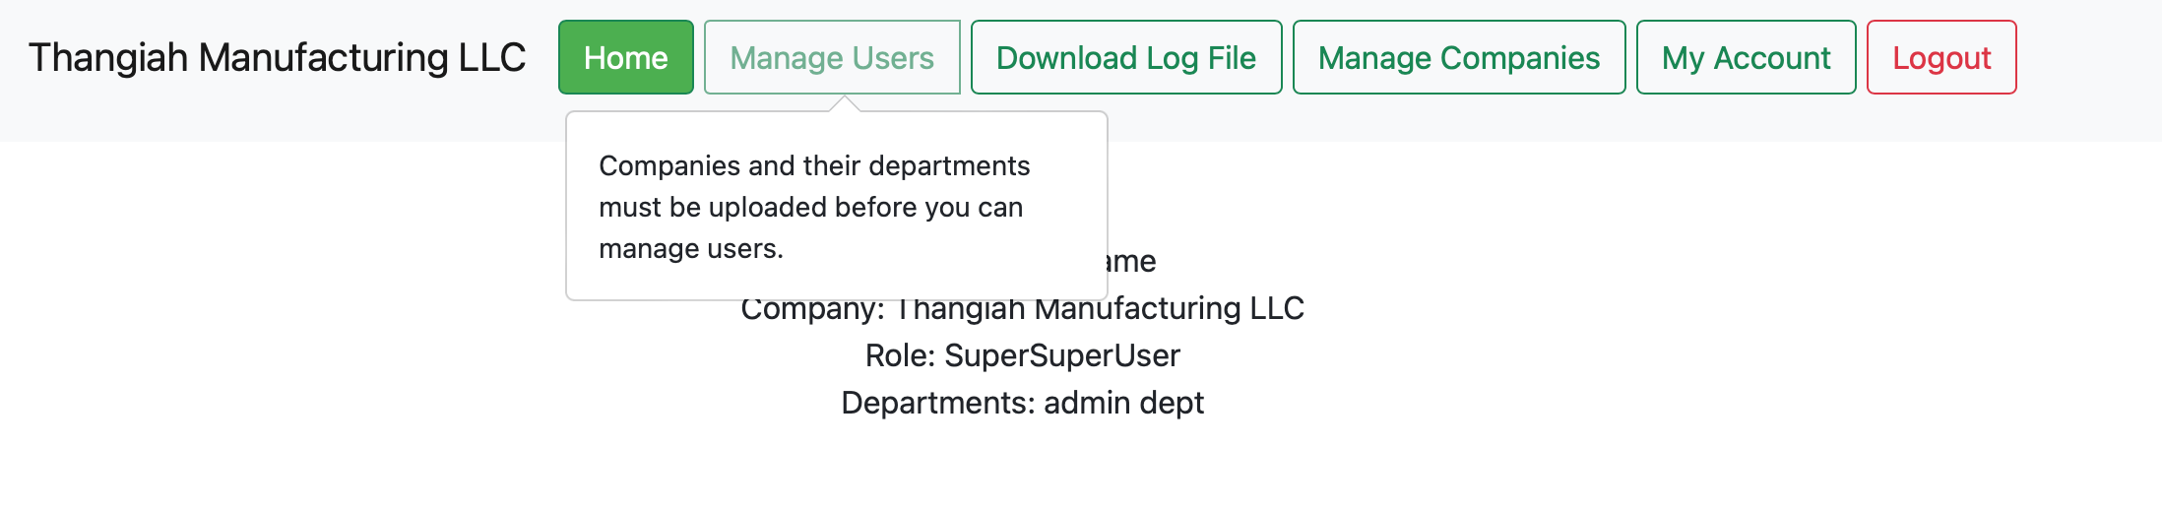

*Figure 13 - Attempting to access Manage Users screen before uploading companies*

## Manage Companies

To upload companies, click on Upload Companies in the navigation bar. Next, click on Upload Company and Choose File. Once you select the file, click on Import and the new companies will be uploaded This is outlined in the screenshots below.

Note that there are already two companies listed in the table**:** Thangiah Manufacturing LLC and Test Company 2. These two companies are created along with the base users since all users must be associated with a company. However, these do not have any departments or additional information shown. Using the provided upload file will resolve this issue.

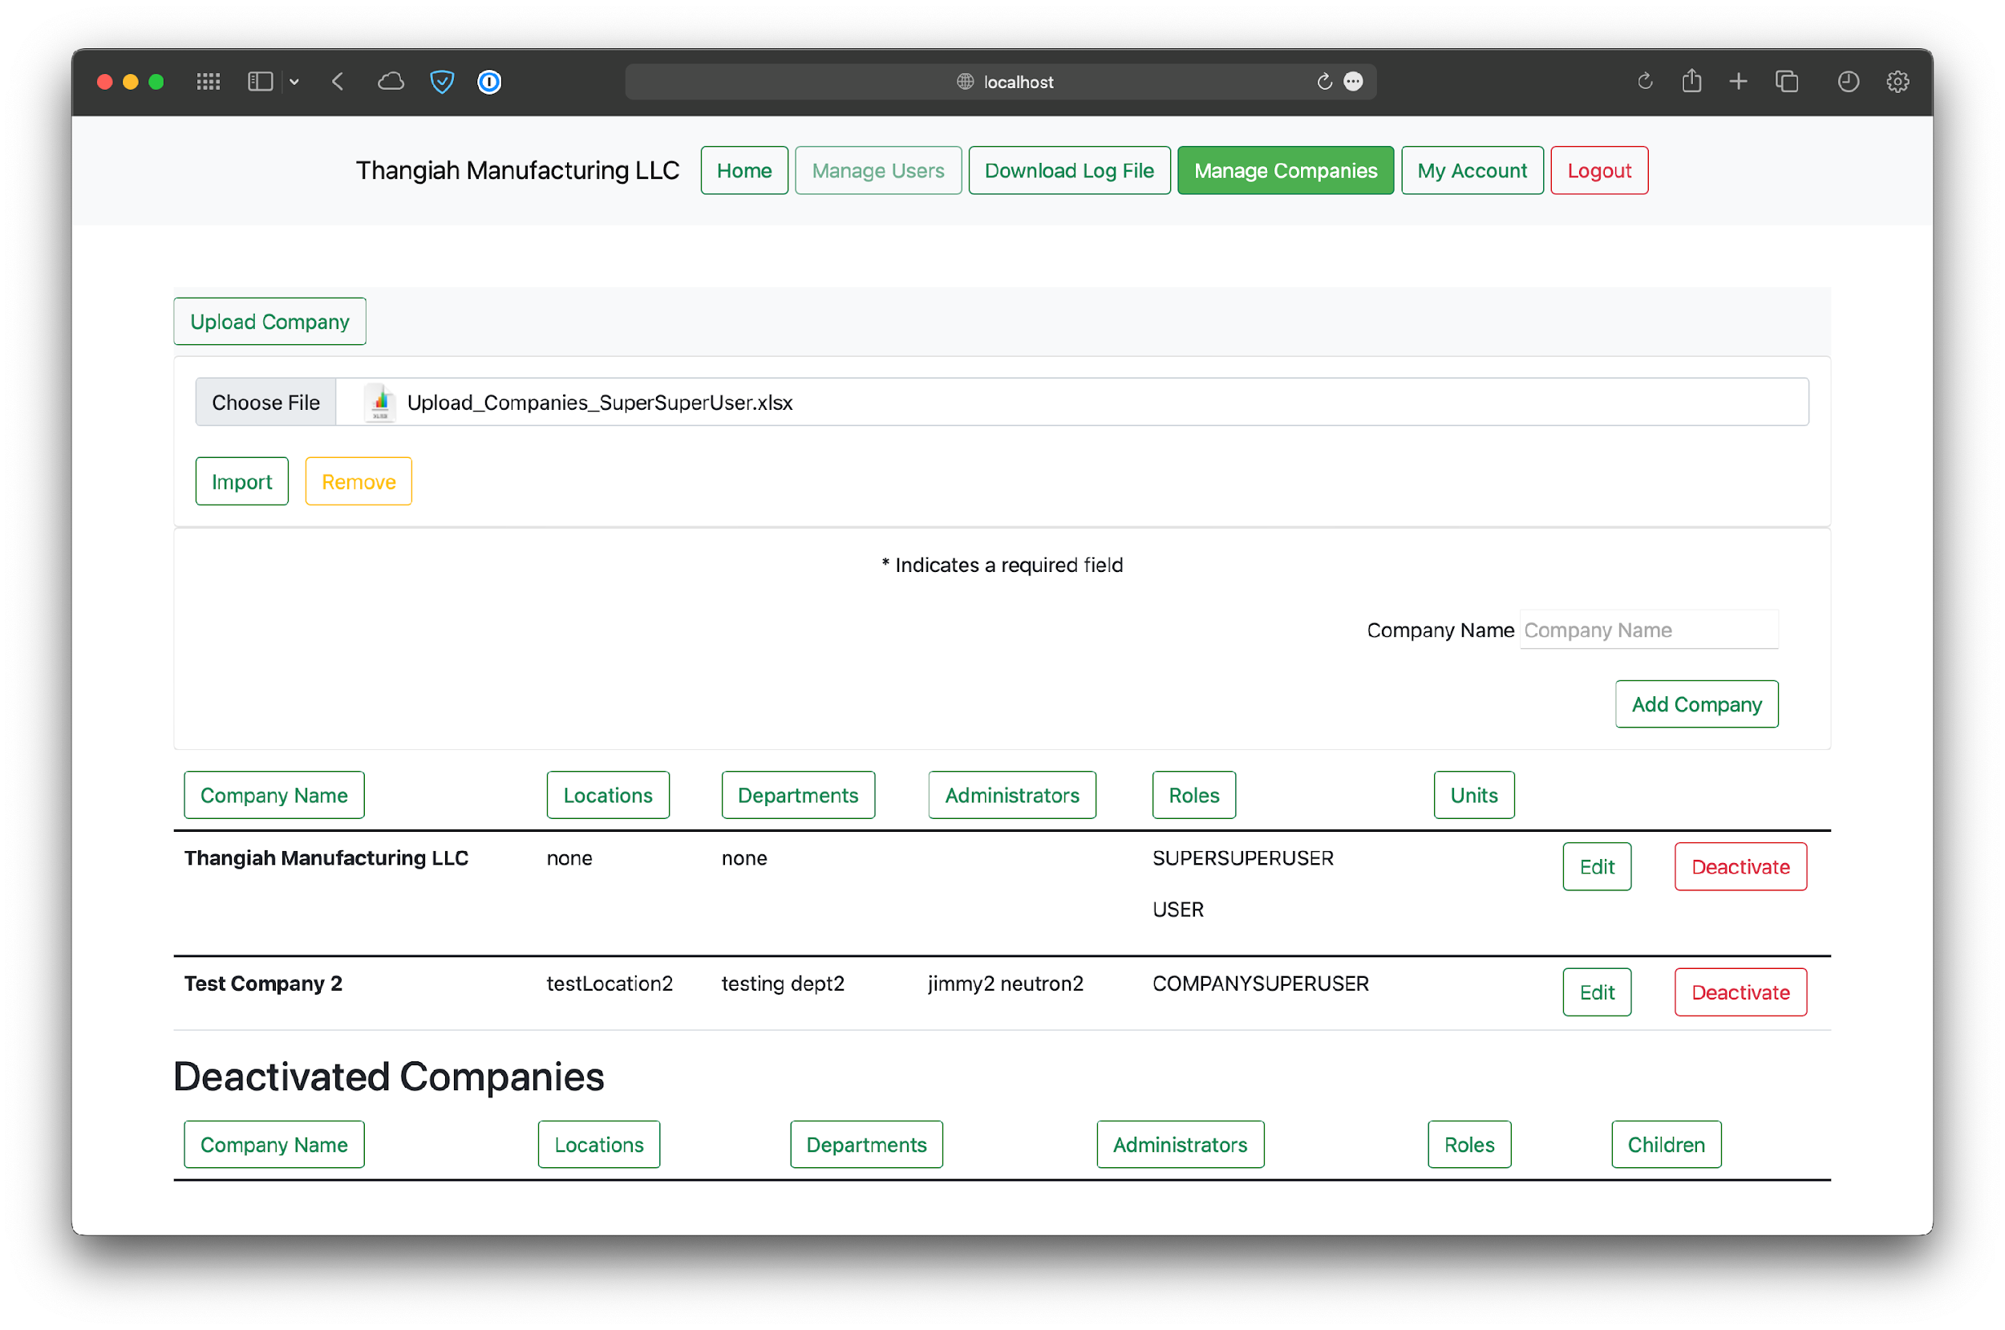

*Figure 14 - Adding the Upload Company File*

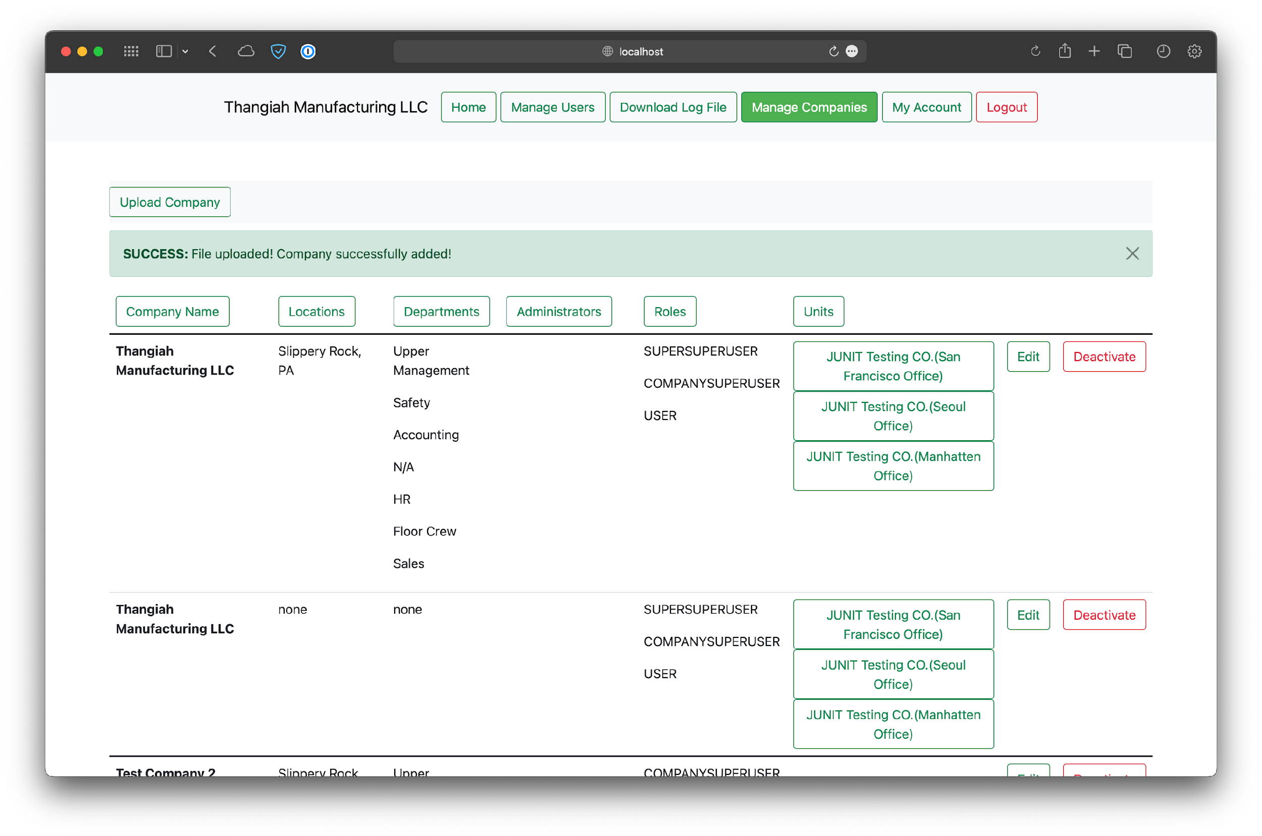

*Figure 15 - Successful companies upload.*

### Editing a Company

The SuperSuperUser can edit companies by clicking on the Edit button. This takes them to a screen where the company can be renamed or deactivated, or the ability to add or deactivate departments. Clicking on a specific Unit for a company will take the SuperSuperUser to a screen where that company’s information can also be edited.

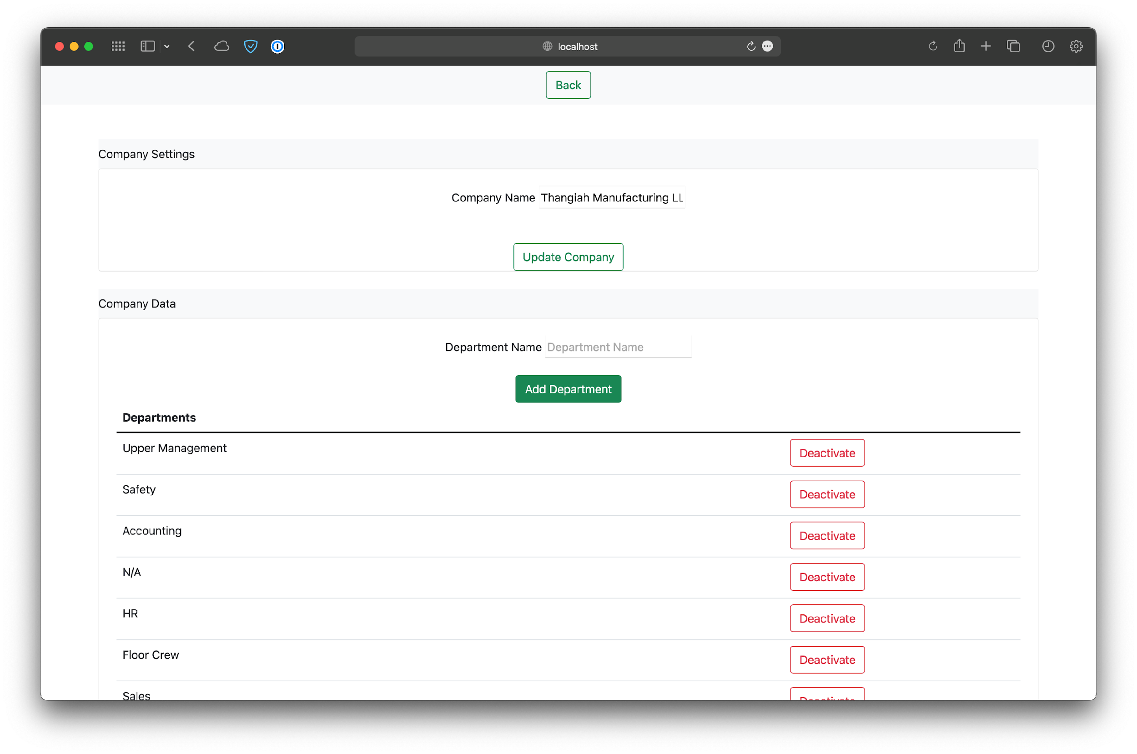

*Figure 16 - Default view for Editing a Company*

### Deactivate Company

SuperSuperUsers also have the ability to deactivate a company, by clicking on the button respective to that company in the table.

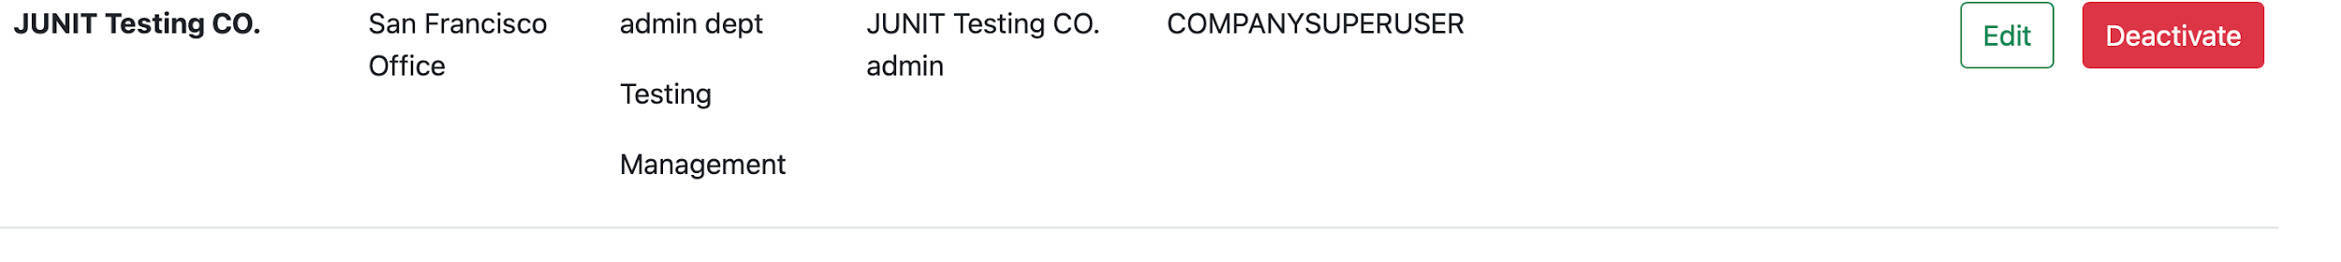

*Figure 17 - Company being chosen to deactivate.*

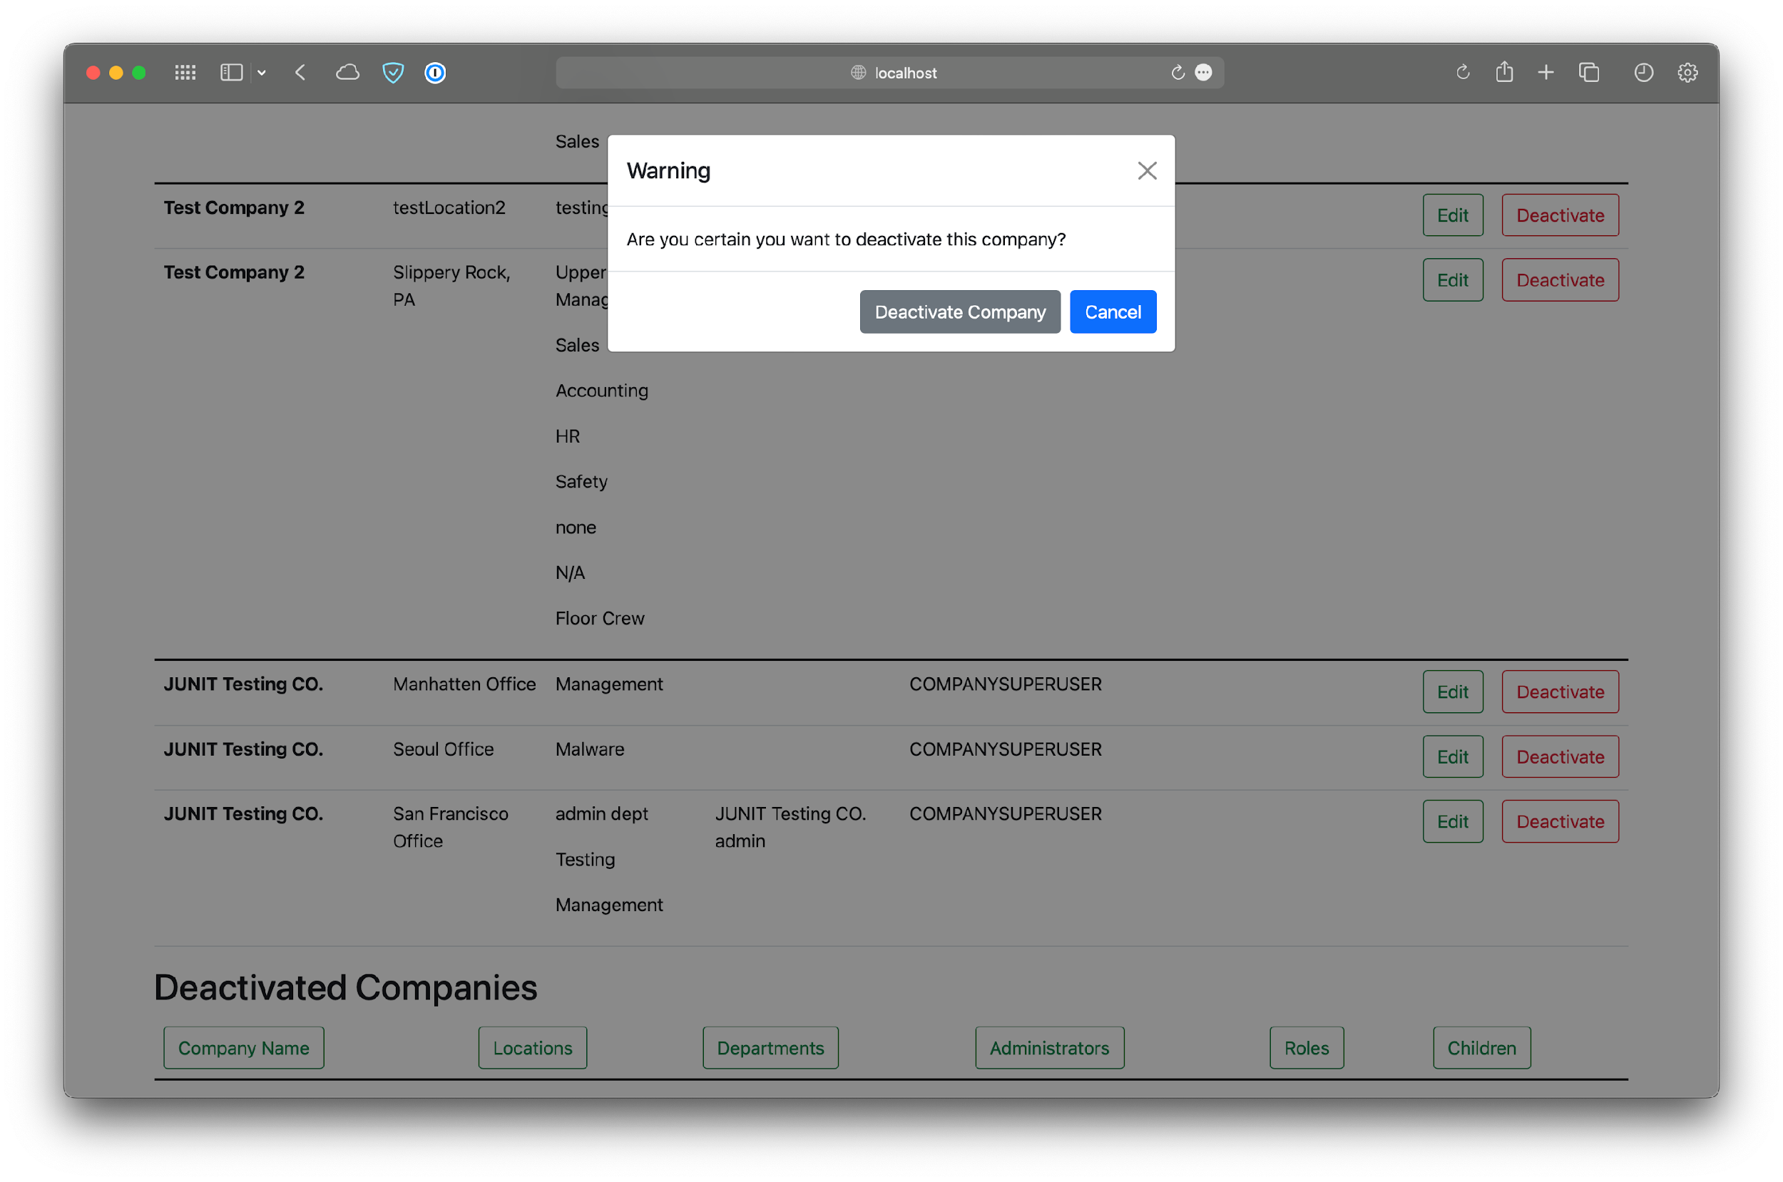

*Figure 18 - Confirmation of deactivating the company.*

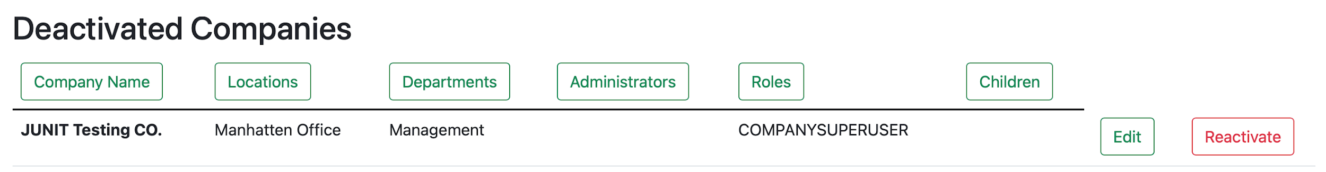

*Figure 19 - The deactivated company is now shown in the appropriate table.*

## Manage Users

SuperSuperUsers also have the ability to manage admins across all other companies. Clicking on Manage Users in the navigation bar will show all admins that were created automatically when uploading companies in addition to any new ones created manually. Note that the SuperSuperUser cannot delete their own account. The adding, editing, and deleting functions are explained later on in the manual, as admins mainly perform this function.

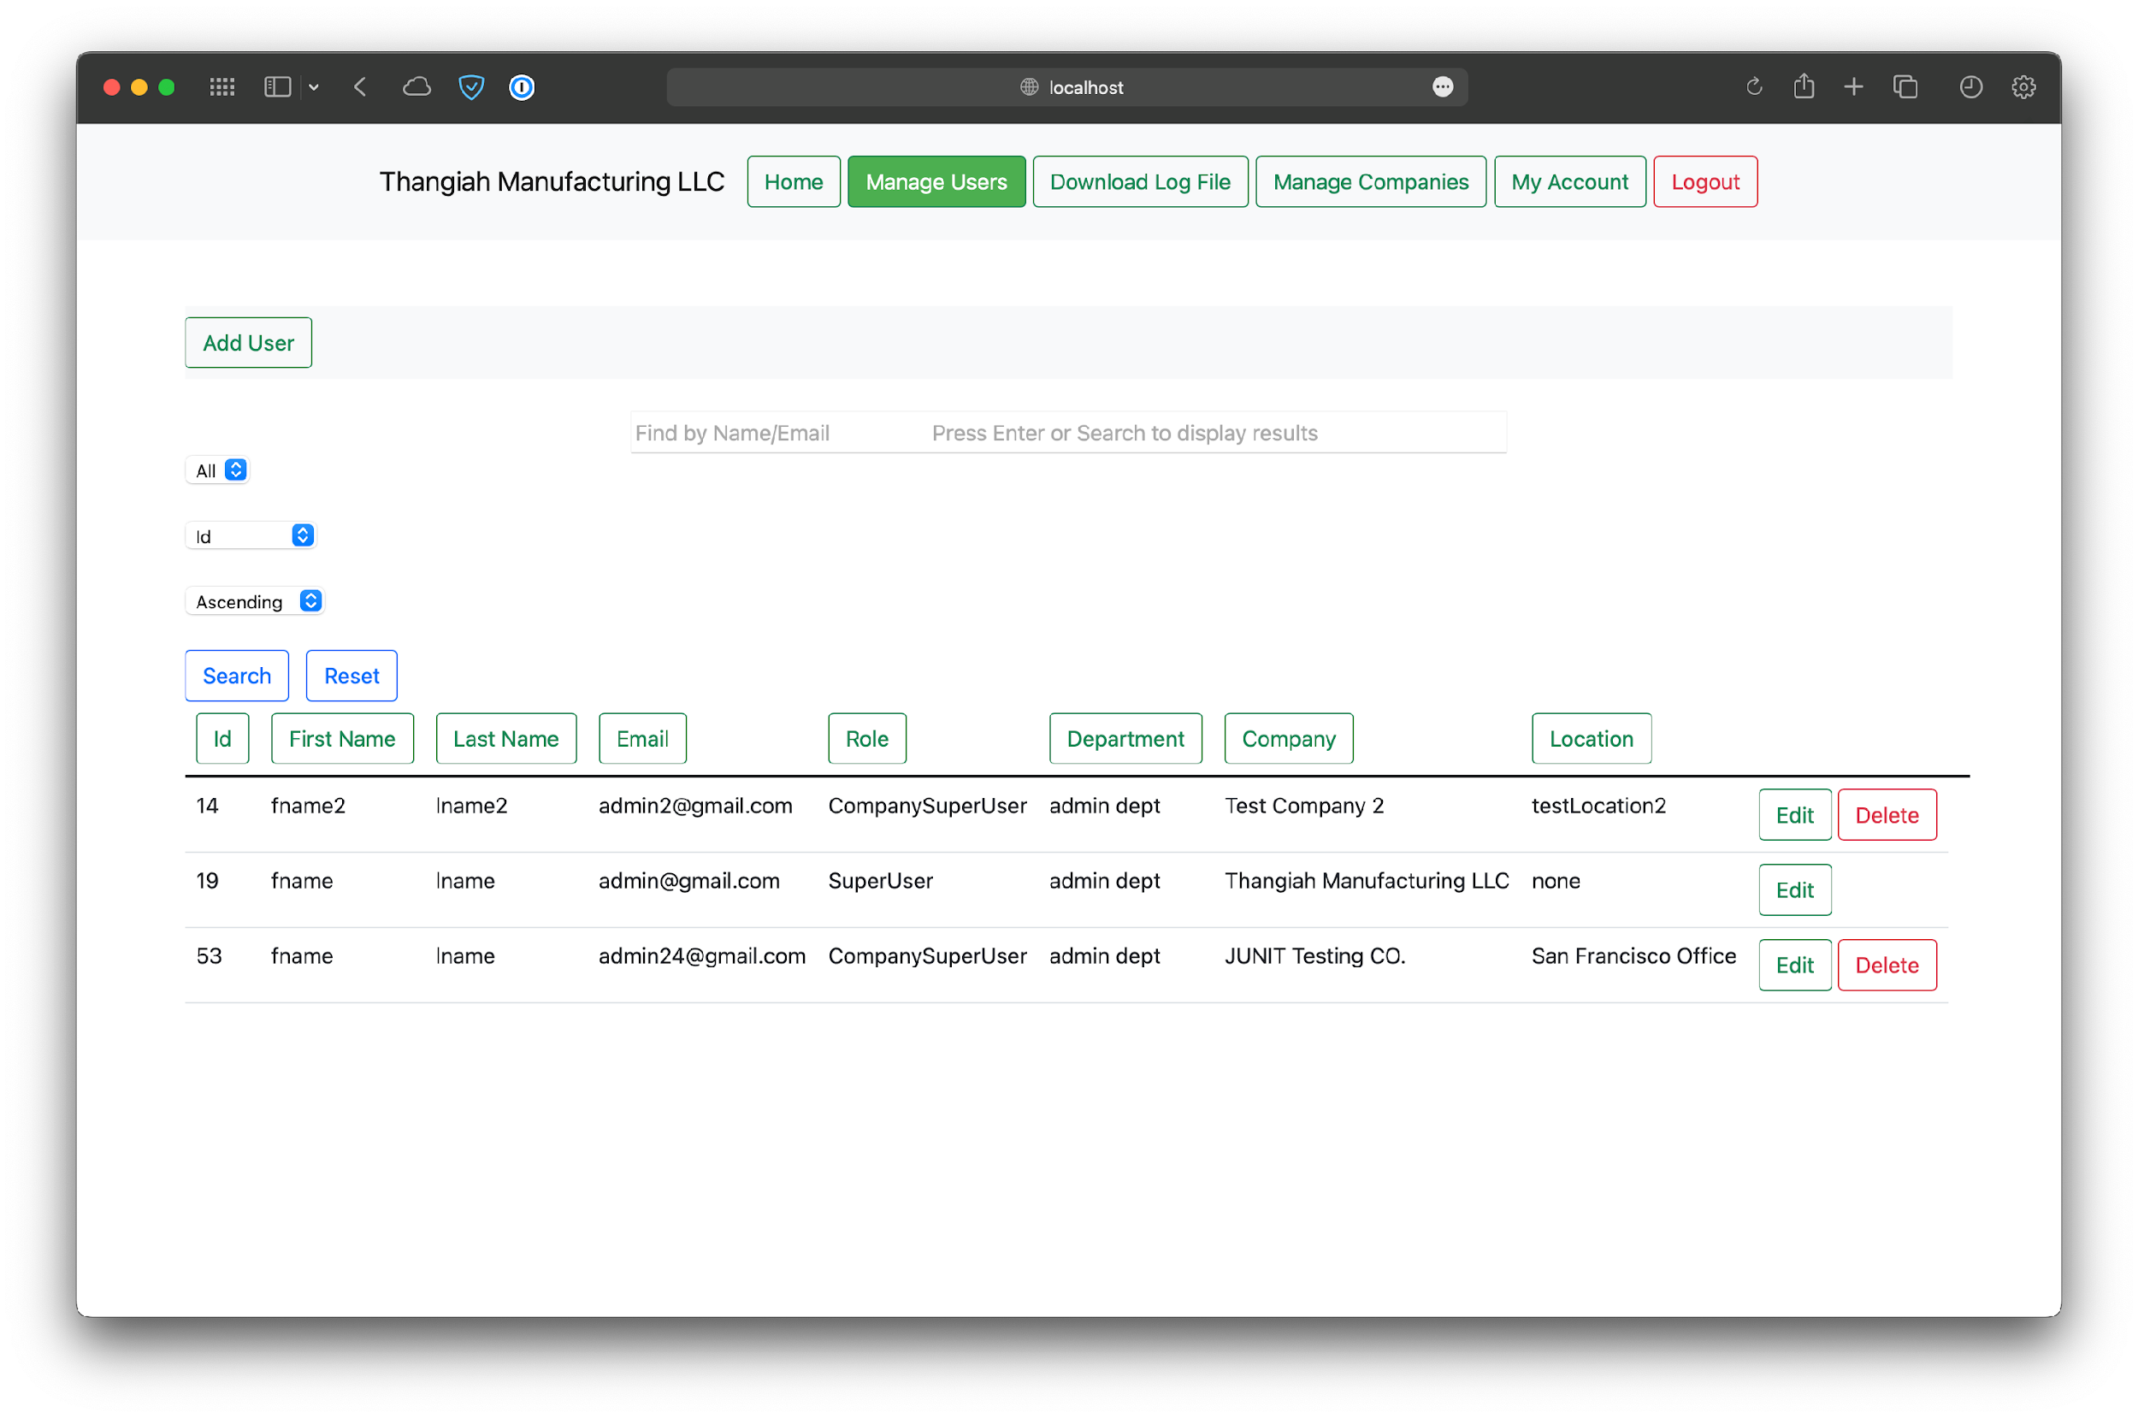

*Figure 20 - Default view of users for SuperSuperUser.*

# Company SuperUser (Admin) Abilities

The navigation bar for admins look a little bit different from the SuperSuperUser. They have a few more screens that enable them to perform various operations in their respective companies. They can manage users, but only after roles have been added. They can also create groups for evaluations, but only after both users and at least one evaluation template have been uploaded.

## Manage Roles

This is the first operation that a company admin should perform. To do this, navigate to the Manage Roles screen. Click on Upload Roles and then Choose File. After clicking Import you should see a success message along with a table of the uploaded roles.

Notice that the number of users for each role is 0 to start. This is because no users have been uploaded for this company yet. Once they are uploaded, returning to the Manage Roles screen will update the values for the number of users for each role.

There is also a tab for Active and Deactivated roles. After a role is deactivated, it is shown in the separate table for deactivated roles, with different functionality than the active roles.

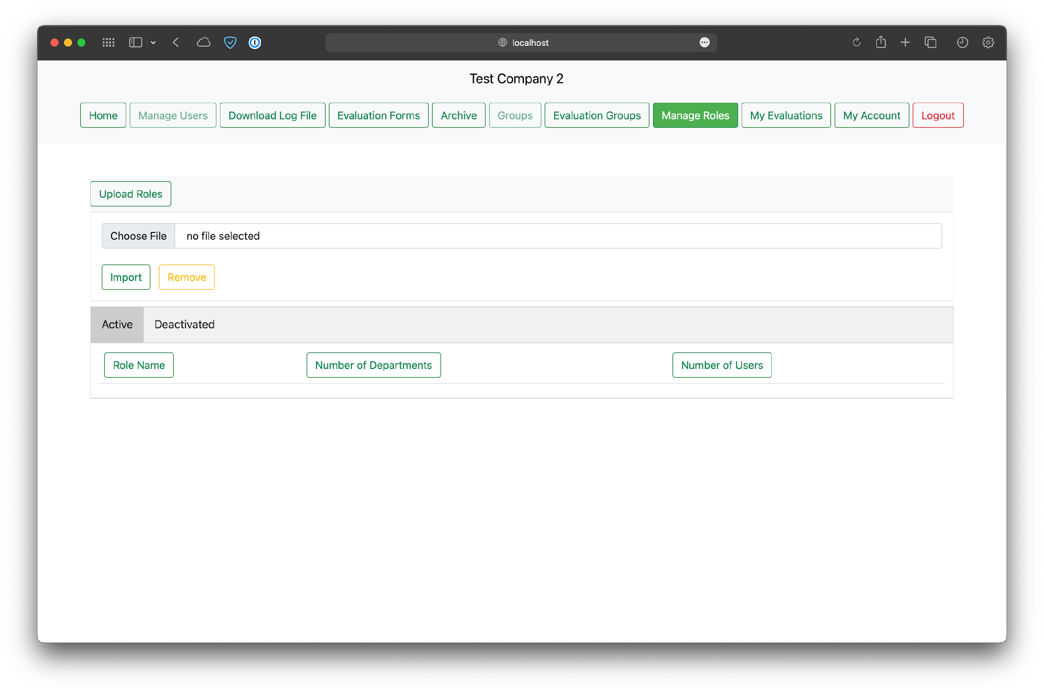

*Figure 21 - Default view for Manage Roles screen.*

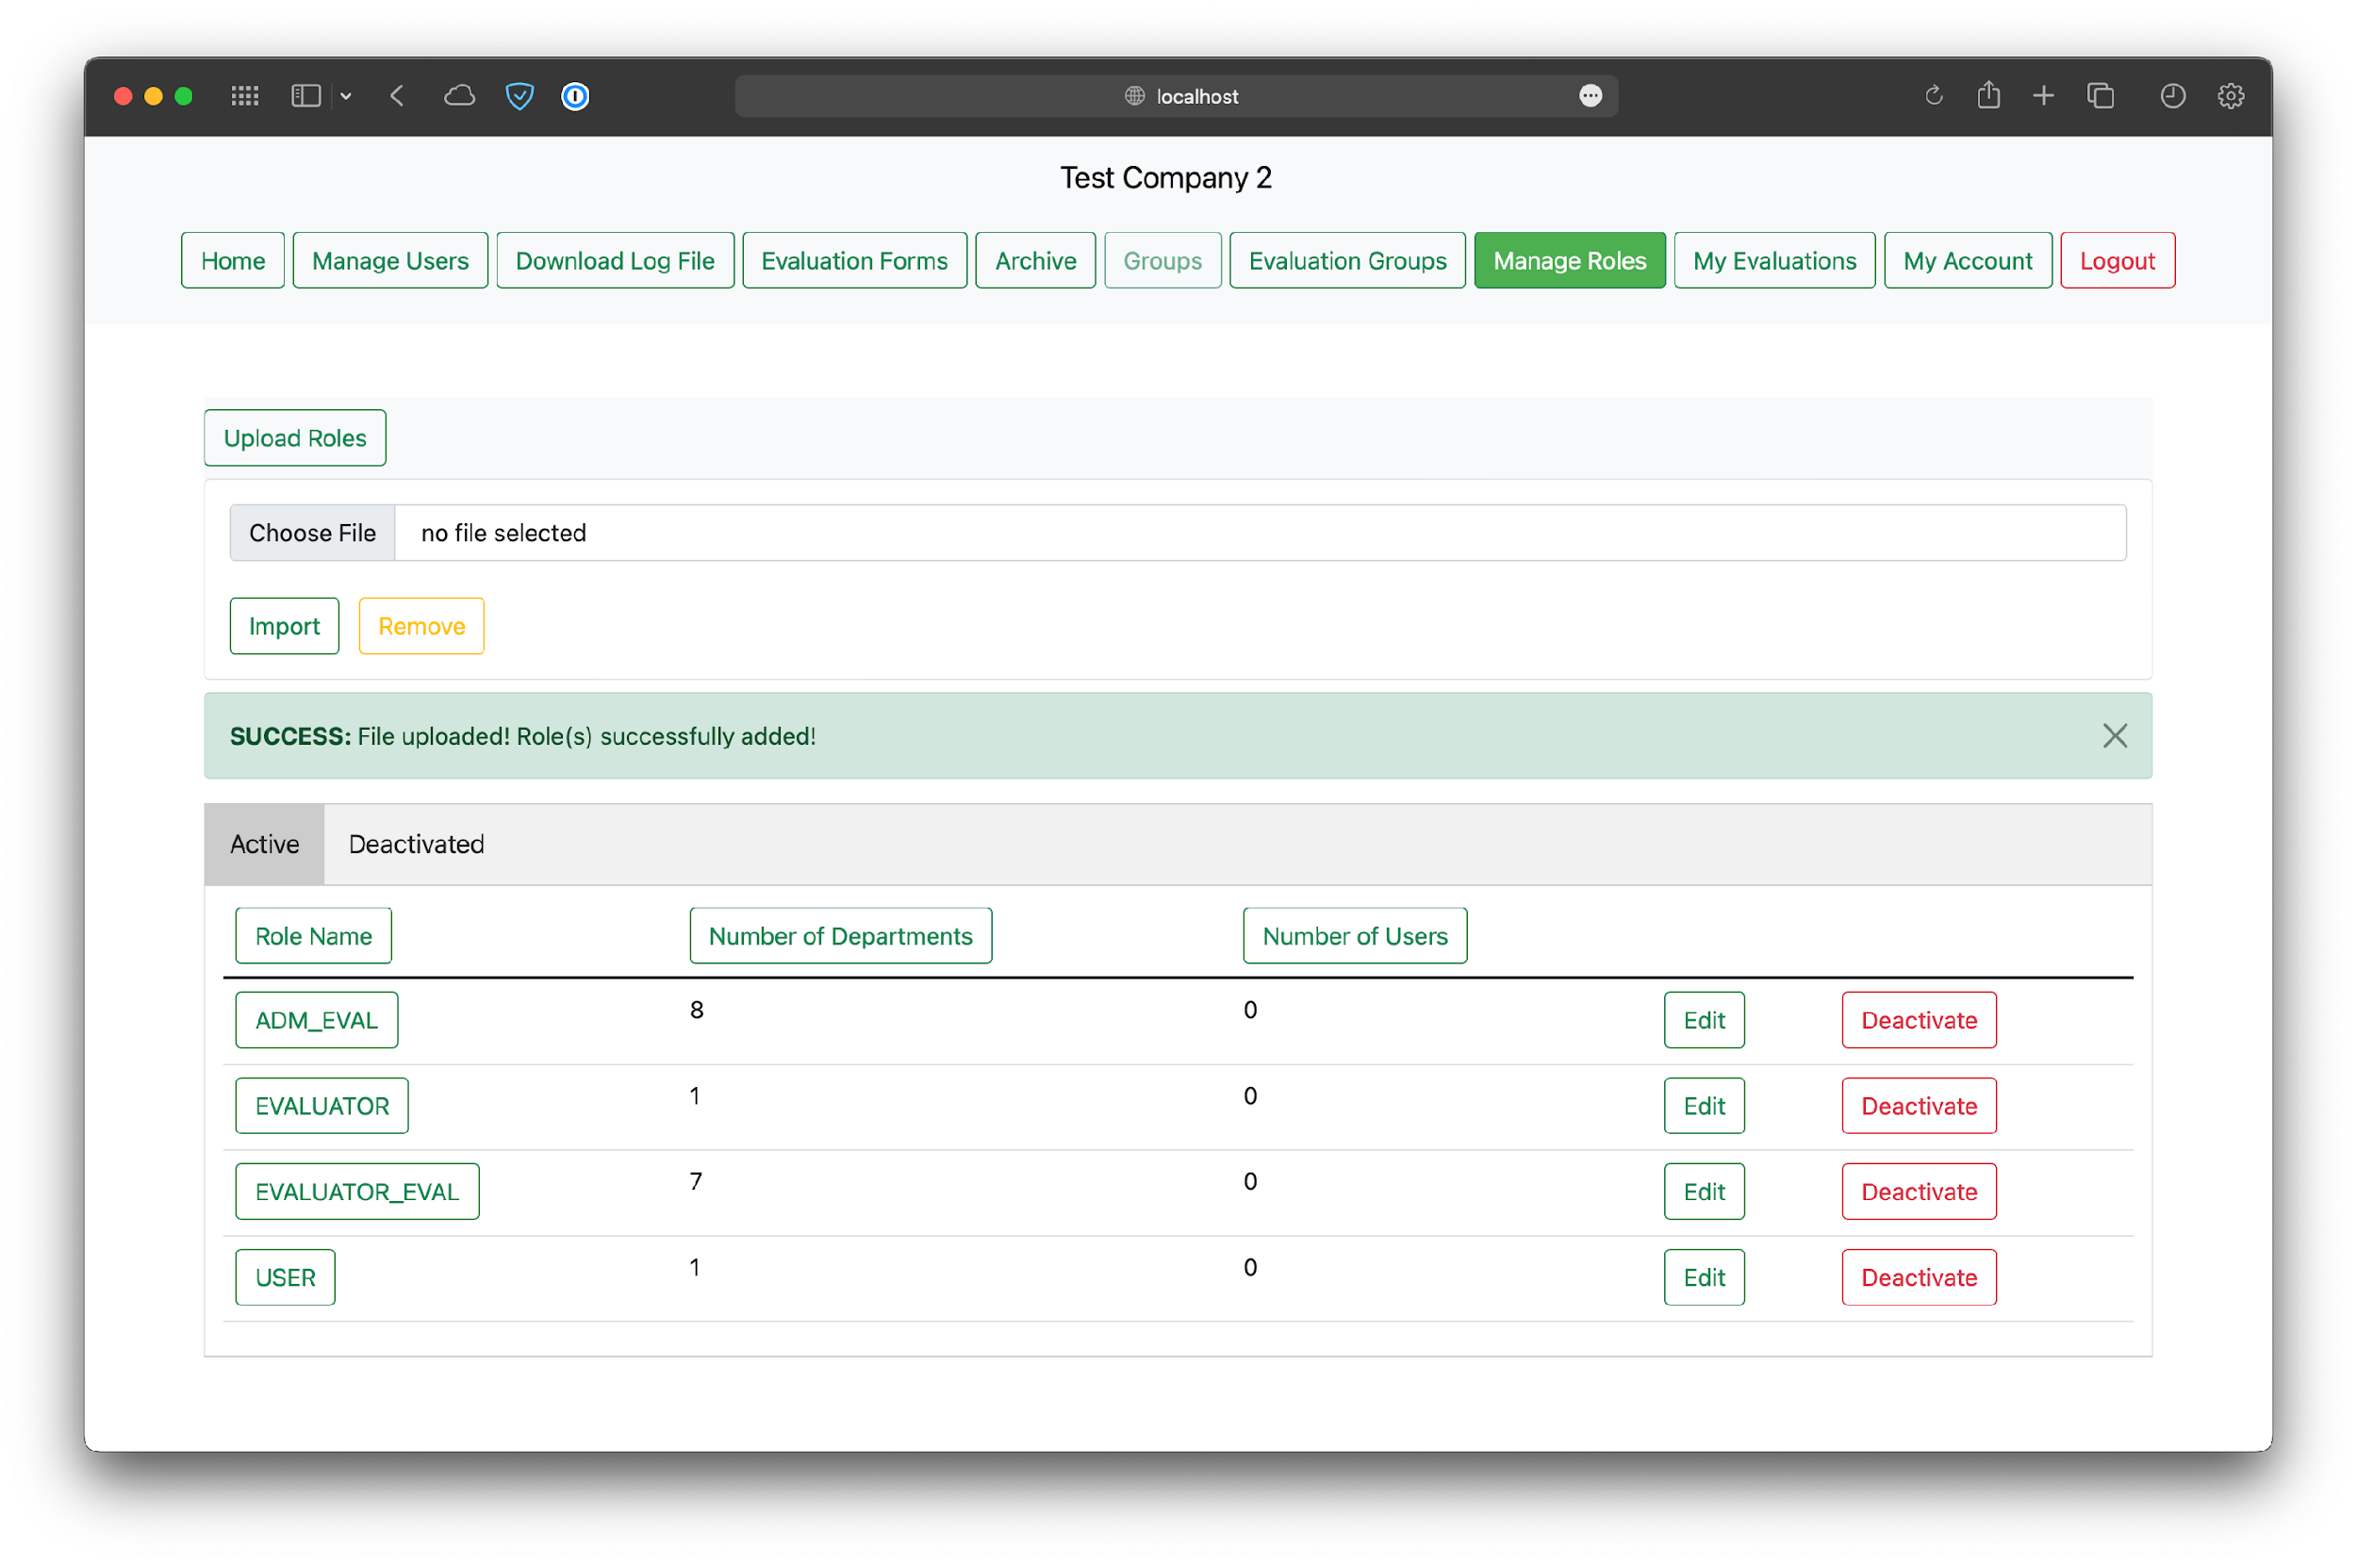

*Figure 22 - View after uploading roles.*

### View Roles in Greater Detail

The table in the Manage Roles screen provides basic information regarding a role. Clicking on the name of the role in a table will open a new screen showing the users, departments, and privileges associated with a role.

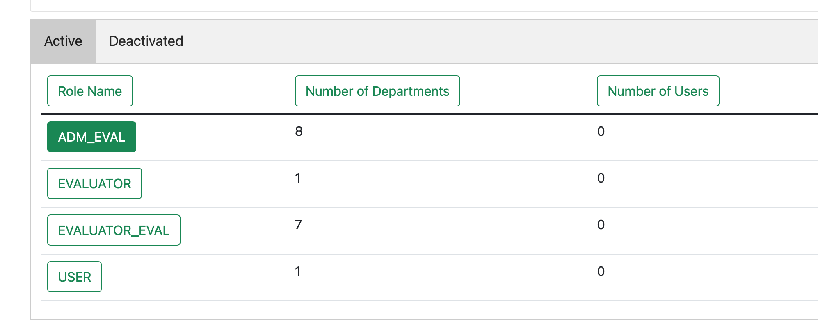

*Figure 23 - Viewing a role in greater detail.*

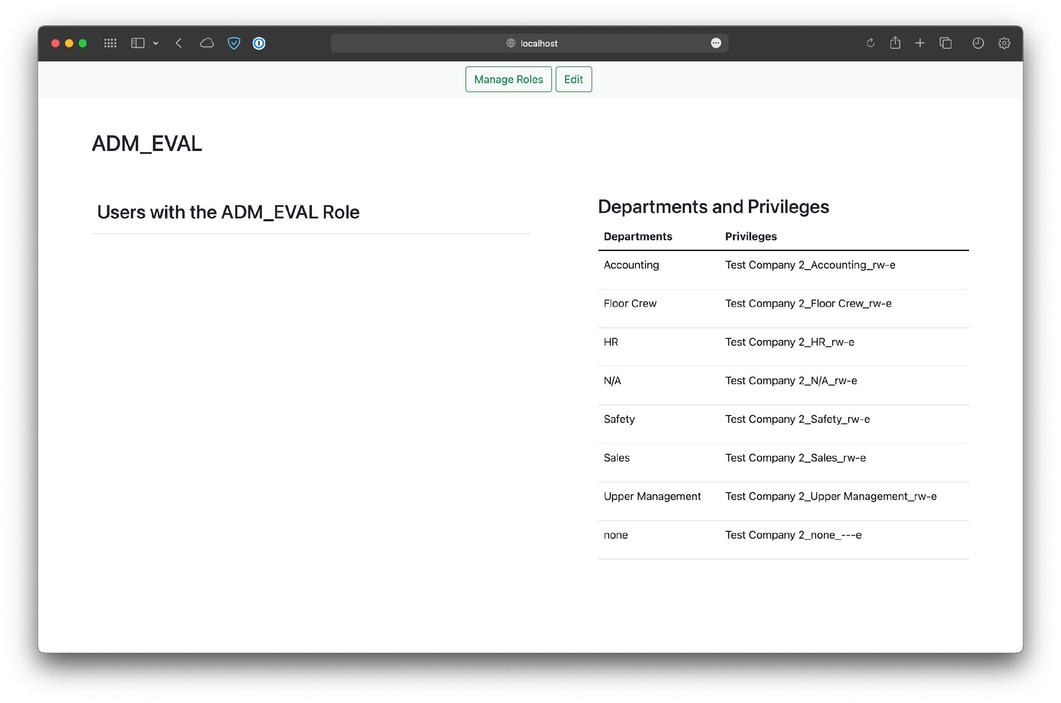

*Figure 24 - Default view for viewing an individual role.*

### Editing Roles

This operation will be the most useful after users have been uploaded for a company. Otherwise, only departments and their privileges can be edited for a role. Clicking on the Edit button in the table or the Edit button in the view screen will take you to a different screen for editing the various components associated with a role. Users that have been uploaded to the company can be assigned/unassigned the role, new departments can be added/removed, and privileges can be updated.

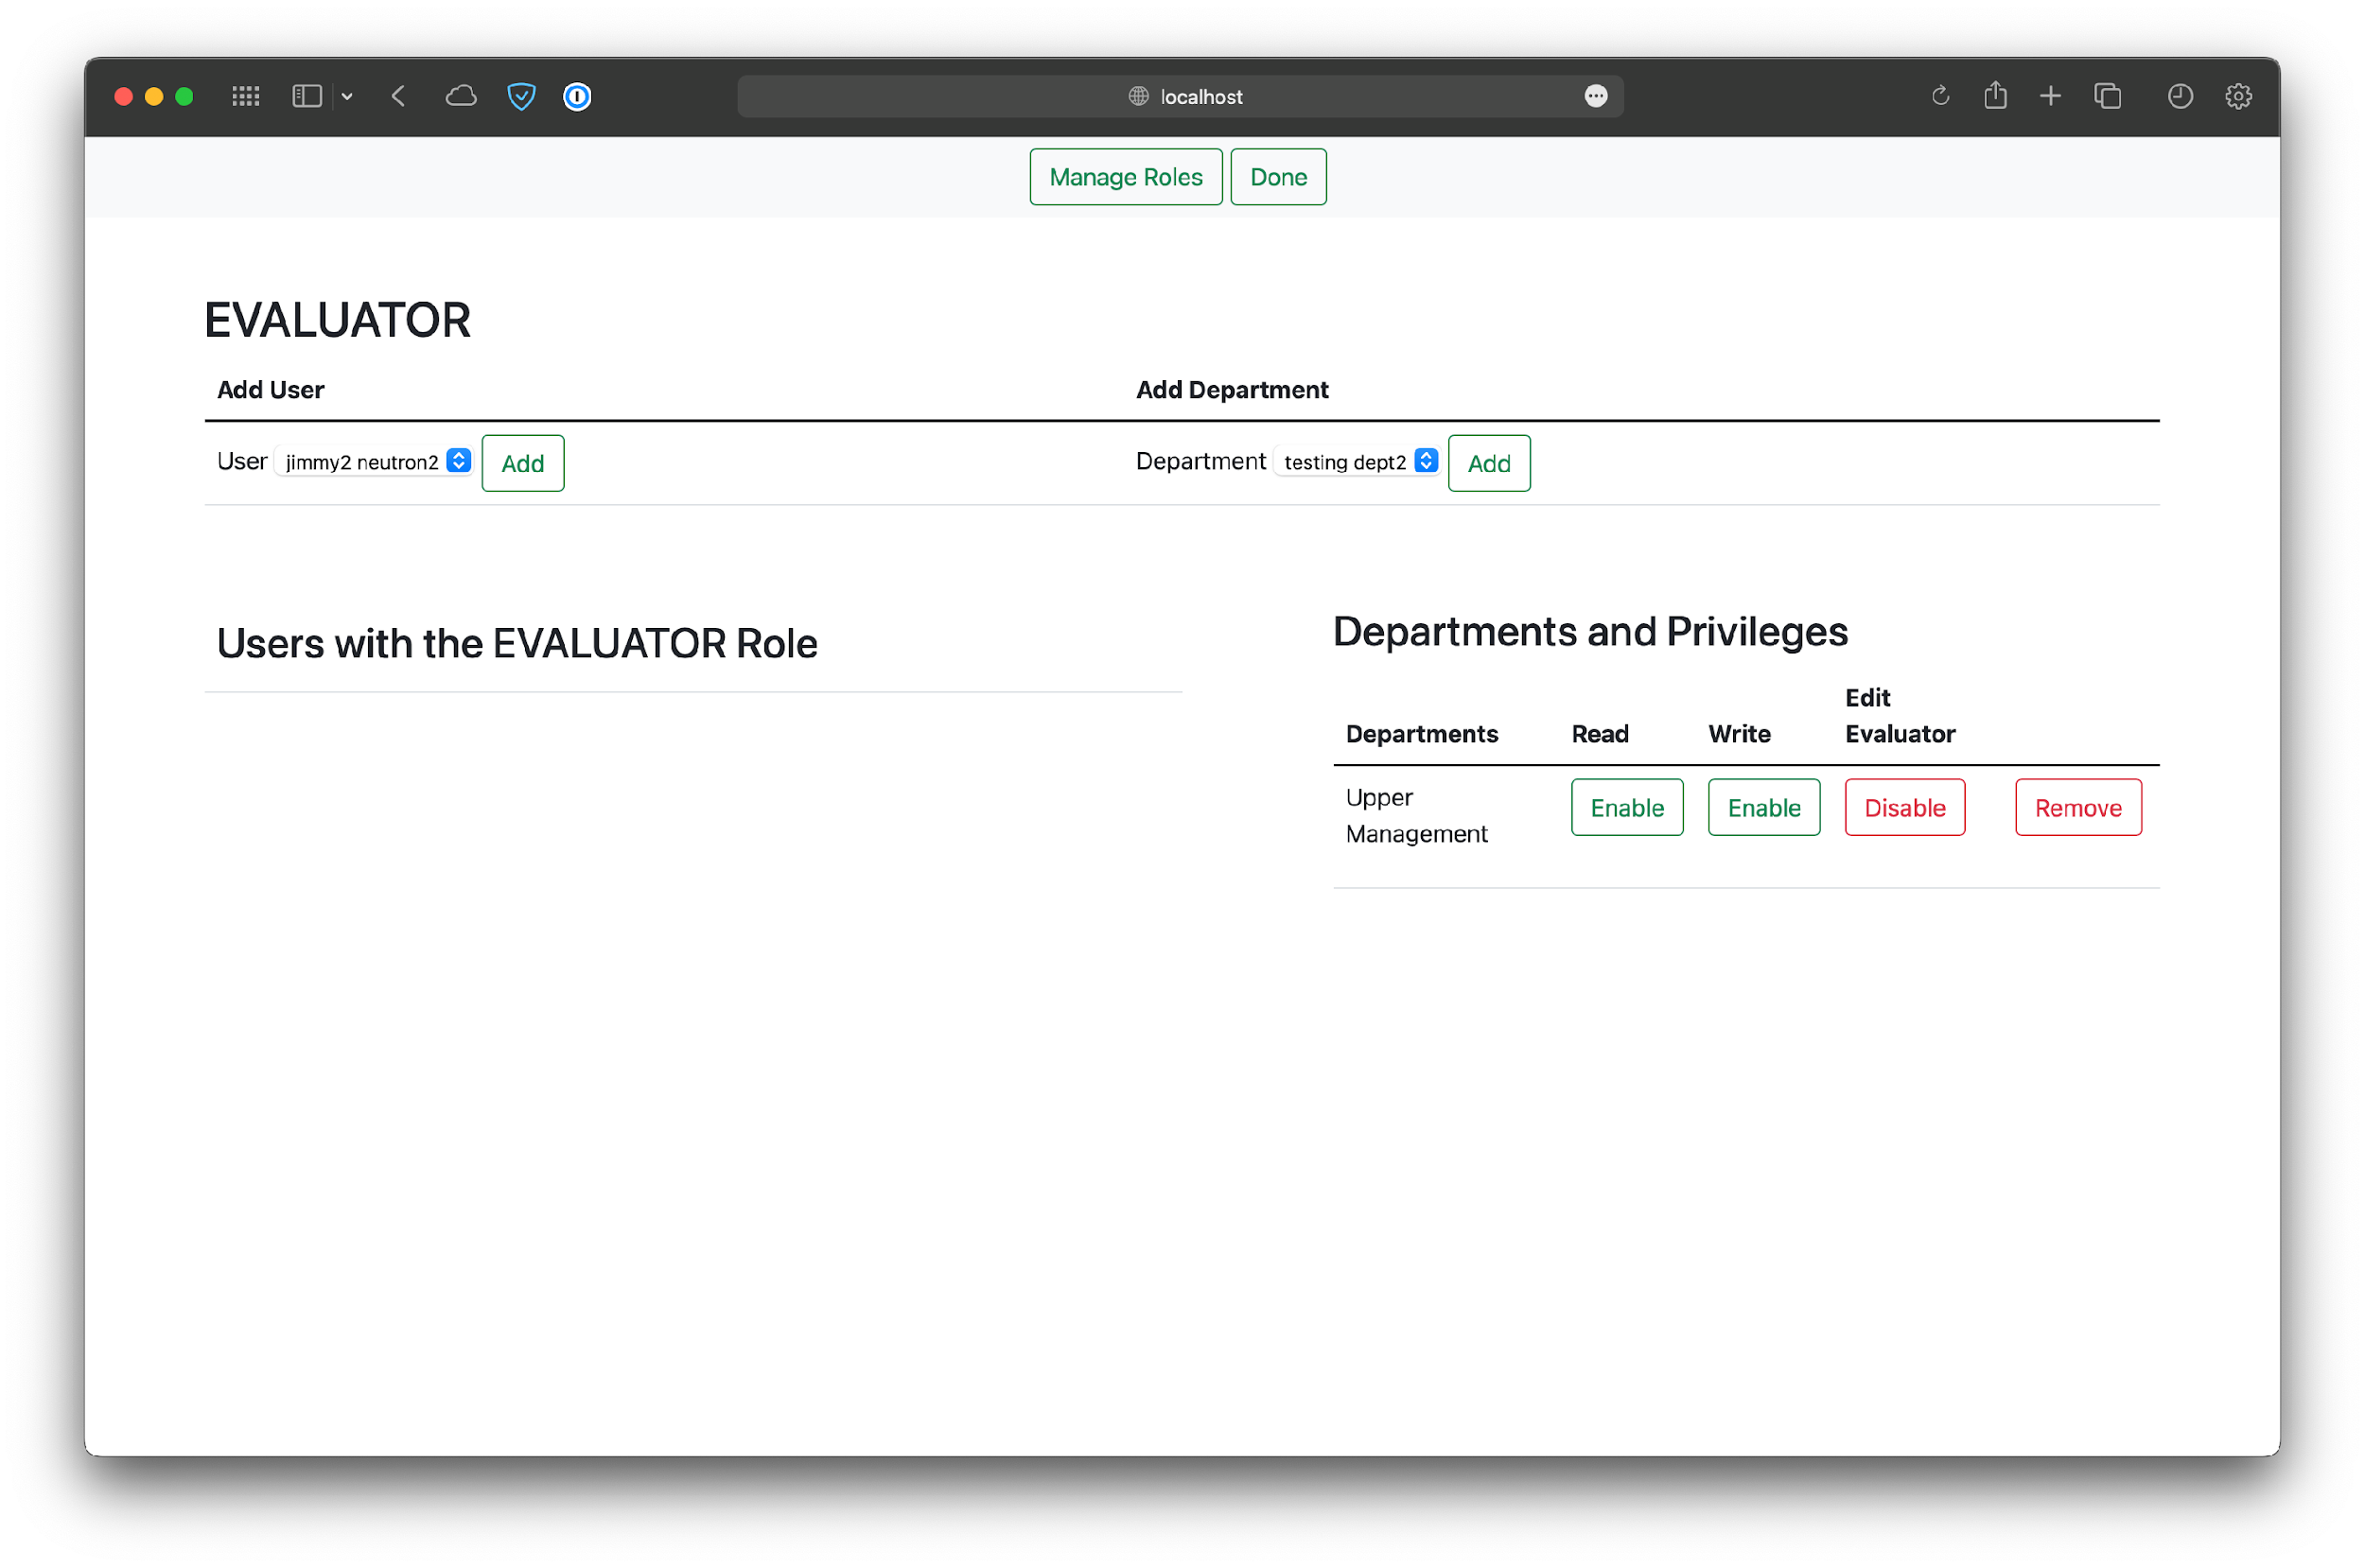

*Figure 25 - Default view for editing a role.*

### Deactivating and Reactivating Roles

Roles can also be deactivated, so that they cannot be used in the company anymore. However, they are not permanently deleted, so they can always be reactivated.

To deactivate a role, click on Deactivate in the table. A confirmation message will then appear.

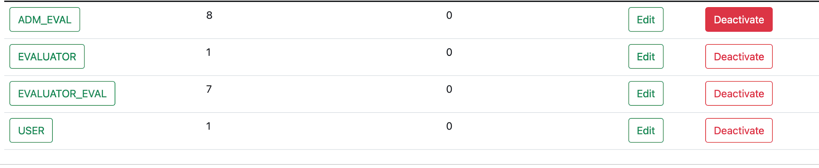

*Figure 26 - Deactivating a role.*

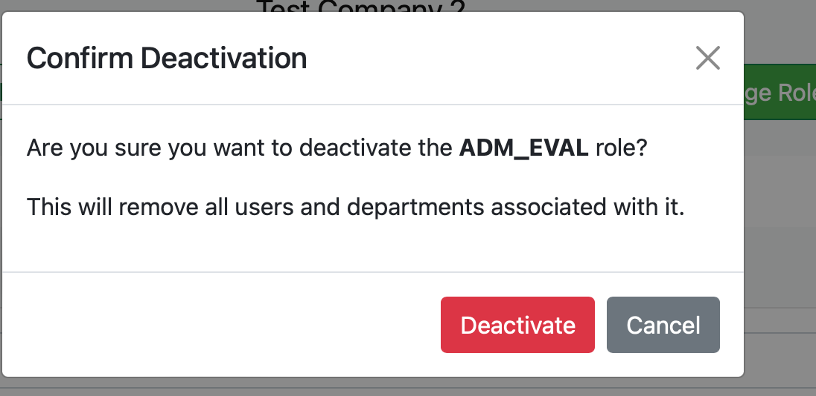

*Figure 27 - Confirmation of deactivating a role.*

Now, if you navigate to the Deactivated section of the table you will see any roles that have been deactivated. There is an option in the table to reactivate it. Note that the users and departments that existed previously were removed once the role was deactivated, so they will need to be added again.

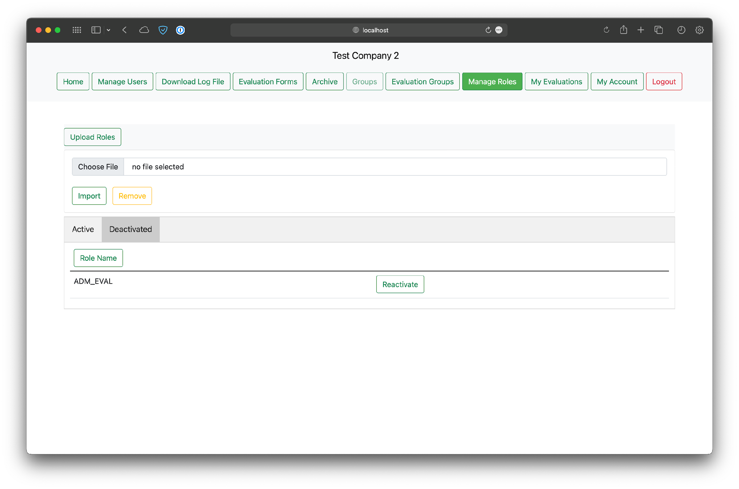

*Figure 28 - Viewing the deactivated roles.*

## Manage Users

The Manage Users button in the navigation bar will also display a webpage where a SuperUser can view, edit, and delete current users within the database as well as add/upload users. These each function the same way for admins as well. However, data shown in the table will vary depending on the administrative privileges the currently logged-in user has. The SuperSuperUser will only see admins in the table, whereas the admins will only see users respective to their company.

On the Manage Users button page, clicking the “Add User” button will display two things: a section with a few boxes to manually add a user new user, and a section with buttons to select and upload an excel file. A user can be created by including a first/last/suffix name, email, password, and role followed by pressing the “Add User” button. There a safeguard for signing up multiple users with the same email address so that no users may share the exact email address from here.

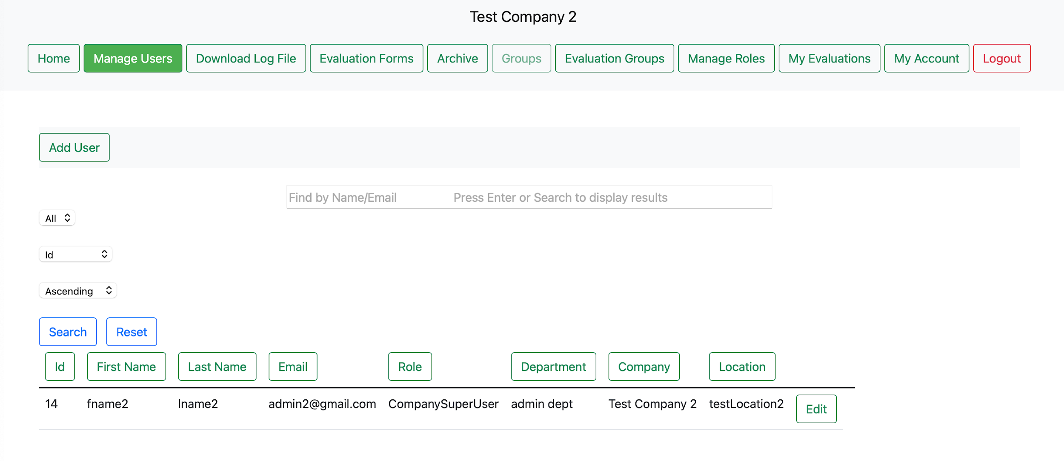

*Figure 29 - Default view before pressing the "Add User" button.*

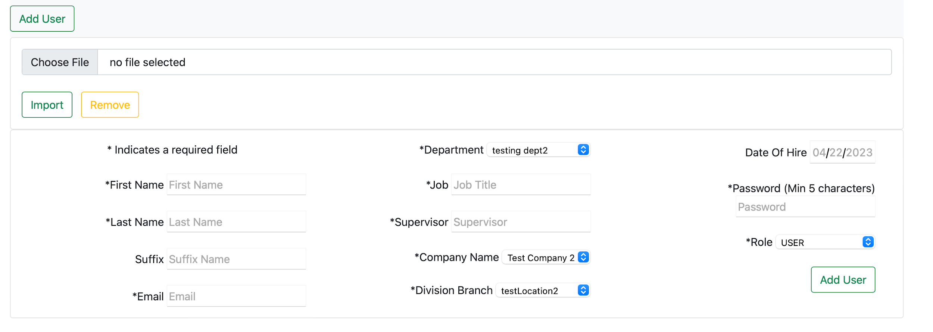

*Figure 30 - Appearance upon clicking the “Add User” button where user details can be entered in the text boxes/ drop-down menus. The user details may attempt to be saved with the “Add User” button.*

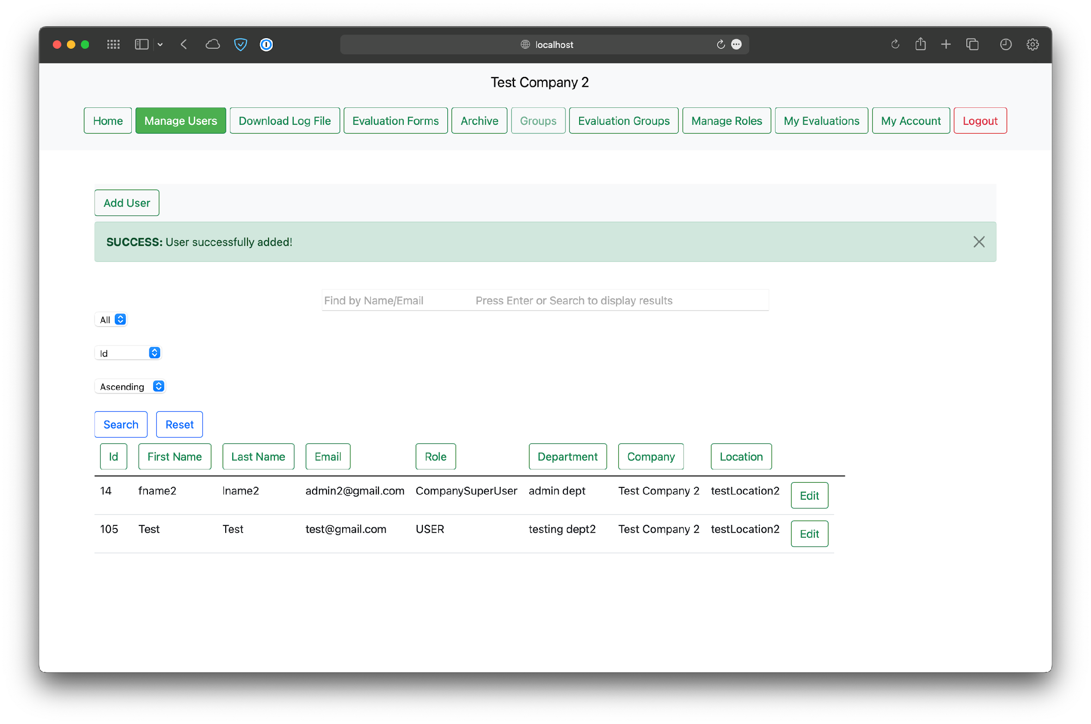

*Figure 31 - View that’s shown when a user (being test test in this case) is successfully added manually once the necessary details were filled up and the “Save User” button were pressed.*

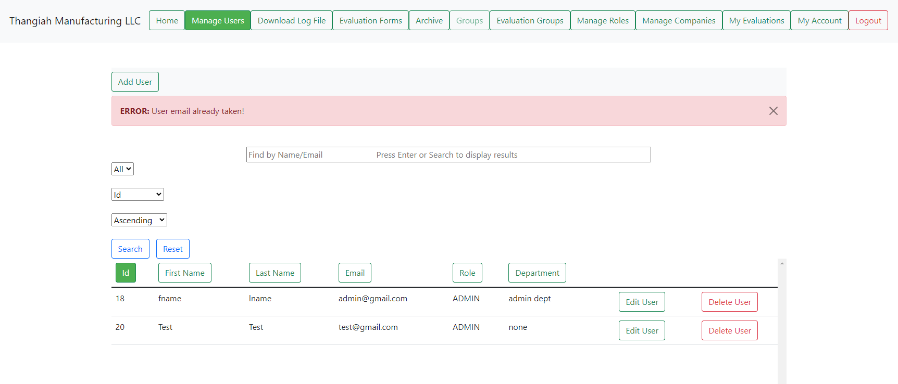

*Figure 32 - Attempting to add a new user that shares the same email as an already-existing user via the “Save User” button. Similar warning errors will display when certain, or all, fields were empty upon trying to add a user.*

The “Upload Users” serves as a way to add users to the database via uploading an excel file. The file must be in particular format as can be seen in the “Program Documents” folder named “Upload_Users_Company_2_Admin2.xlsx”. Users may create their own version of an user upload file following the “Upload User Template Manual.docx” in the documents folder. It does check if the file is able to be uploaded as well as checks for users that are already in the database and refuses to make duplicates based on user emails. The user must click on “Choose File” and then click “Import” upon selecting a file to be uploaded. Feedback will be provided if the upload is successful or not. If a file is chosen, and the user decides that they don’t want to upload it, they may press the “Remove” button in order to deselect the file.

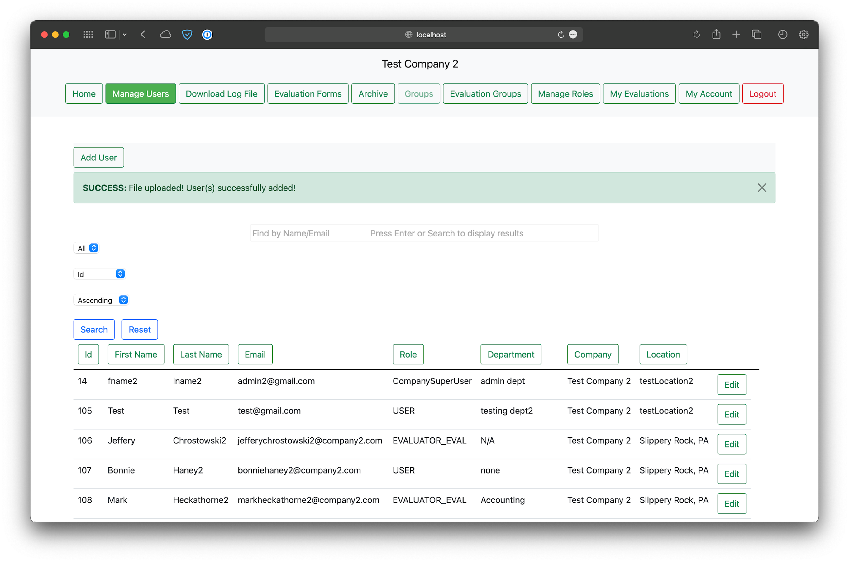

*Figure 33 - View when users were added to the database from an appropriate file, after clicking the “Import” button.*

### Viewing the Users

After pressing the Manage Users button, the users will be able to see a table of pre-existing users with the ability to “Find by Name/Email” as well as select from drop-down menus in order to select some choices for a search. The drop-down menu on the far left directly underneath the search bar has the following choices: “ALL”, “10”, “20”, and “30”. Choosing one of those options and pressing the “Search” button under it will display the users in those respective formats. “ALL” will show all users with no restraints. “10” will display ten users at a time, where if there are more than ten users then the other users not being displayed will be viewable from clickable page links just under the search bar. “20” and “30” will do the same thing as “10” but only they’ll they display groups of 20s and 30s respectively.

The second drop-down menu, to the right of the previously mentioned one, will allow for the choice of how the list of users should be organized. The choices are by: “Id, First name, Last name, and Email”. The selected organization will provide the information in ascending order (starting from 0 or A depending on what’s being organized) and will be applied when the “Search” button is pressed or when one of the selectable buttons about each column is pressed. Once an organization method is selected and the output is provided, it’ll be indicated the drop-down box’s default option as well as the respective button, which will be filled in, above the column it represents.

A Third drop-down menu can be found under the search bar, set to the far right where the options of sorting the list of users in either ascending or descending order.

Clicking on buttons such as an “Edit User” or “Delete User” will maintain the users per page count and the sort type. Both tidbits of information are only maintained until leaving the Manage Users page.

The search bar allows the user to populate it with the characters, terms, or names that the user wishes to search for. The “Search” button must also be pressed when searching for a user. The currently-selected user-per-page and sorting value selected will be applied to any searches done. The “Reset” button will display all users on one page.

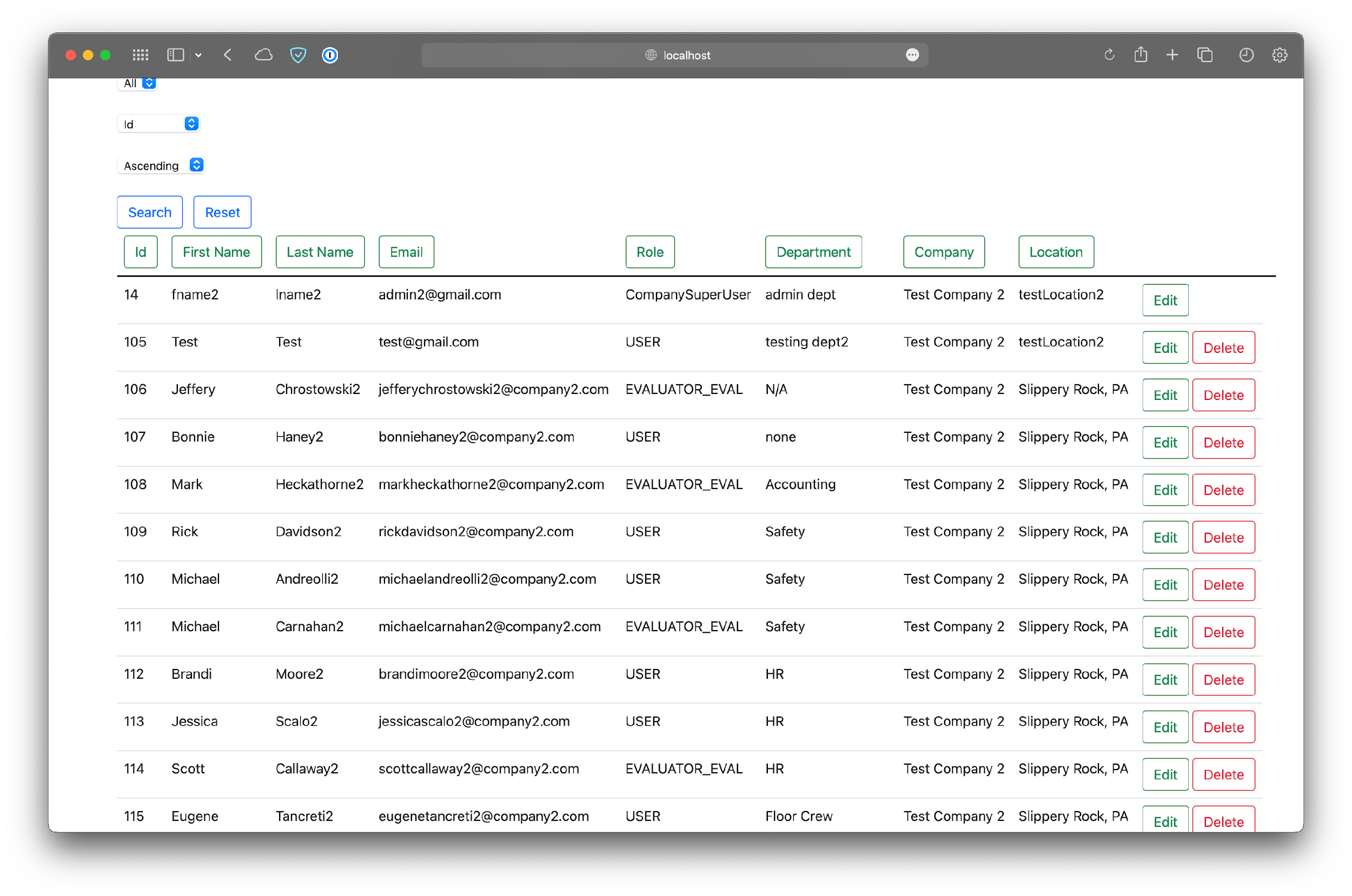

*Figure 34 - Users with ascending Ids (Post uploading users).*

### Editing Users

Clicking on “Edit” beside any user under the users table will provide a page where the selected user can have their first/last/suffix name, email, job, supervisor, company name, division branch, date of hire, password, and role changed and saved upon entering and selecting the respected values and submitting the changes with the “Update User” button. Feedback will be provided depending on whether the change was successful or not.

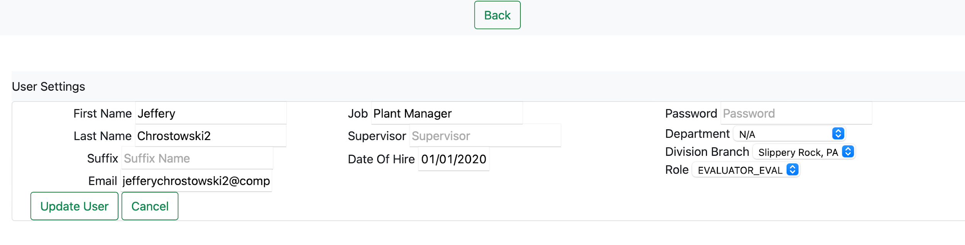

*Figure 35 - Default view after pressing an “Edit User” button.*

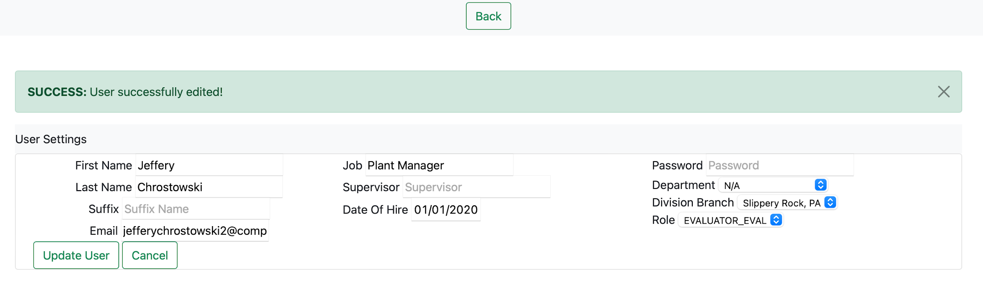

*Figure 36 - View when changes were successful.*

### Deleting Users

Upon returning to the previous page with the Users button in the navigation bar or the “Cancel” button on the editing page, the “Delete” button will delete a user as long as they’re not a part of group yet.

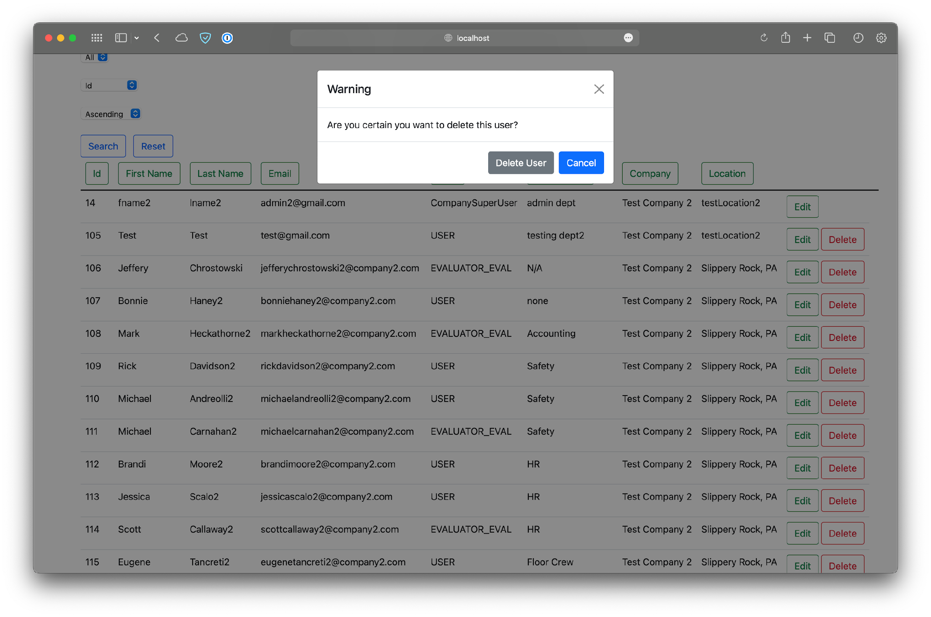

*Figure 37 - View upon clicking a “Delete User” button.*

# Evaluator Admin Abilities

## Evaluations Form Navigation Bar Options

A user with the role “ADM_EVAL” must be created here in order to view the content below. Once an evaluator admin has been created, they will see that, upon logging in, that the Home button serves the same purpose as it does for those with the “ADMIN” role, which brings you to the home page, which is the exact page a user sees upon logging in. A button in the same general area/row that will be covered next is the Evaluation Forms button. That button links to a page with the ability to “Upload New Evaluations”.

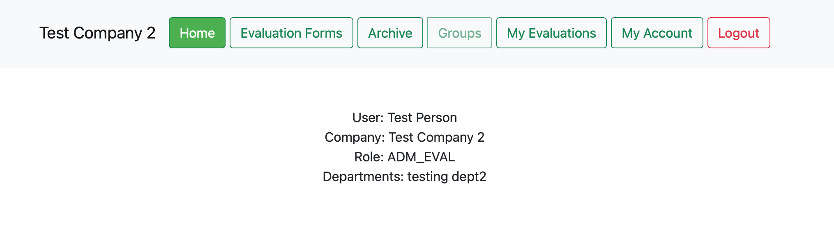

*Figure 38 - Default view for Admin Evaluator.*

## Uploading a New Evaluation

Upon clicking the Evaluation Forms button and being redirected to a new page, a section will be viewable that will allow an evaluation template to be chosen and uploaded with the “Choose File” and “Import” buttons respectfully. Multiple files can be uploaded in a linear fashion. The file to be uploaded must follow the proper format to be interpreted and displayed on the page. Example excel documents will be provided in the “Program Documents” folder. Any excel file which follows the correct format can be uploaded, allowing for customized evaluation questions to be used. Refer to “Evaluation Template Manual.docx” in the “Program Documents” folder to see instructions for creating a customized evaluation template document.

In order for a template to be added to a department the second page of the template must include the department name. This means if a template is only designed for the accounting department it should only have Accounting on that page. If it has that it will only be able to be added to the groups containing only members of the accounting department. You need to ensure to have descriptive names for the id of the template.

Since the templates list the departments they are a part of at the top you can check which templates can be assigned to which users.

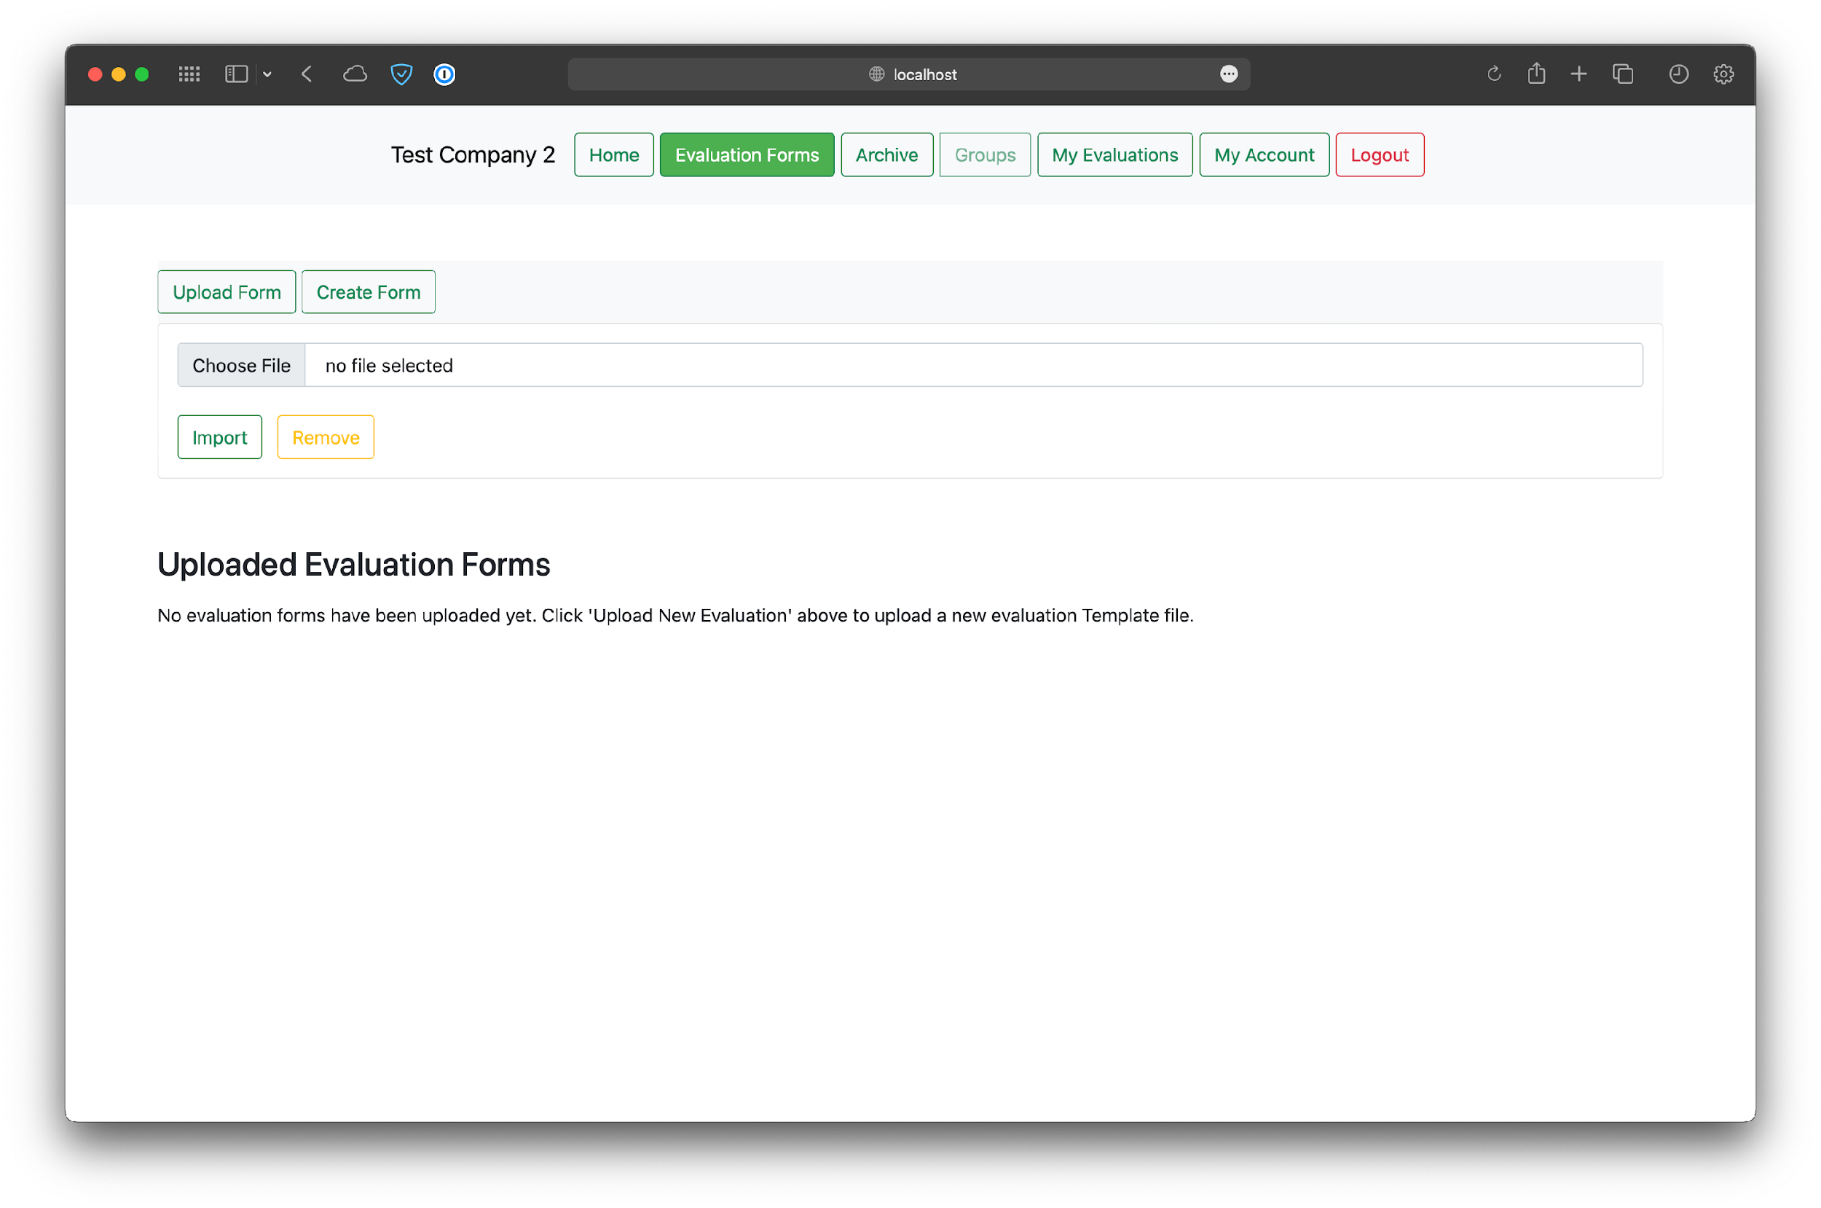

*Figure 39 - Default view before uploading evaluation forms.*

A file can be removed after being selected, but before being imported via the “Import” button, by pressing the “X” button to the left of the “Import” button. Clicking “Import” will save the template to be used for evaluations and the webpage will display a text signifying that the upload was successful as well as a preview of the file chosen. The preview can be removed by pressing the “Toggle Preview” button.

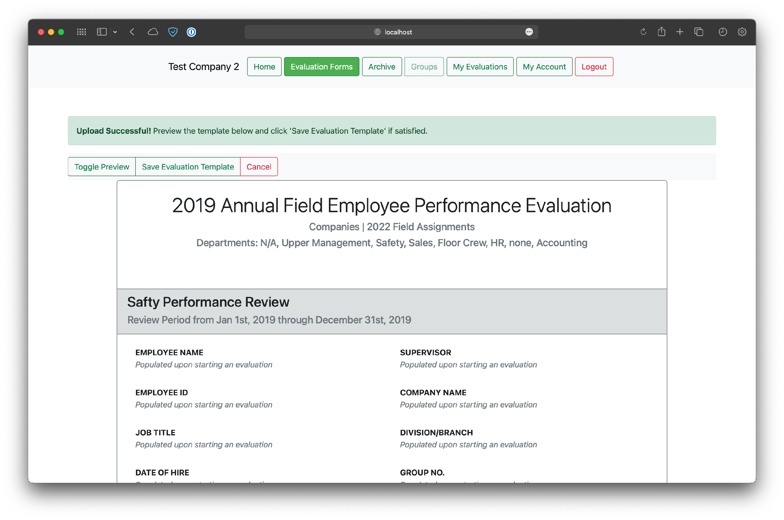

*Figure 40 - View after selecting a valid evaluation form and pressing “Import”.*

In order to use the chosen evaluation form, you must press one of the “Save Evaluation Template” buttons either above or below the preview. You can also see the department you can assign this template to.

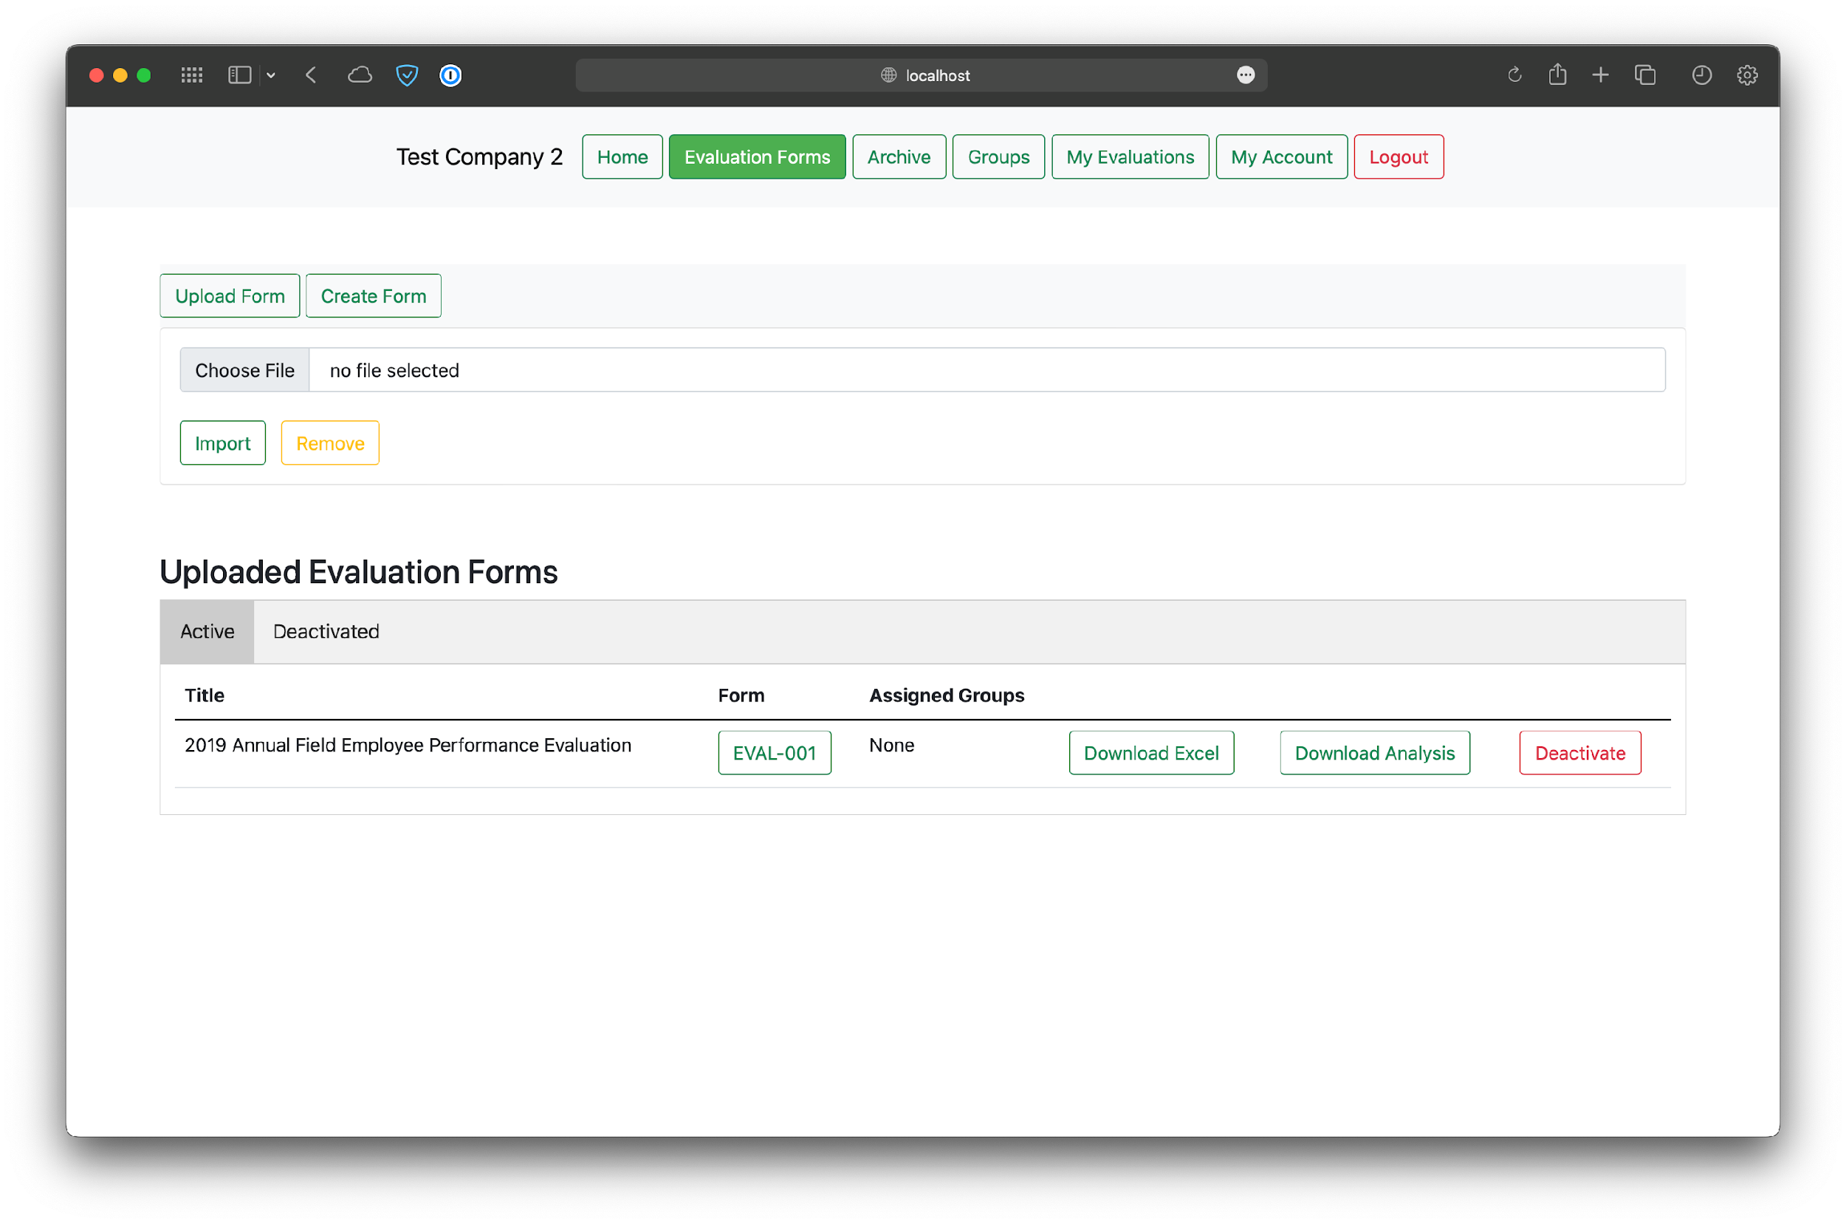

*Figure 41 - View after clicking the “Save Evaluation Template” after importing an evaluation file.*

## Viewing an Evaluation Form

After uploading a form there is an option in the table to view it. By clicking on the name of the form in the table, a screen will pop up with a preview of the form.

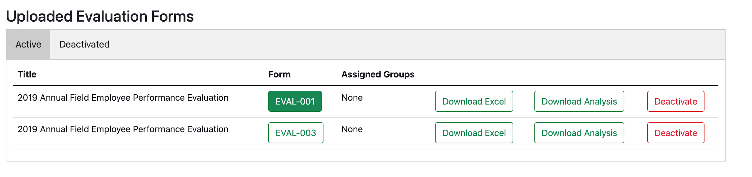

*Figure 42 - Clicking on a form to view it.*



*Figure 43 - View after viewing a form.*

The preview can be dismissed by either pressing escape on the keyboard or clicking the X in the corner.

## Downloading an Evaluation Analysis

Upon uploading users, evaluation forms, and groups and performing at least one evaluation, an “EVAL_ADMIN” may press “Download Analysis” on an evaluation form in order to see a performance score from the given questions in a form. If there are no evaluations done using a form, then there will be no scores displayed in the form’s analysis.

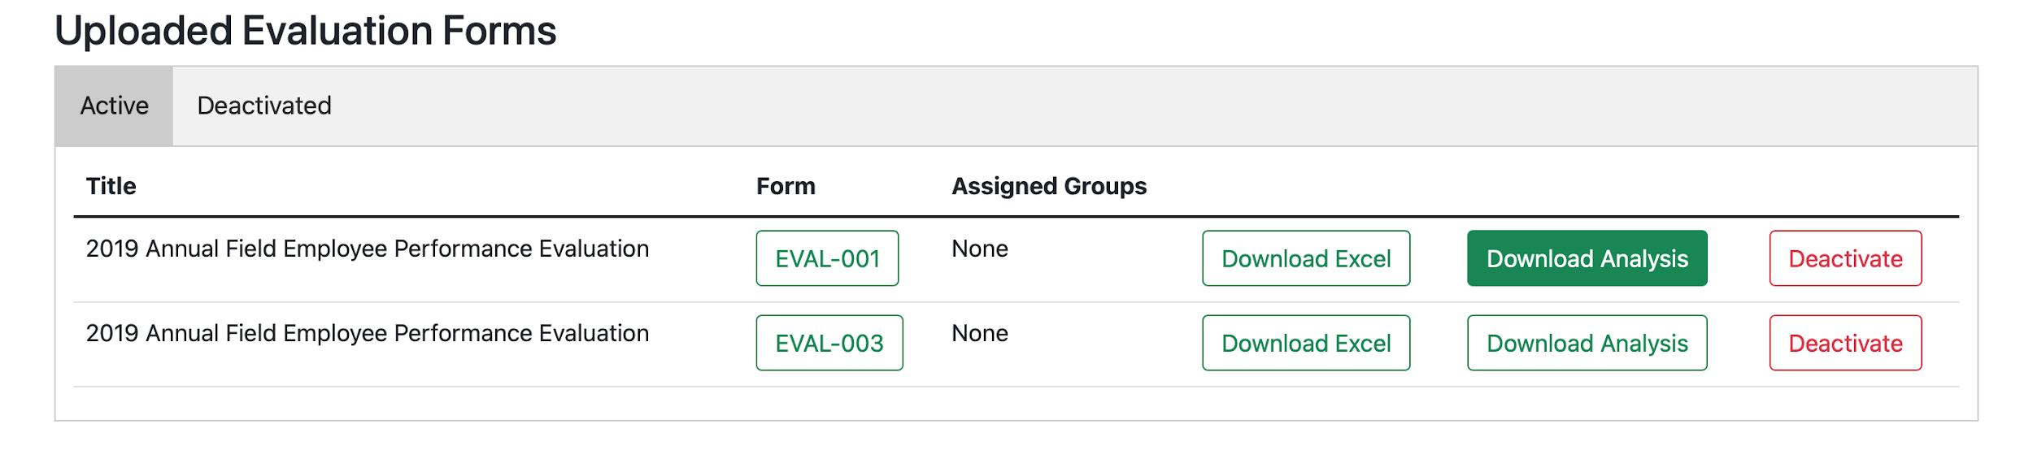

*Figure 44 - View of downloading analysis.*

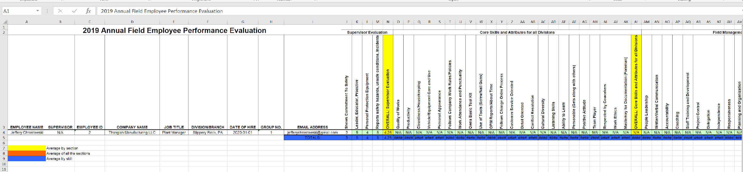

*Figure 45 - The fractional pre-evaluation view of the other sheet located in the file obtained from the “Download Analysis” button mentioned previously. This sheet example has a single evaluation done with this particular form.*

## Deactivating Evaluation Forms

Admin_Evals have the option to deactivate evaluation forms if they’re not assigned to any groups. If there are groups assigned to the particular form upon trying to deactivate it, then the button will be disabled and a note will notify the user that the form is in use. Otherwise, a form may be deactivate.

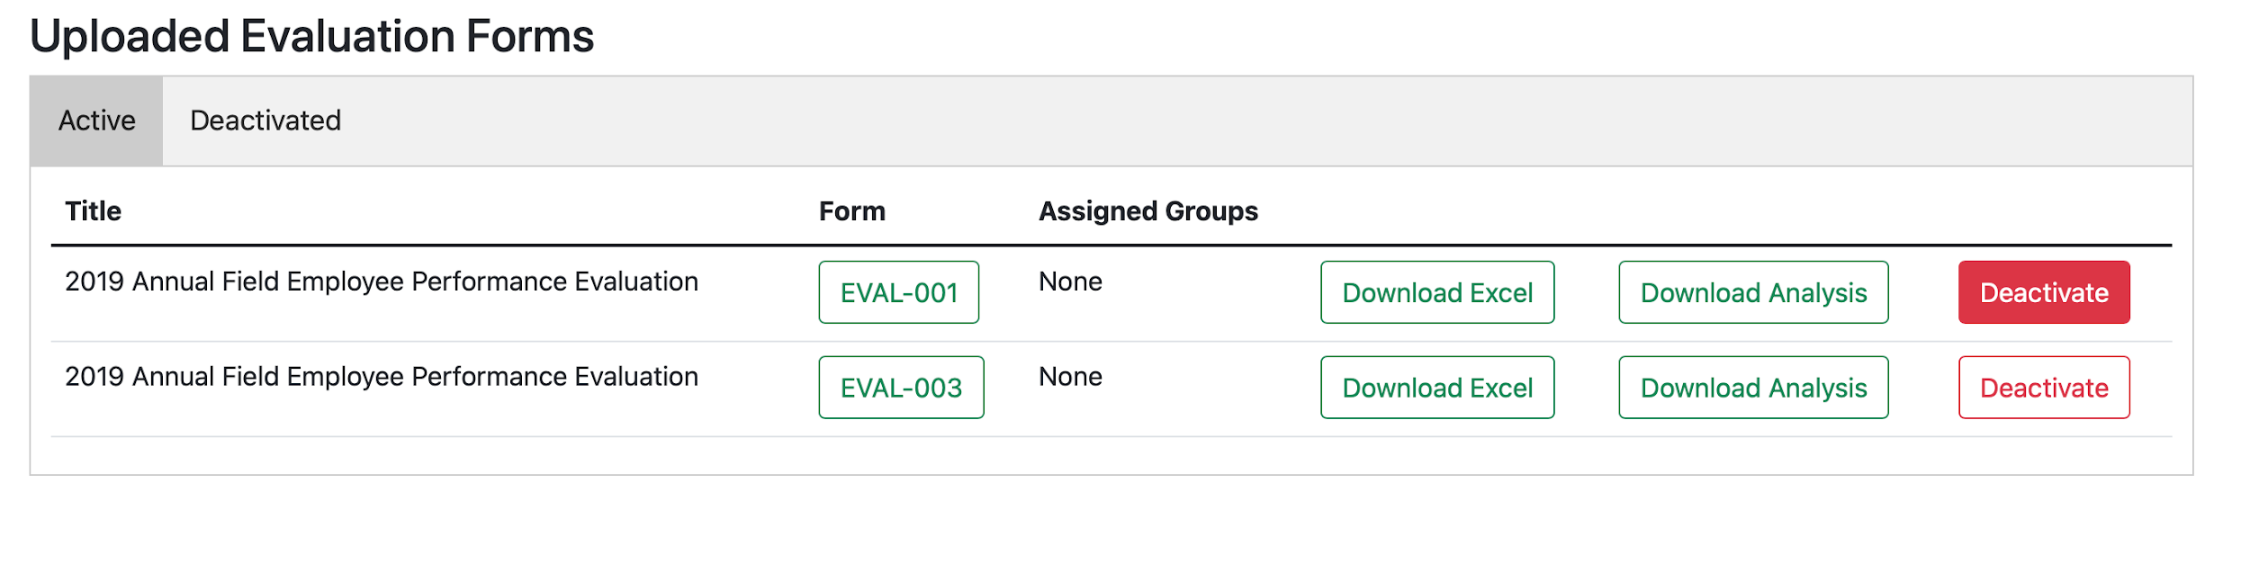

*Figure 46 - View of deactivating an evaluation form.*

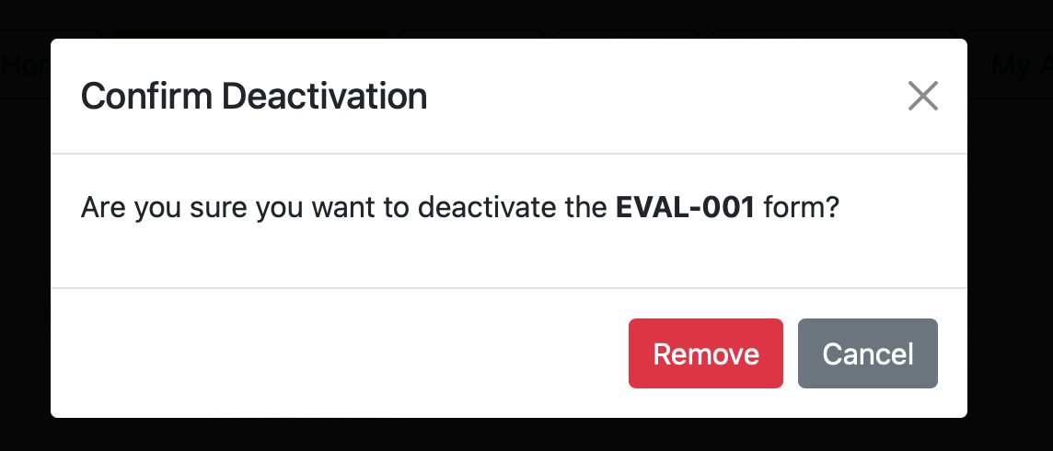

*Figure 47 - Confirmation of deactivating a form.*

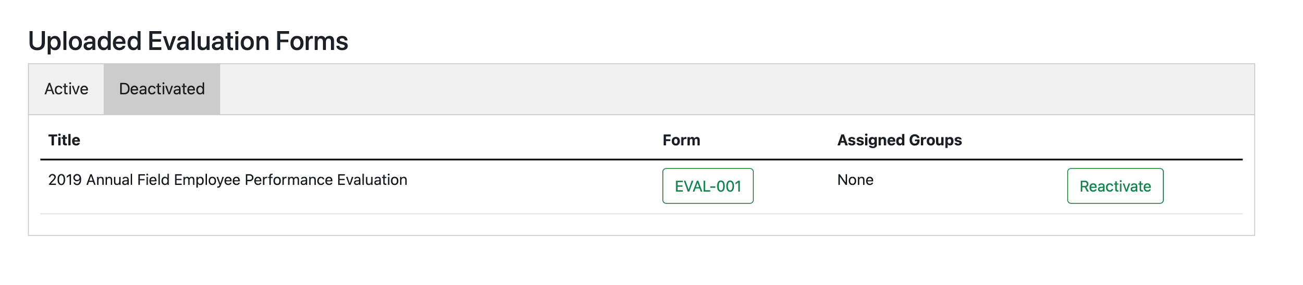

*Figure 48 - Form is added to the "Deactivated" table.*

## Manage Groups

The Groups button brings the options to “Add Group”, “Edit Group”, and “Remove Group”, though only the former option is visible until groups are present.

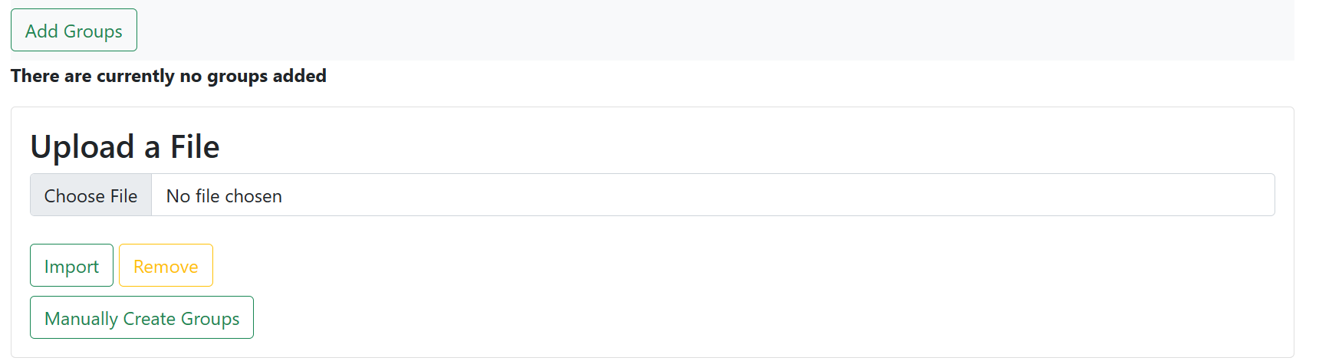

*Figure 49 - Default view.*

## Adding Groups

The “Add Groups” button will display a section that allows for a file to be selected and uploaded, from the “Choose file” and “Import” buttons respectively, in order create groups from a given excel file that is properly formatted. An example will be provided in the “Program Documents” folder called “Upload_Groups_Company2.xlsx”. In order for each group to be added all of the eval forms needed in the upload template need to be present. The templates also need to have been assigned to each department in the group, whether that is a list of user that are all in different or the same department(s) or a list of departments. Similarly, one can now manually create a new group through the “Manually Create Group” option. Upon selection of this option, you may now create a group from scratch, as shown below.

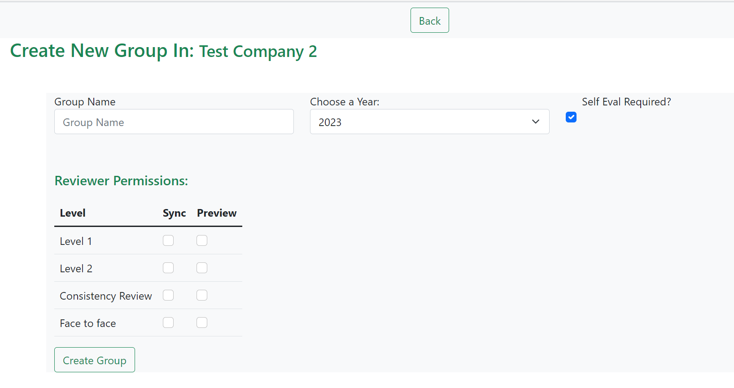*Figure 49.1- Creation view*

**Note: If you want to create a group out of a department, you must add the department name to the “Upload_Groups_Company2.xlsx” in place of a name on sheet 1. This file is located in the aforementioned “Program Documents” folder.**

Upon uploading a group from the “Import” button, groups should then populate the webpage, as long as the users for the respective groups are present in the database. If the user(s) do not exist, then no groups will be created.

The groups page has multiple options available upon upload. One of those being viewing the groups. This can be done by selecting the “group” button associated with the group name. For example, “Group 1” in figure 17. This leads to the group information page which displays the users being evaluated and their related evaluators. Each user can then be viewed displaying which evaluations they have completed.

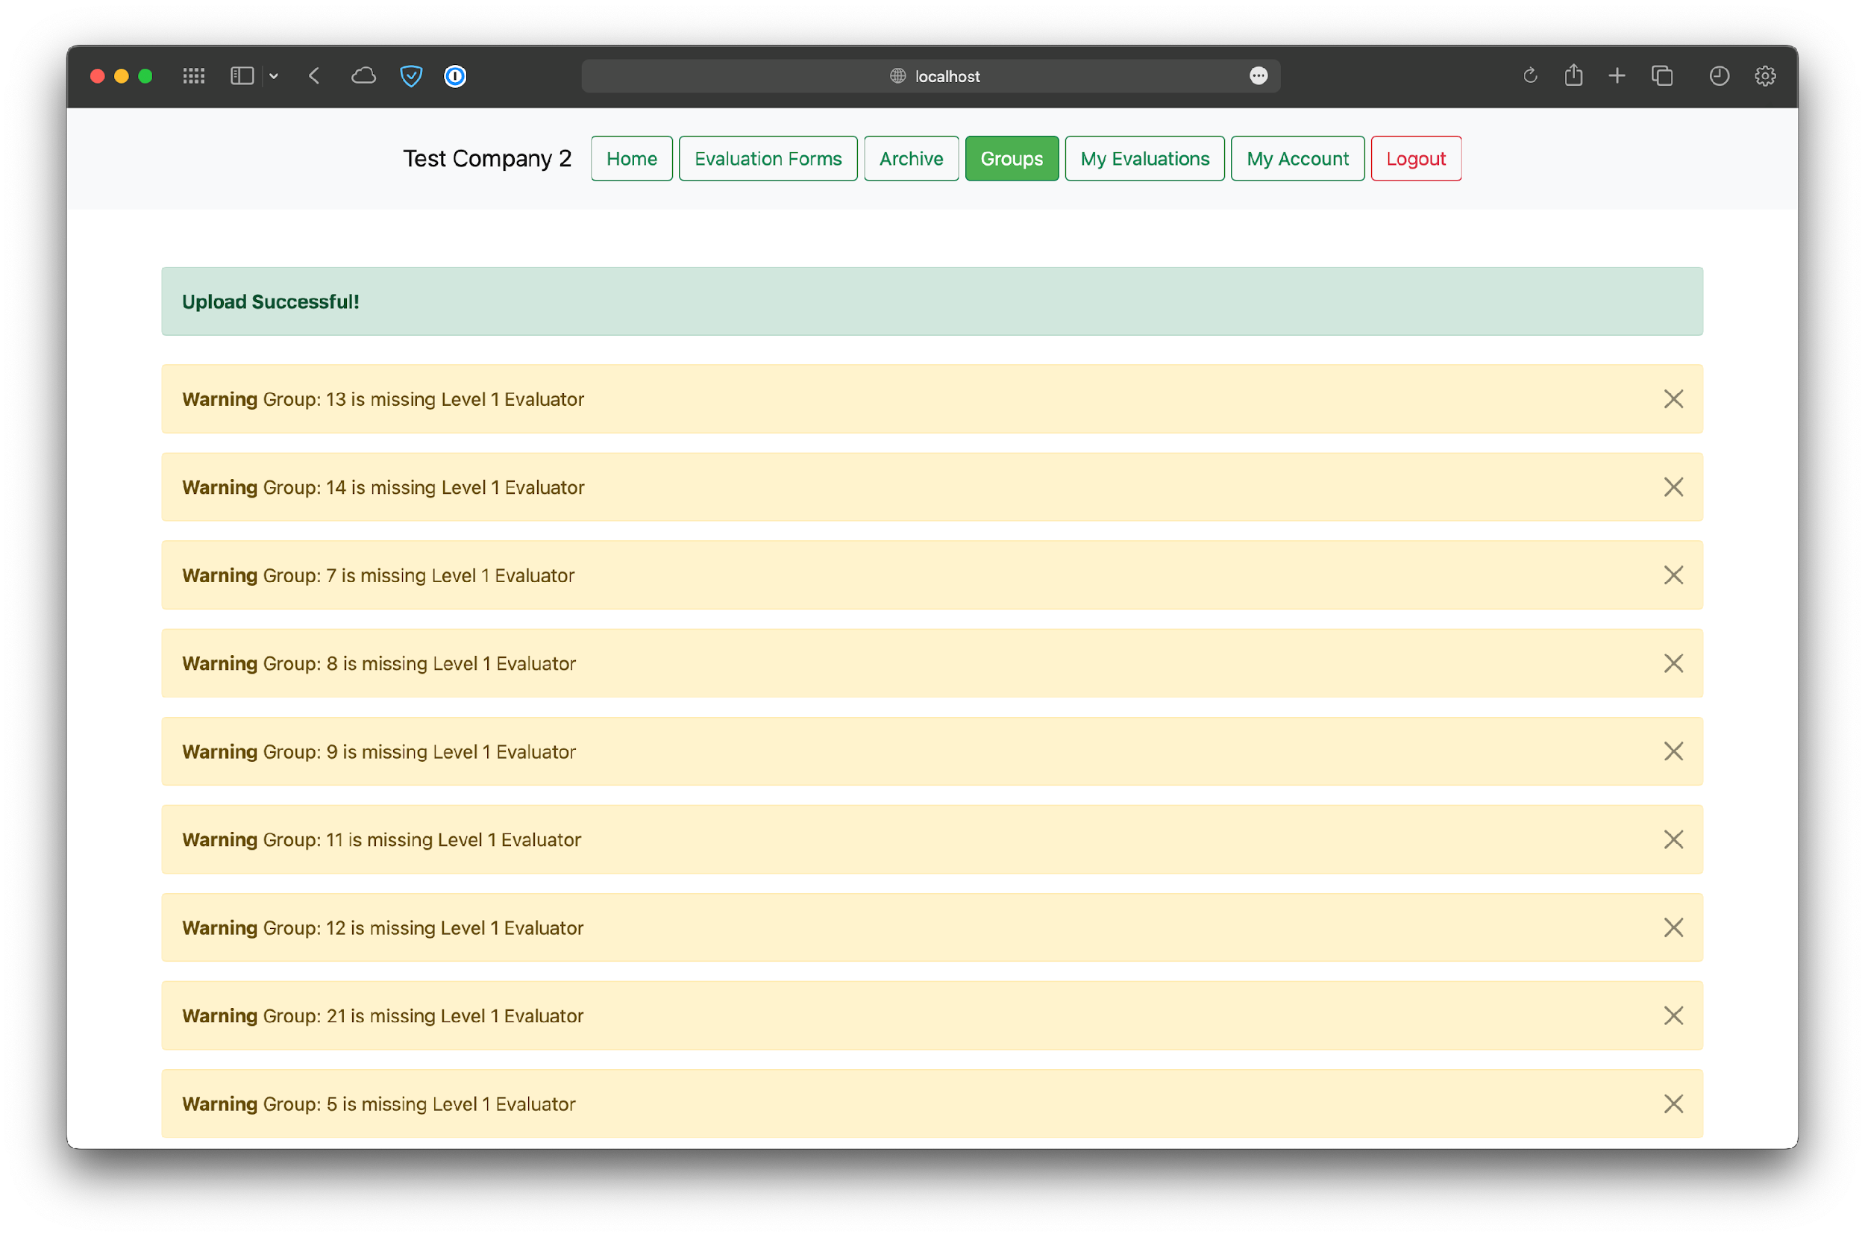

*Figure 50 - View after successful groups upload.*

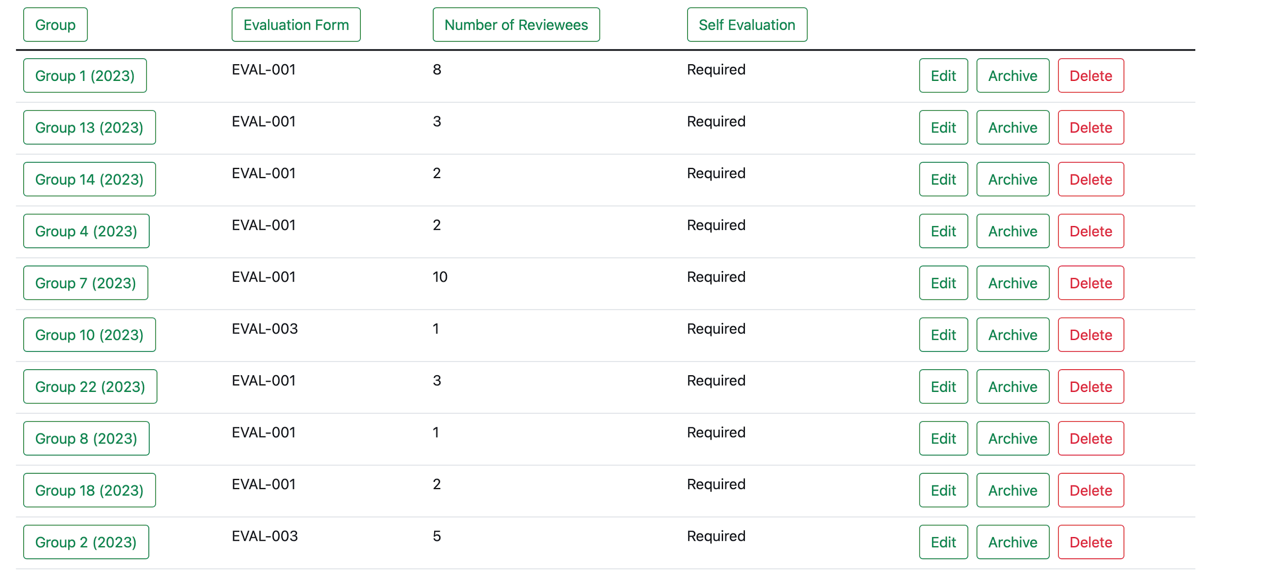

*Figure 51 - Company groups listed out in a table.*

### View Groups

Clicking on the name of a group will take you to a detailed screen showing reviewees and evaluators.

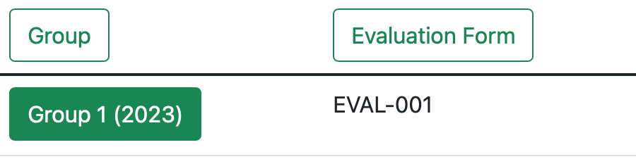

*Figure 52 - Clicking on the name of a group.*

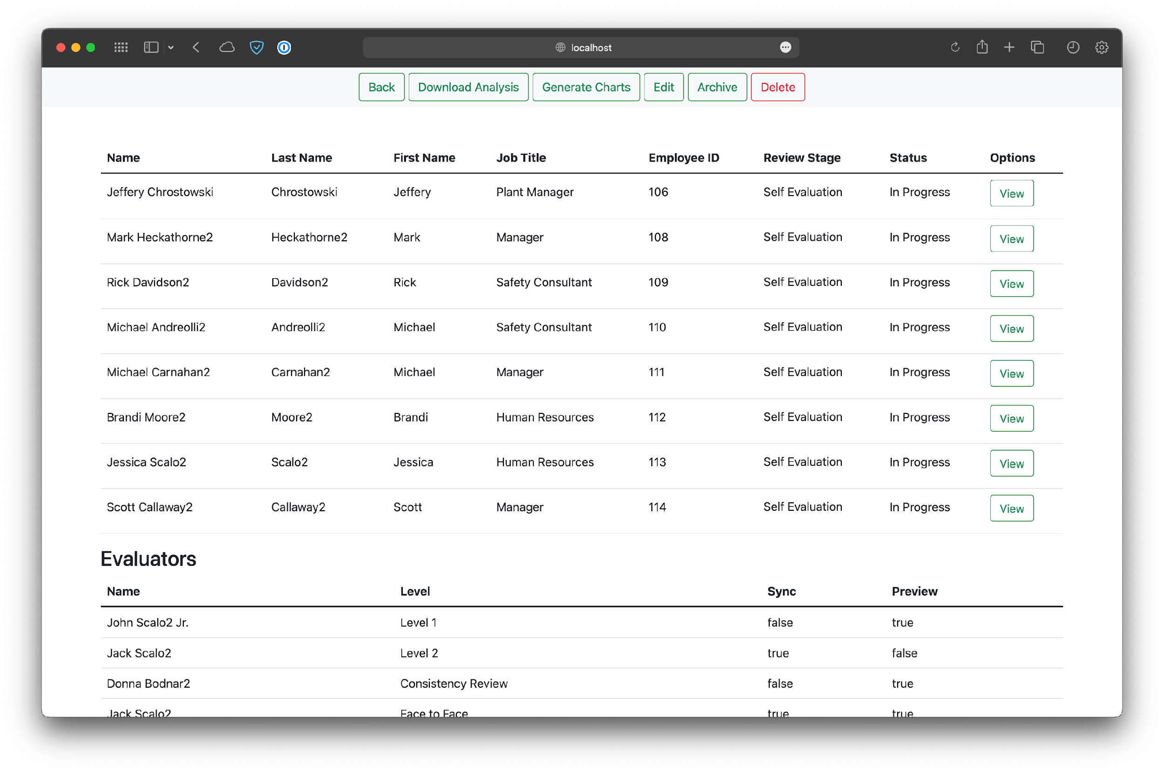

*Figure 53 - Viewing a group in greater detail.*

Clicking on the View button for a reviewee will show even greater detail of the evaluation they are receiving, and the status of it.

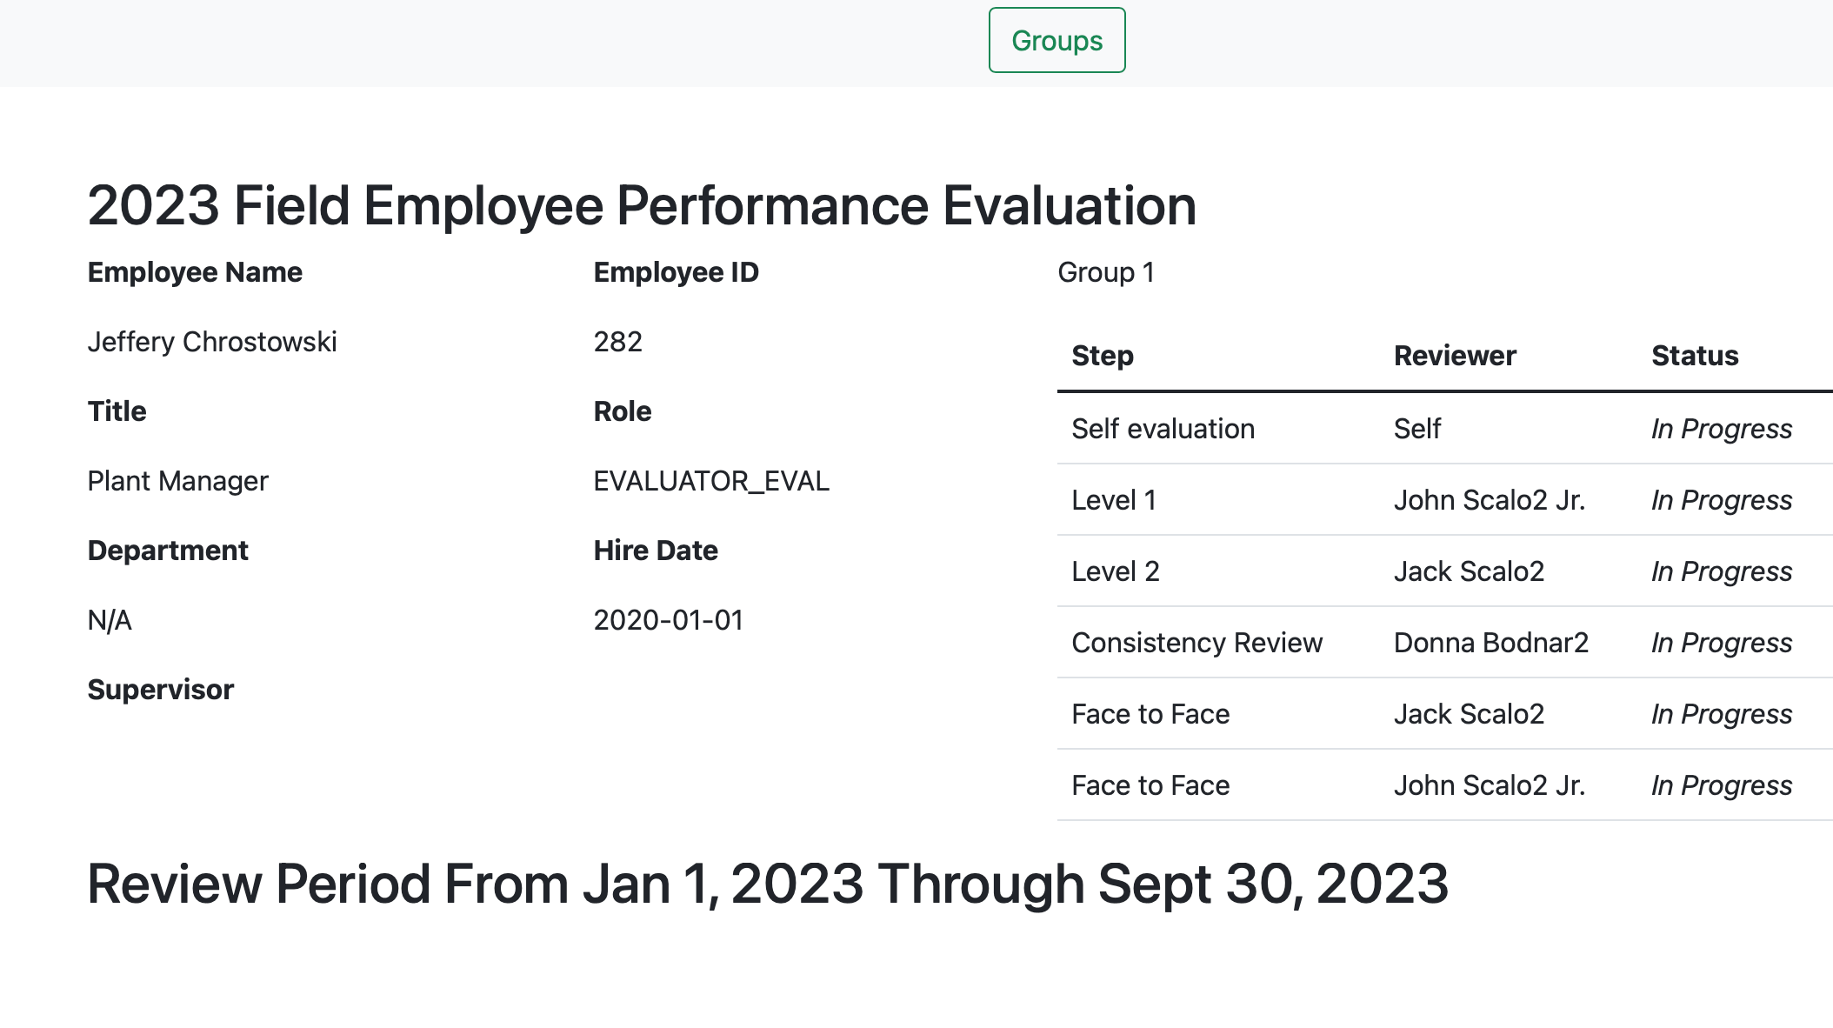

*Figure 54 - Reviewee information.*

### Editing a Group

Pressing the “Edit group” that’s located next to each group on the main Groups screen will allow the user to make changes to the reviewees and evaluators in the respective group. There are also options to change the group name, number, and year.

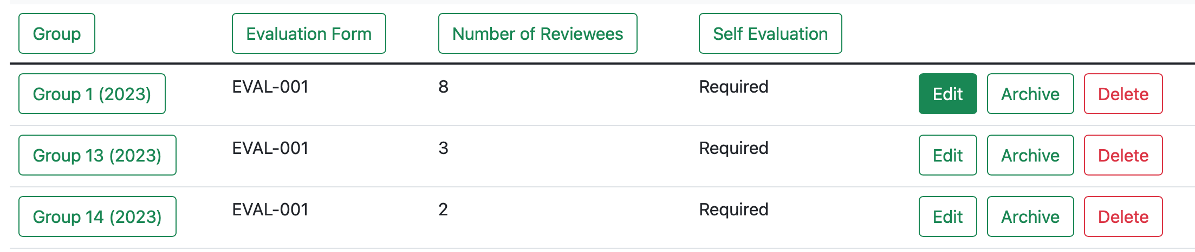

*Figure 55 - Edit group button.*

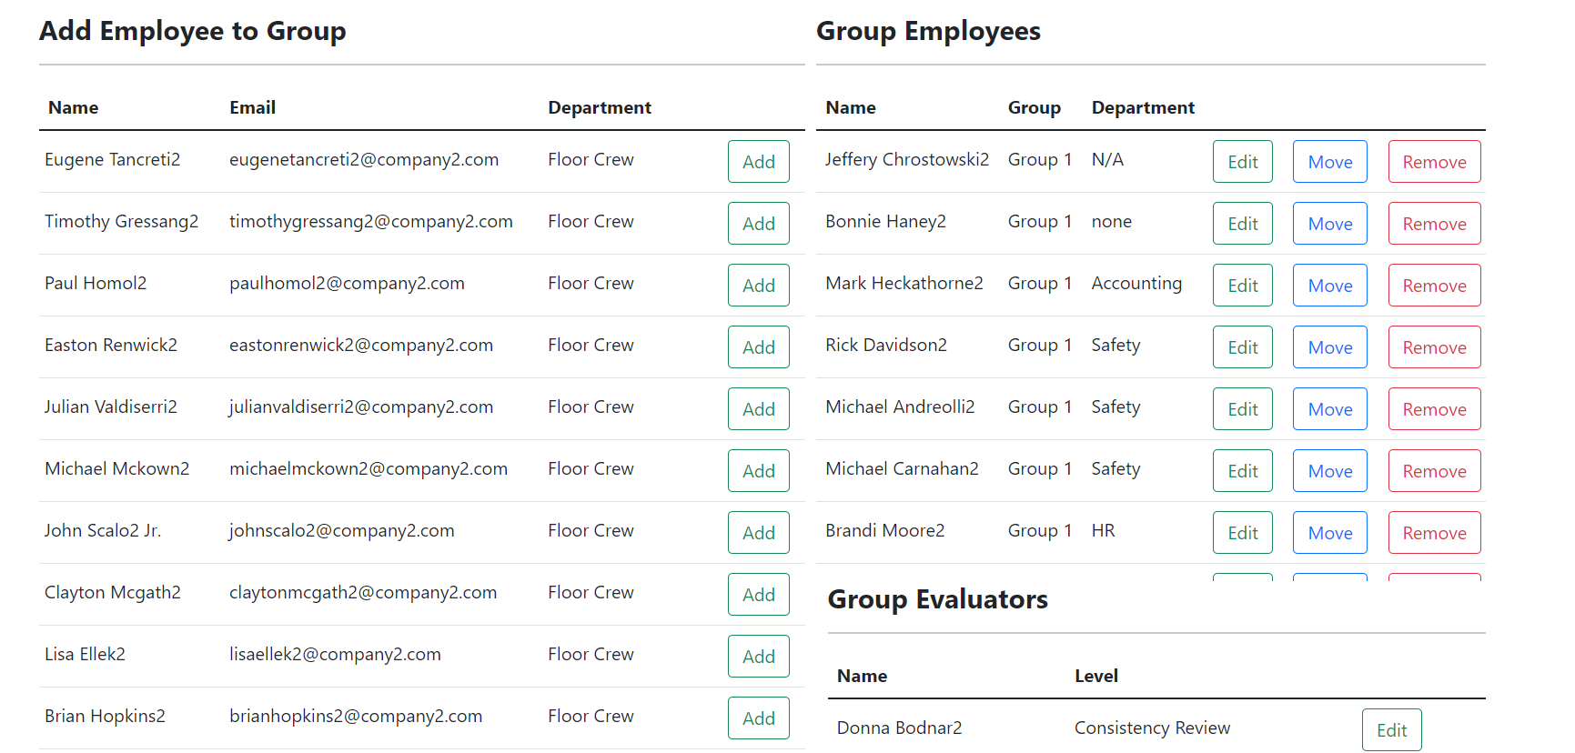

*Figure 56 - Default view.*

### Archiving a Group

The option to archive a group is available on the main groups page next to each group. The group will be moved to the Archived Groups table on the main groups page. Once the group is archived it will not be editable until it is unarchived again.



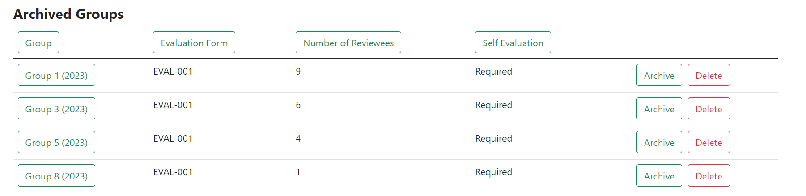

### Adding a User to Group

The option to add a user to a group comes with the button labeled “Add” which is located next to each user listed under the Add Employee to Group title. The button will only add a user to the group if the user does not already belong in the group. The page will then be updated and shown Under the Group Employees list.

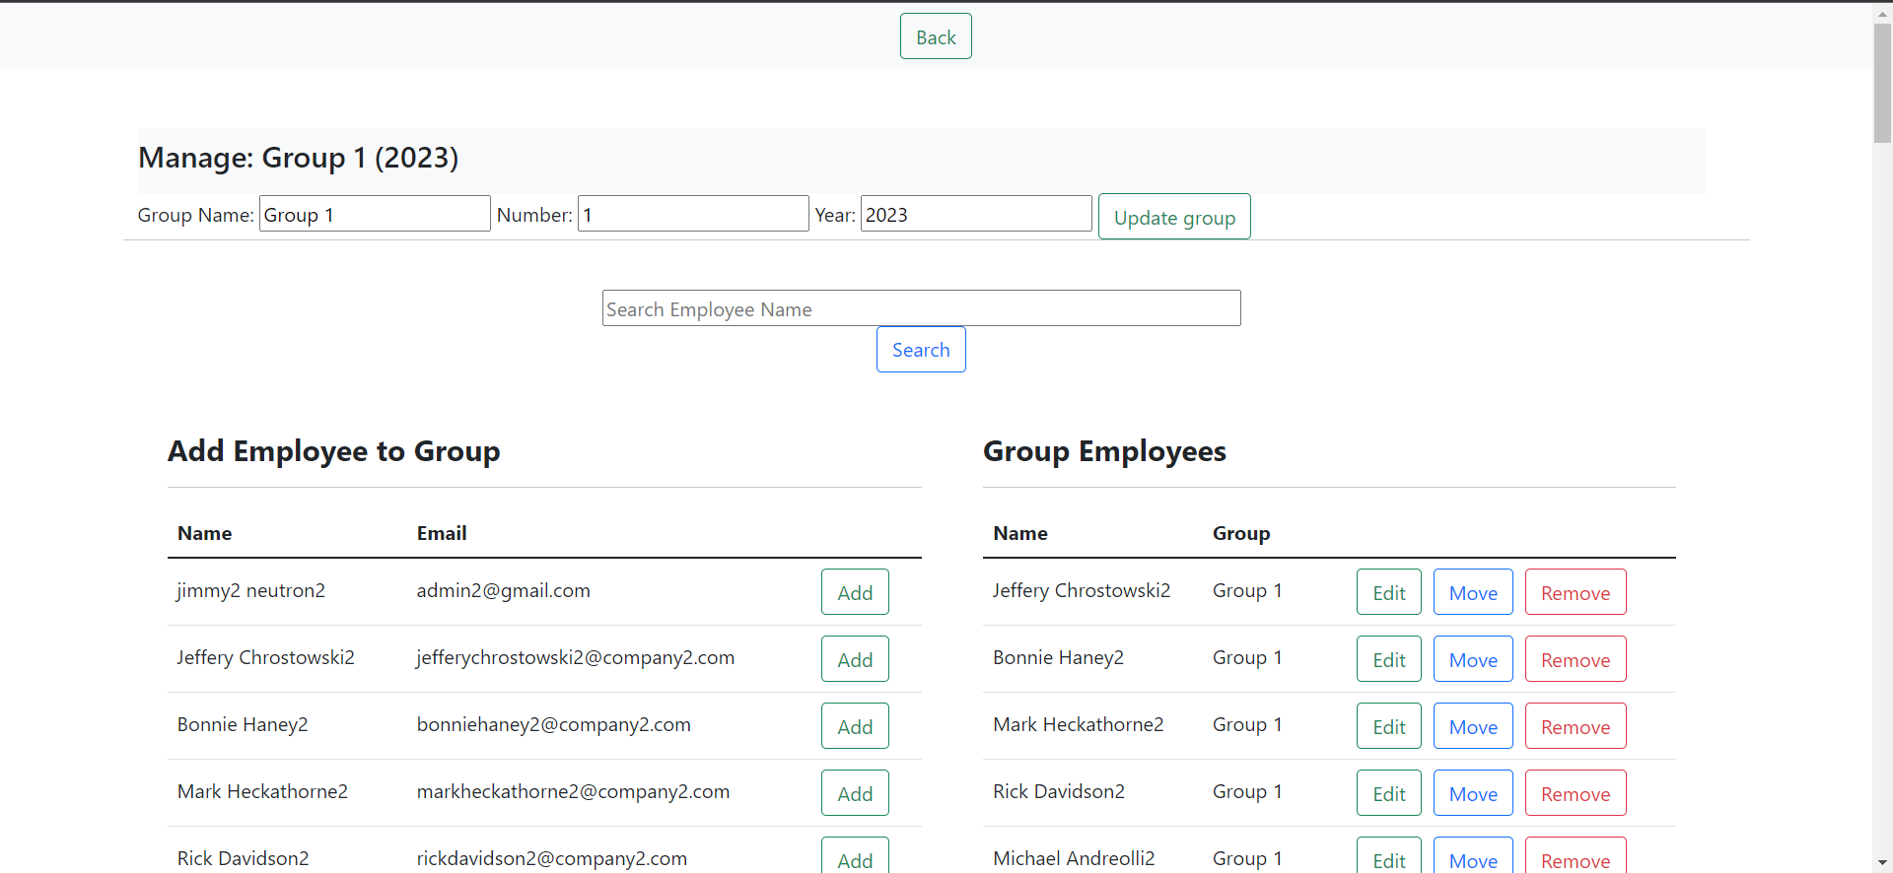

*Figure 58 – Add User to Group Button.*

### Searching a User to Add to Group

The option to search for a user with the textbox labeled Search “Employee Name” is located above the Add Employee to Group title. The search can be activated by pressing enter or by pressing the Search button next to it. The search will list any employee in the company that is not already in the group containing the searched phrase. Below the search bar is a dropdown box containing all the departments of the company. The resulting search can filter to show only employees from the chosen department.

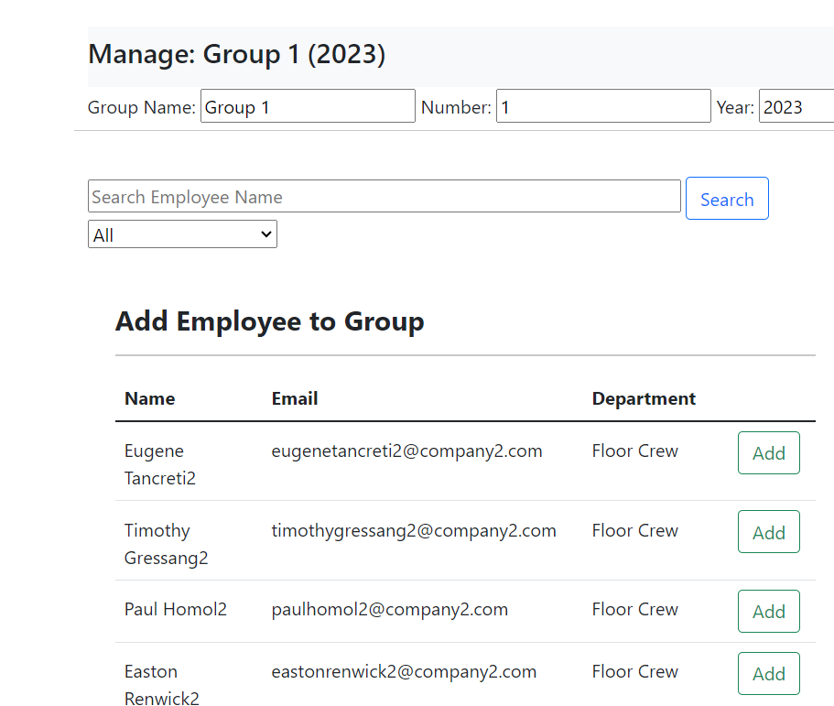

### Moving a User to a Group

The option to move a user to a different group is available next to each user in the Group Employees table. A form will be brought in showing the user’s first name, last name, department, and current group. You can choose which group you want to move the user to in the dropdown menu labeled New Group. To submit the change, press the button labeled submit next to the dropdown menu.



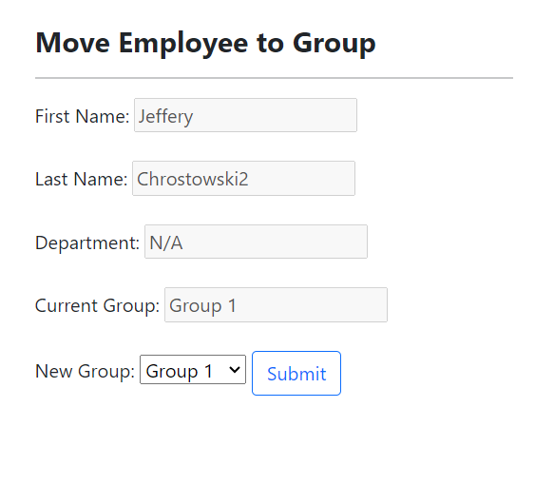

### Editing an Evaluator of a Group

The option to edit an evaluator of a group is available next to each evaluator in the Group Evaluators table. A form will be brought in showing the evaluator’s name and level. You can choose which level you want the evaluator to have and also an evaluator to replace the current one with in the dropdown menus. To submit the change, press the submit button next to the new evaluator dropdown menu.



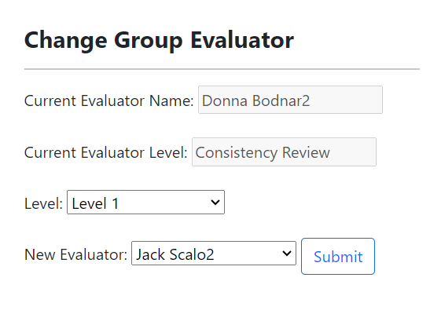

### Adding an Evaluator to a Group

The option to add an evaluator to a group is available in the Group Evaluators table if there is not a sufficient number of evaluators for the group. A form will be brought in showing the evaluator’s name and level. You can choose which level you want the evaluator to have and also an evaluator to be added in the dropdown menus. To submit the addition, press the submit button next to the new evaluator dropdown menu.

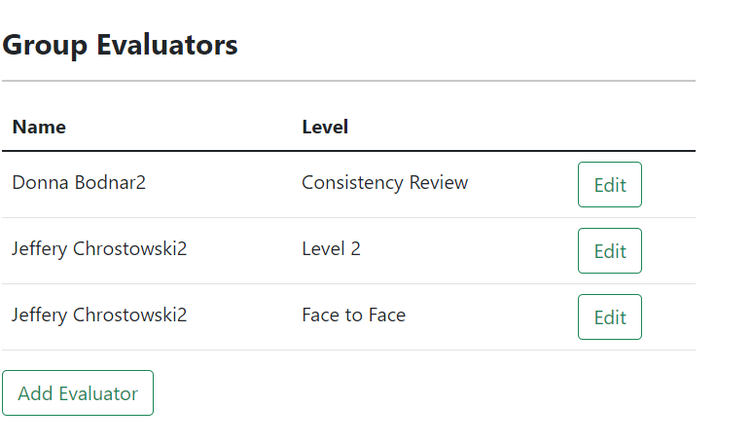

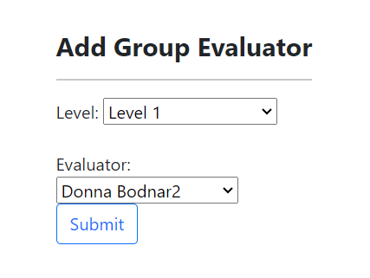

### Deleting a Group

The option to delete a group comes with the button labeled “Delete Group” which is located beside each group listed. A delete button will only attempt to delete the group it sits beside. A group can only be deleted if there are no completed evaluations done for the group. If there is at least one completed evaluation, then the delete button will only serve to archive the group and its evaluations.

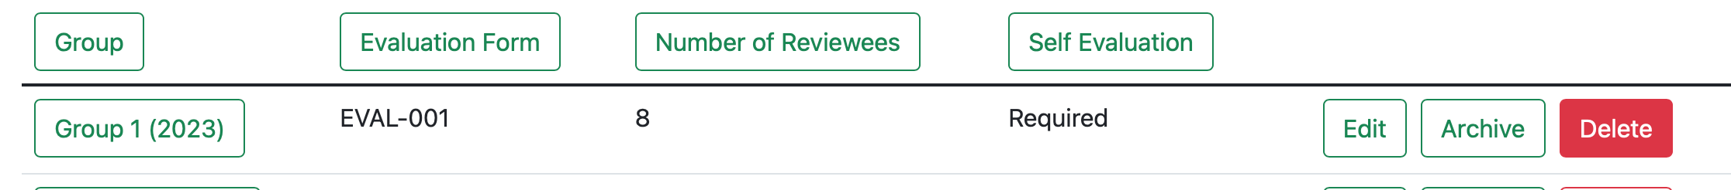

*Figure 59 - Deleting a group.*

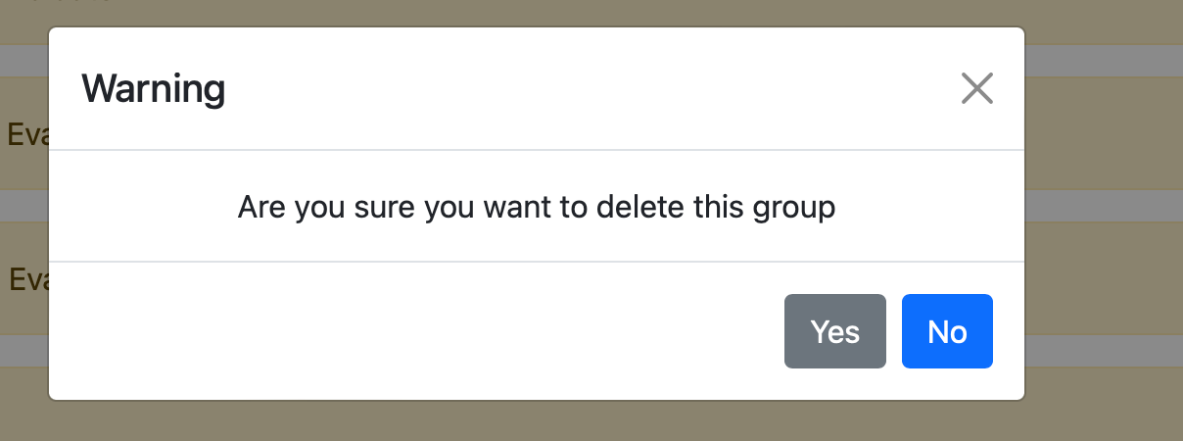

*Figure 58 - Confirmation of deleting group.*

### Chart Generation and Analysis

The “Download Analysis” button serves a similar purpose to the one located on each evaluation form on the Evaluation Forms page for the “EVAL_ADMIN” role, but instead of the analysis results on every person evaluated on the respective form, it is the results exclusive the particular group selected.

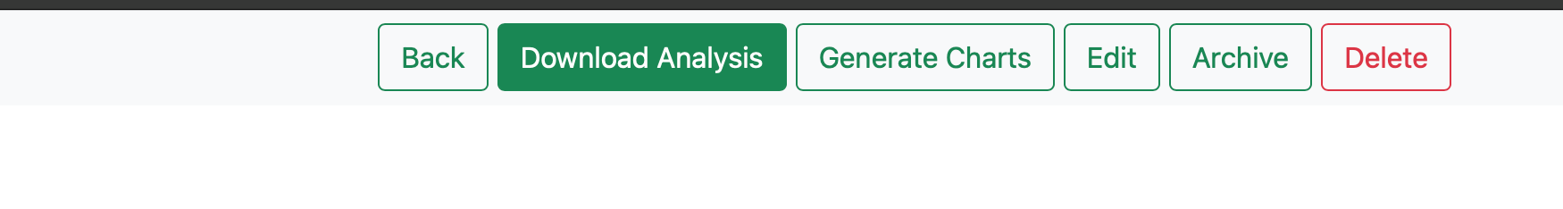

*Figure 59 - Downloading an analysis.*

An “EVAL_ADMIN” also has the option to view data visualizations of the evaluations for users in a group upon pressing the “Generate Charts” button. The button will take the user to a page where several types of charts can be selected from for each individual user for each evaluation done on them as well as an average all the evaluations for a user. Each user also has a button associated with them, once an evaluation has been performed on them, that is called “Pdf Generation” that when press, will download a pdf file with the four types of charts displayed on the file as well as information about the results.

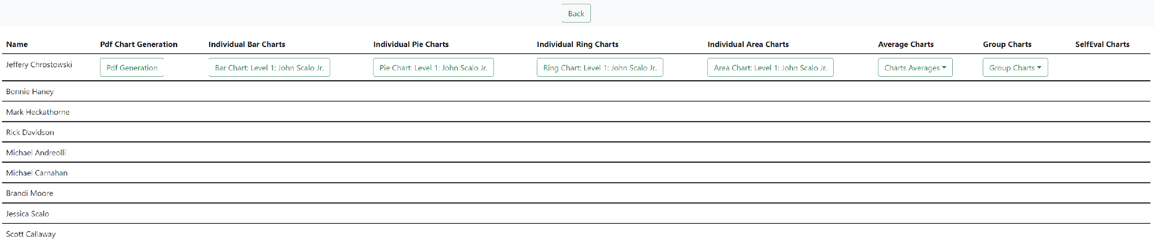

*Figure 60 - View after Generating Charts in view screen.*

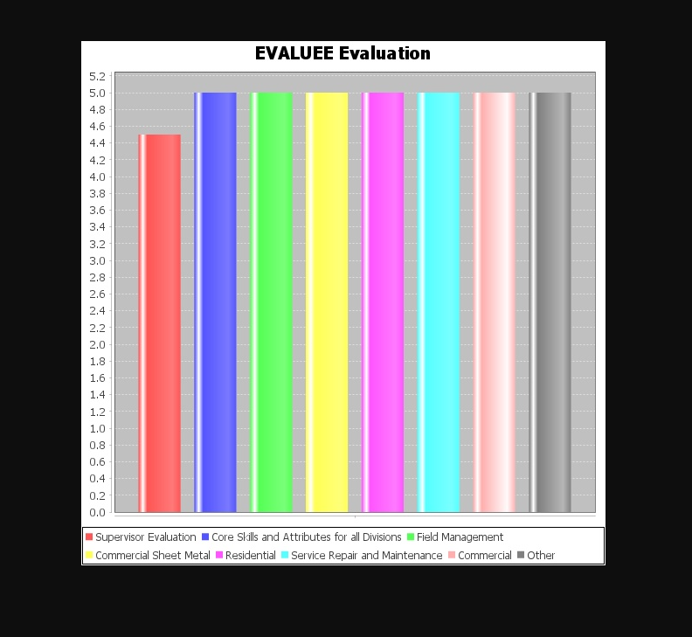

*Figure 61 - View after pressing “Bar Chart Level 1: John Scalo Jr.” from the previous figure.*

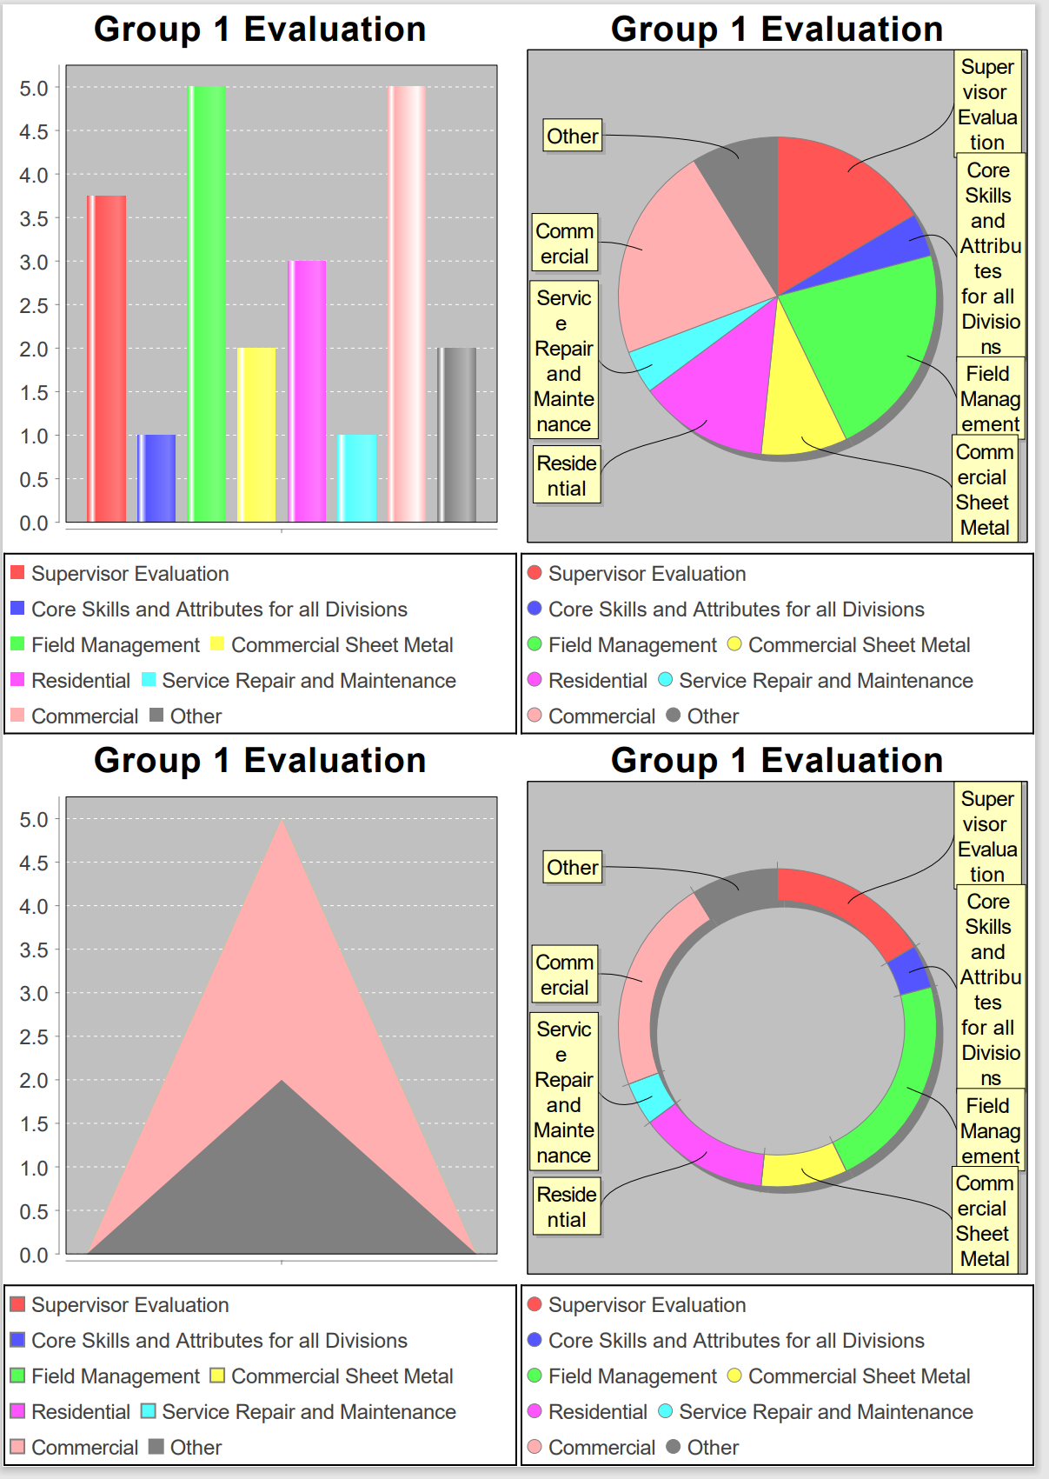

*Figure 62 - Partial view of the pdf generation file that’s downloaded when the “Pdf Generation” button is pressed.*

## Archived Groups

Upon navigating to the Archive button, the user will be greeted with a page if a group with completed evaluations has been deleted. If there hasn’t been a group with completed evaluations deleted, then the page would be blank aside from the navigation bar. From this page, the user may view archived group evaluations done by clicking on the “View” button next to each evaluation.

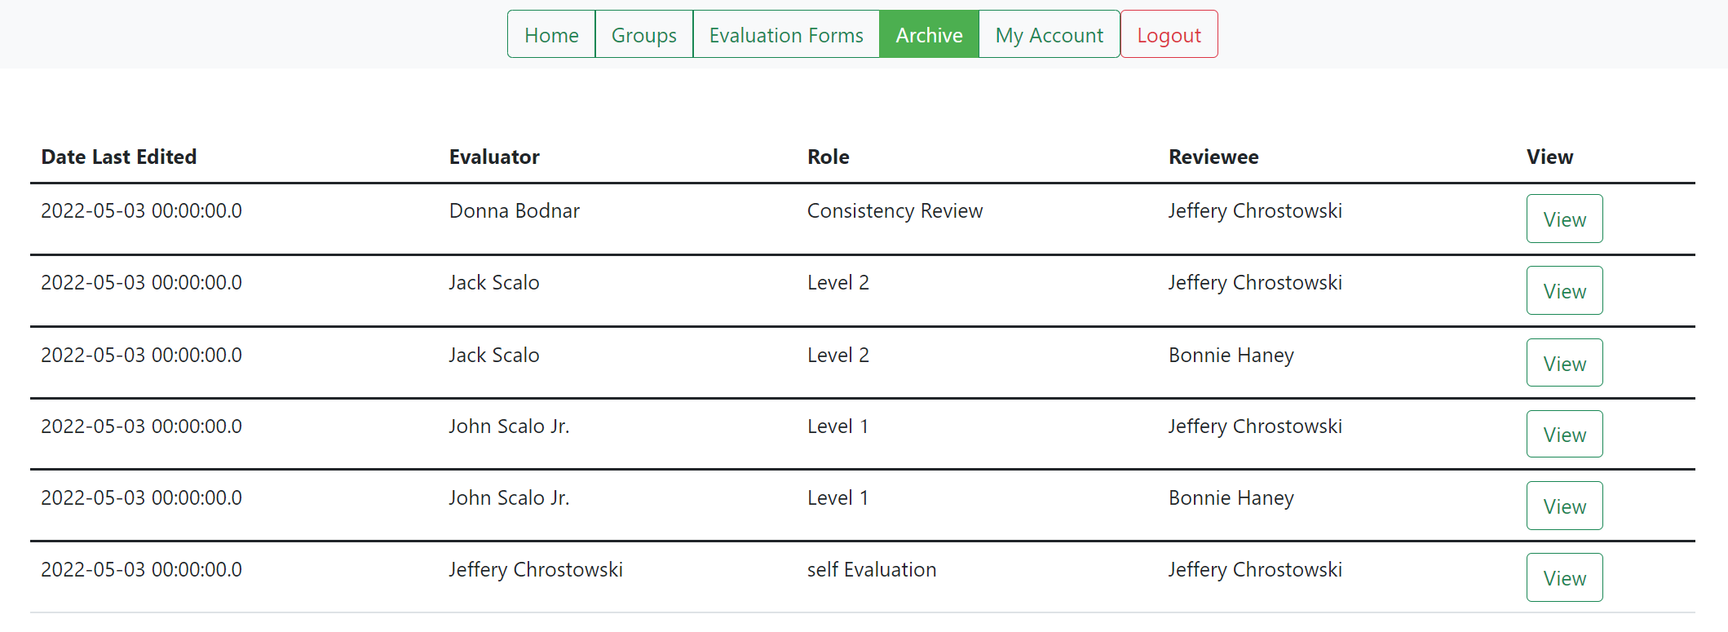

*Figure 63 - View of the Archive page if groups with completed evaluations were attempted to be deleted.*

The “View” button displays the evaluation in the same way as previously shown for reviewees.

# User Abilities

Now, onto users with the “USER” role and what they can do and see. An account with the role “USER” can be accessed after uploading the provided file. The user will be able to see a Home, My Evaluations, My Account, and Logout on the navigation bar. All buttons on the navigation bar serve the same purpose as the ones that users with the “ADMIN” role do other than the My Evaluations button.

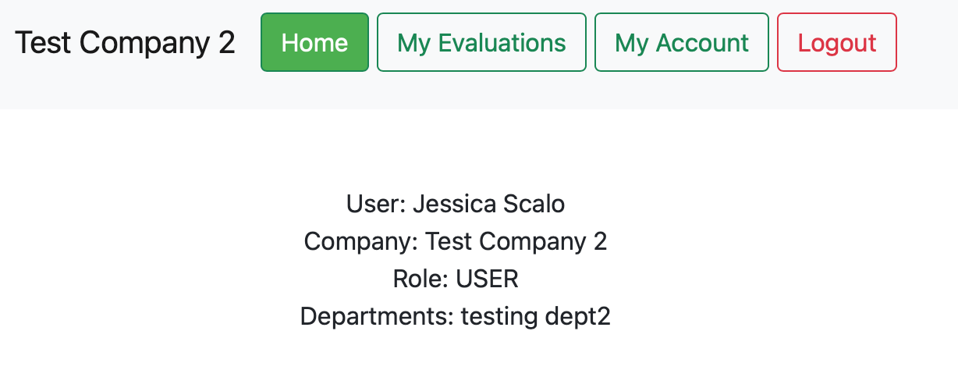

*Figure 64 - Default view.*

## Evaluation

The My Evaluation button provides the user to write their own self-evaluation. Upon clicking the button, the user will be taken to a webpage where any evaluations that either have or need to be done. The user may select evaluations done on them, or perform a self-evaluation with the “Complete Self Evaluation” button if any are available/allowed to be done.

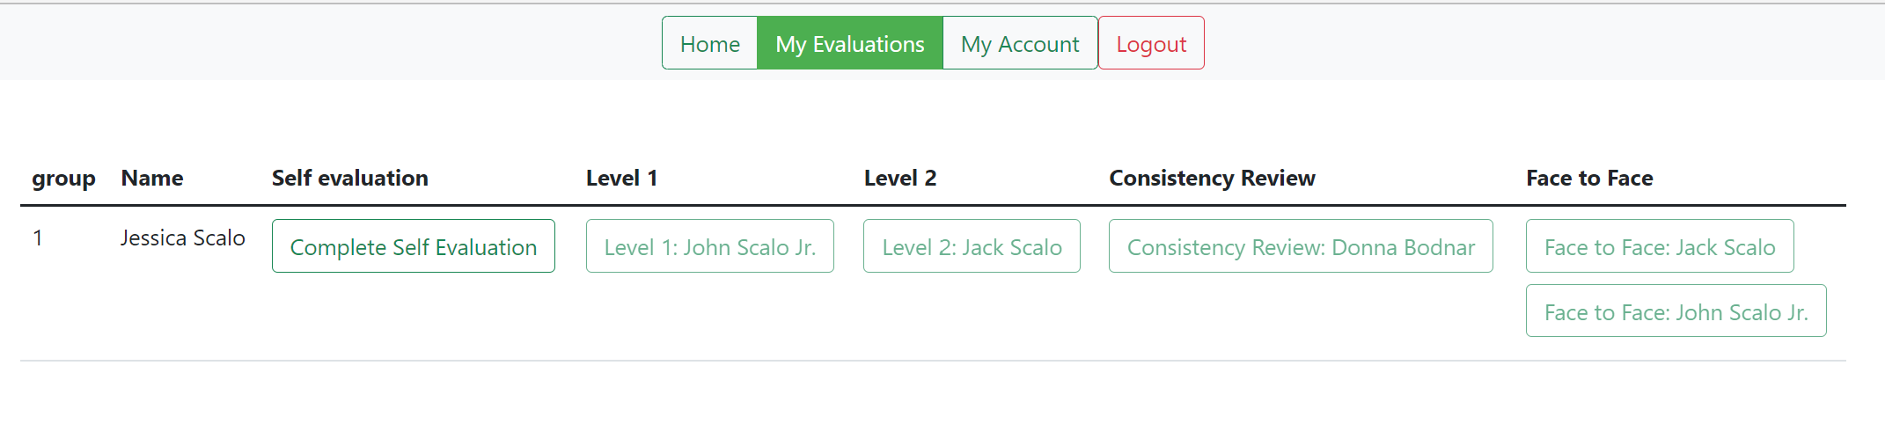

*Figure 65 - Default view.*

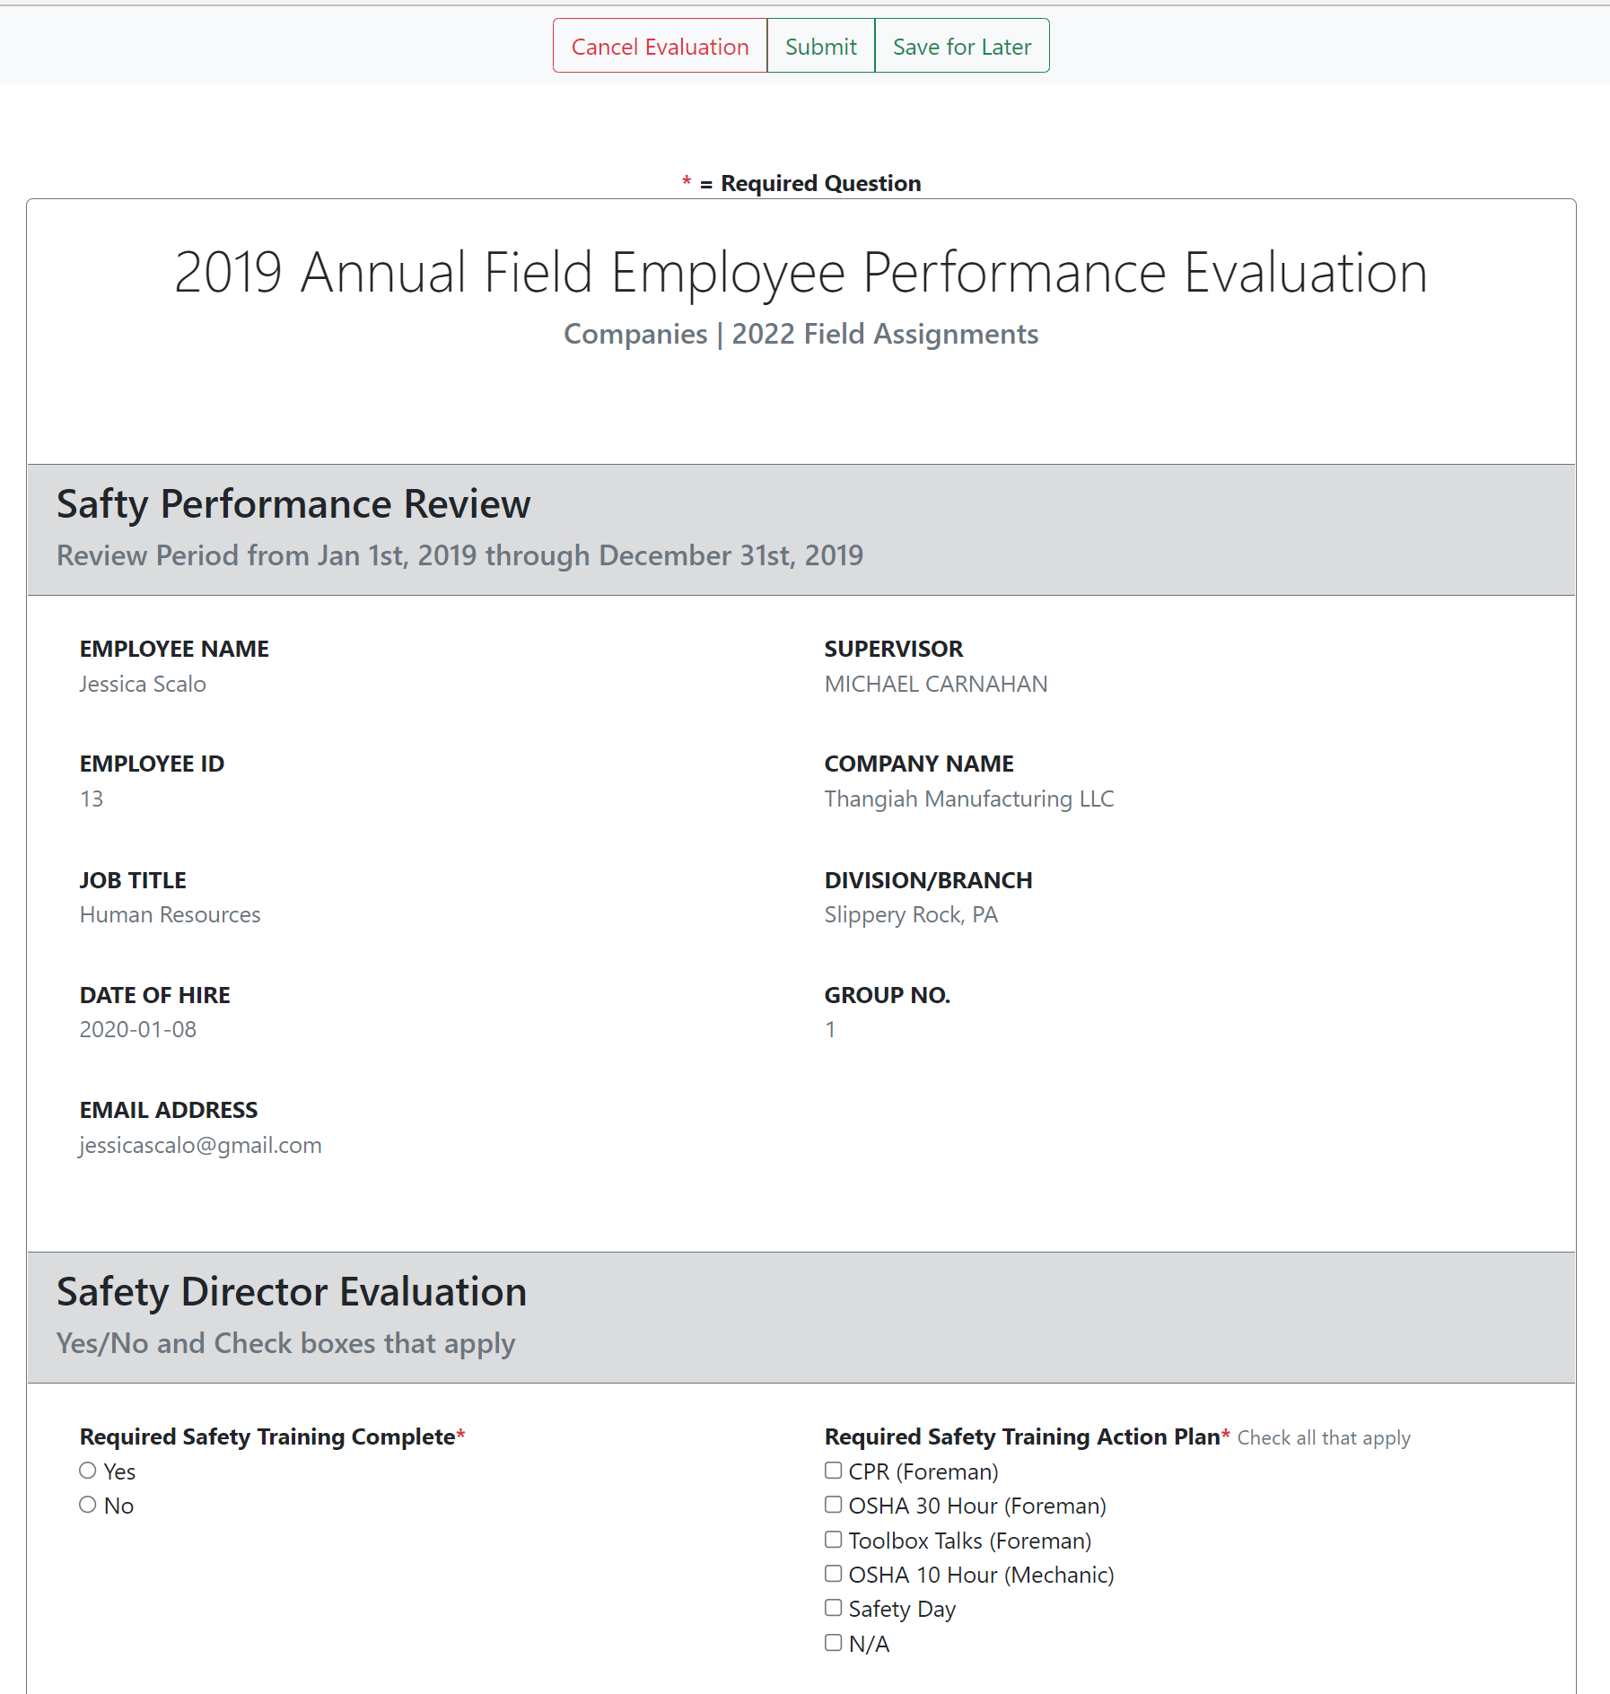

*Figure 66 - Default view of the self-evaluation page after pressing the “Complete Self Evaluation” button.*

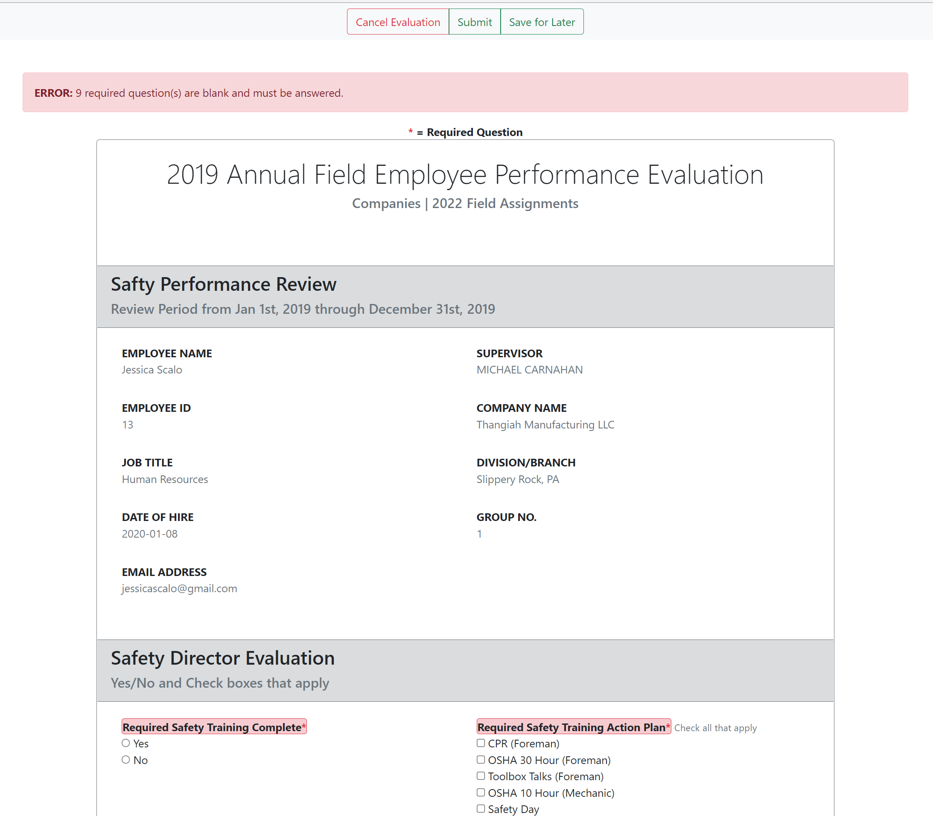

*Figure 67 - View upon trying to submit any type of evaluation without completing the required questions.*

The “Cancel Evaluation” button at the top will bring the user back to the home page. The “Submit” button must be pressed in order to save the changes made to the evaluation form. Once submitted, the user will automatically be taken back to the home page.

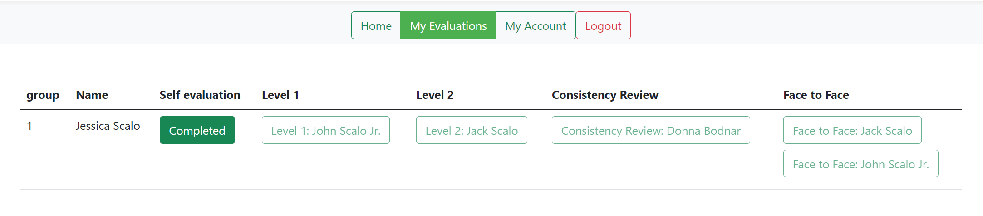

*Figure 68 - View upon filling out the required questions and clicking “Submit” during the self-evaluation.*

# Evaluator Abilities

The last roles to talk about are the “EVALUATOR” and “EVALUATOR_EVAL” roles which only login and view a basic evaluator page where four options lie: Home, Evaluate/Evaluation Groups, Account, and Logout. Users with the “EVALUATOR” role only serve to perform evaluations, while those with the “EVALUATOR_EVAL” role can perform evaluations as well as have evaluations done on them.

The “EVALUATOR_EVAL” role has the “Evaluate” drop-down which has the “View Groups” button to view groups to perform evaluations and the “My Evaluations” button to see evaluations to be performed on them as well the ability to perform a self-evaluation.

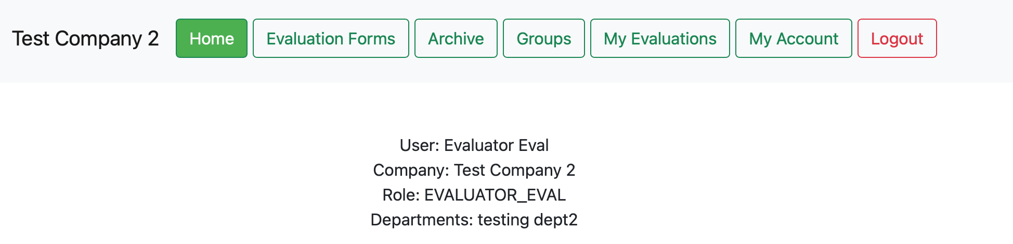

*Figure 69 - Default view for EVALUATOR_EVAL*

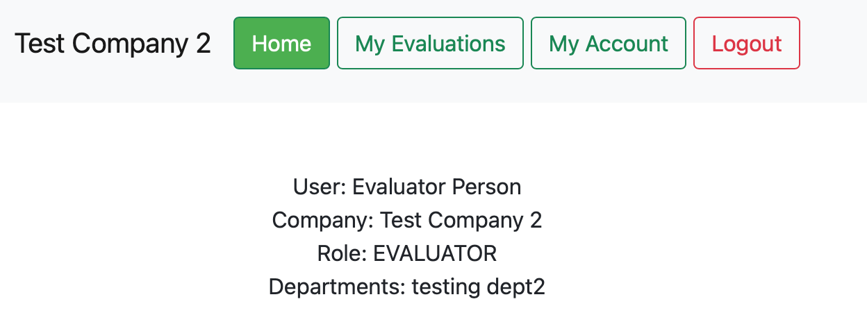

## Evaluation Groups

Clicking on the Evaluation Groups button in the navigation bar will show a table with information relating to the status of the different groups evaluating.

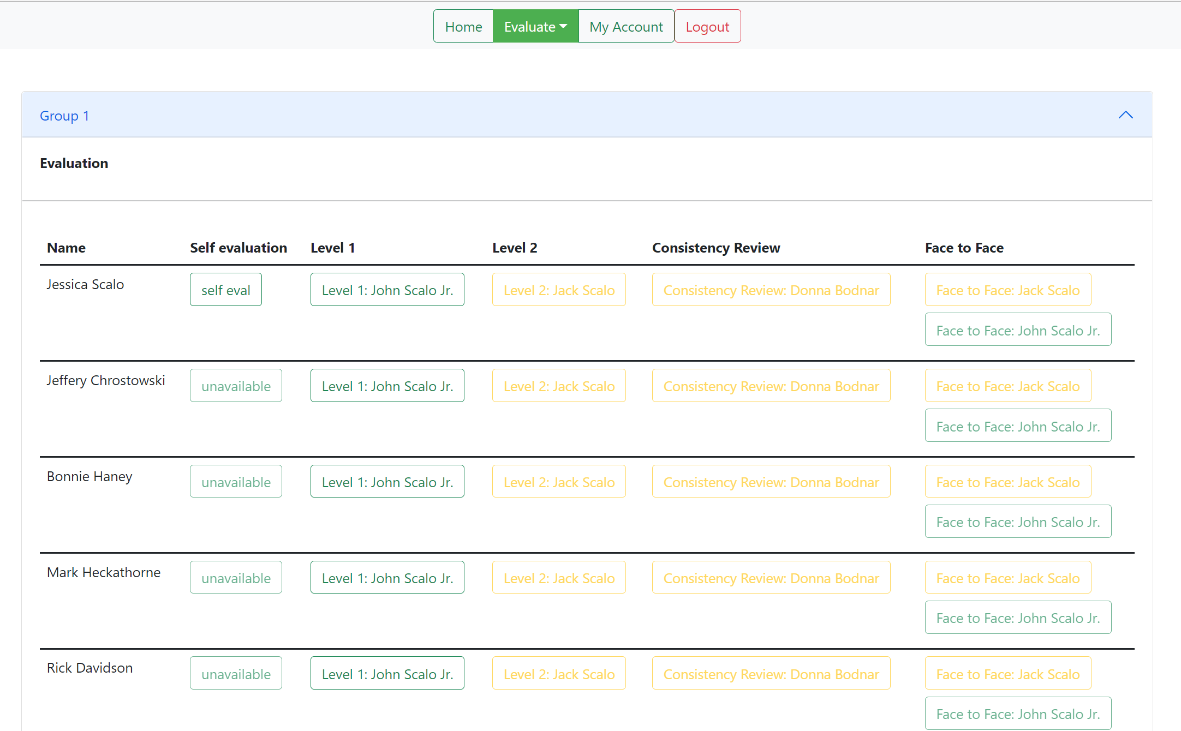

*Figure 70 - Evaluation Groups view.*

Upon clicking a level to review, such as “Level 1: John Scalo Jr.” for the user “Jessica Scalo”, the evaluator will be taken to a webpage to begin an evaluation. Any edits down to the page can be saved and a score is given for drop-down related answers. Files with a size of 8 megabytes or lower may be uploaded along with the submission of the file by clicking the “Choose File” at the top of the form. The form can be saved by scrolling to the top or bottom of the page and clicking “Submit”, after filling out the necessary questions, “Save for Later” in order to be able to revise and finish the evaluation, or cancel and go back by clicking the “Cancel Evaluation” button.

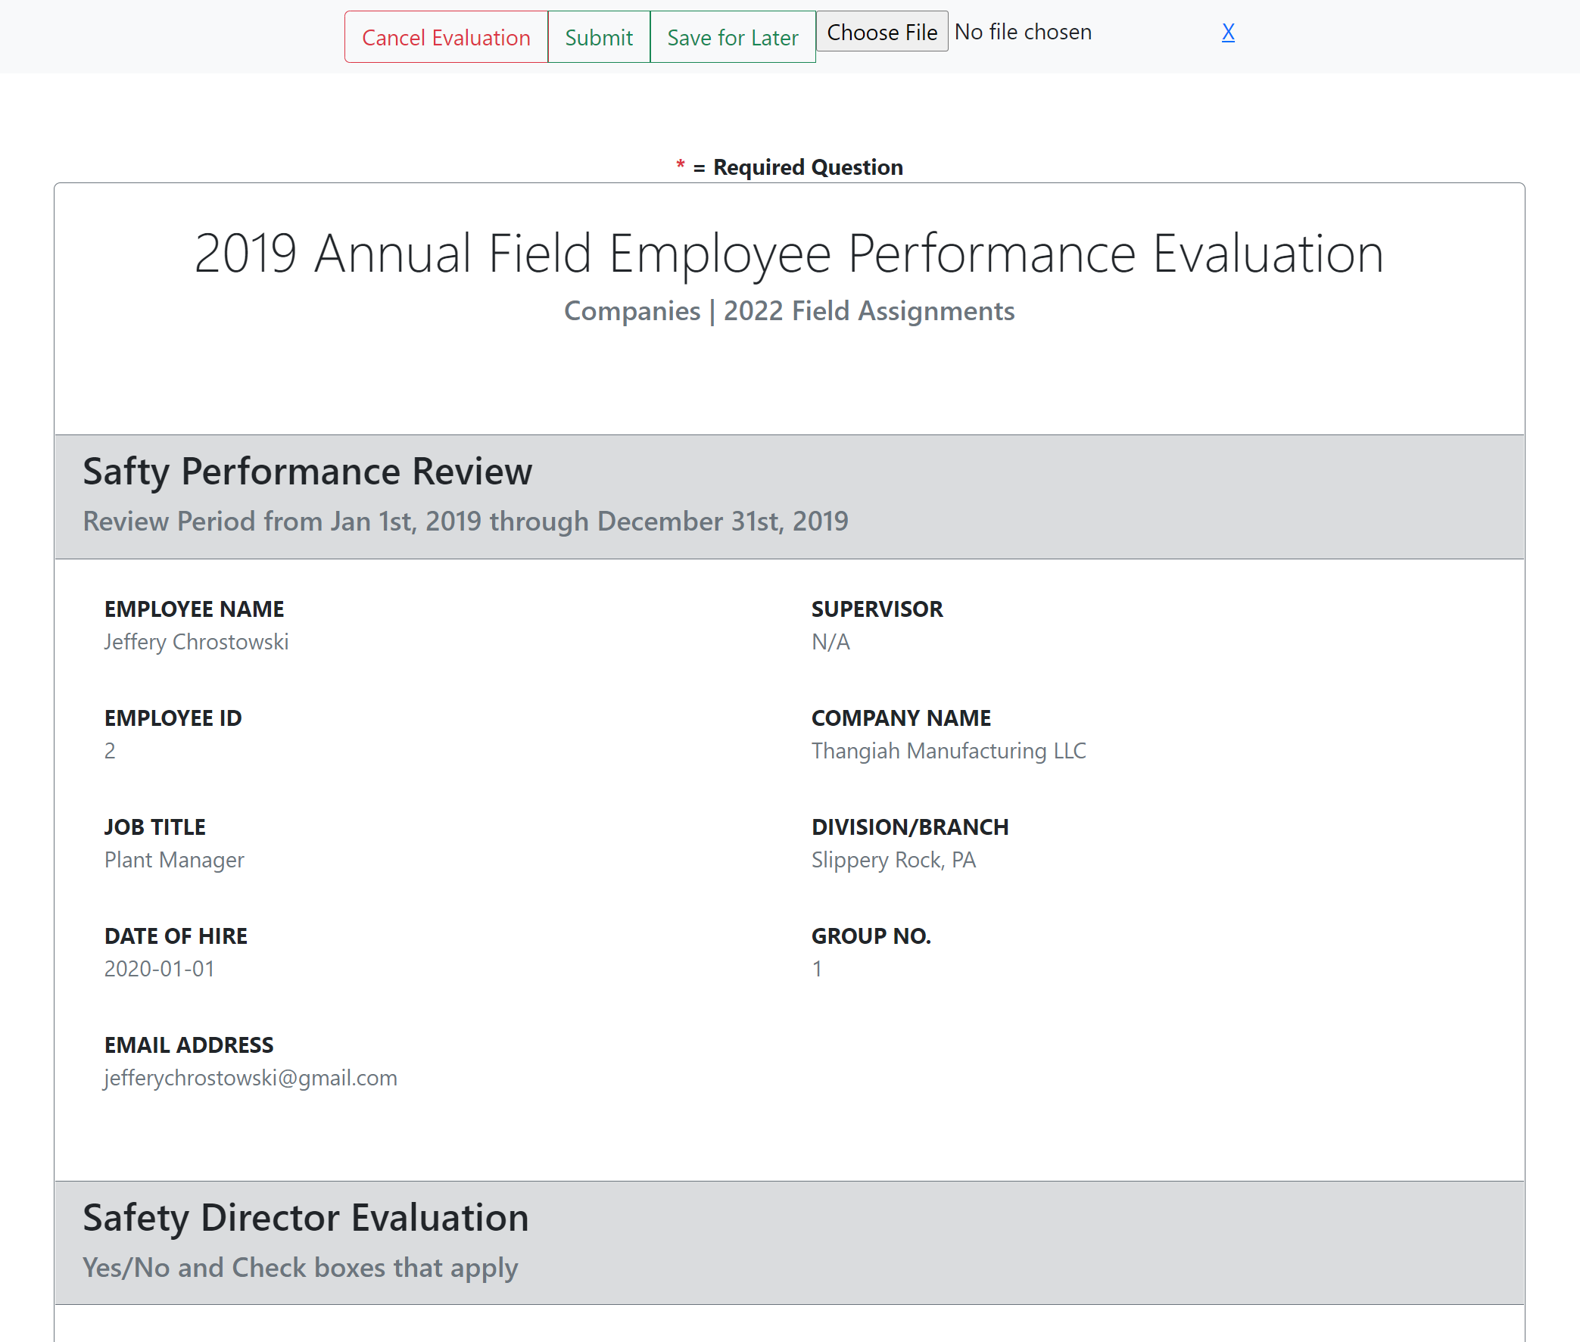

*Figure 71 - View after selecting an available evaluation to be completed.*

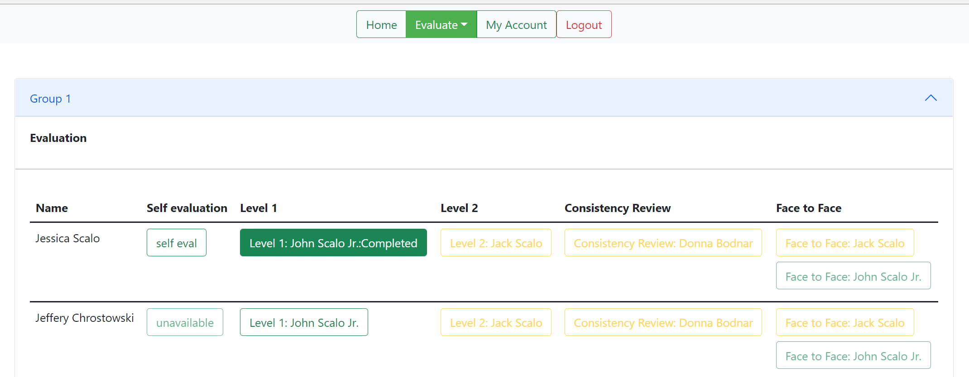

*Figure 72 - View upon displaying the contents of a group that the user completed an evaluation on.*

After submitting the evaluation, it’s possible to view what was submitted by following the previous steps for performing an evaluation. From the preview screen of an evaluation, you may download the attached file with the “download” button. Other evaluators that are of a higher level can then complete their evaluations as each lower-level evaluator completes their evaluations. The next-up evaluator after “John Scalo Jr.” for the user “Jessica Scalo” would be “Jack Scalo.”

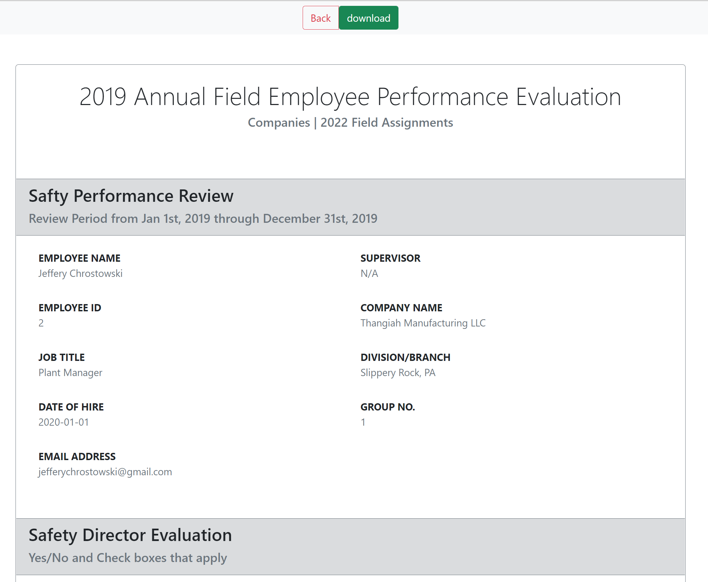

*Figure 73 - View upon clicking the previously completed evaluation to preview the evaluation. The “download” button is present to download the attached file.*

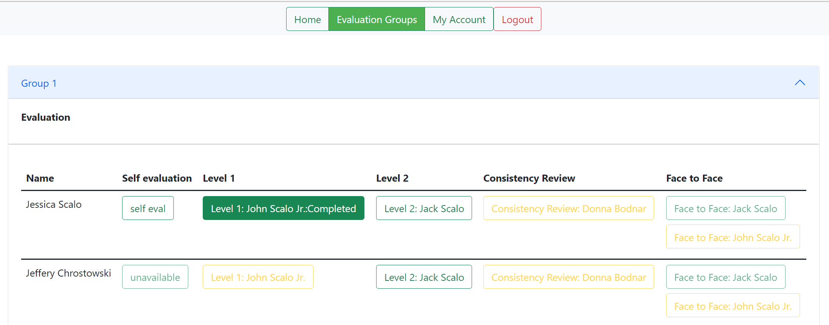

*Figure 74 - View upon logging in to jackscalo@gmail.com to complete the next level evaluation.*

# Testing

To test the current functionality of the Excel conversion from the given Raw Data file to a final User file and Groups file, please view the test directory, excel subdirectory, and the ExcelMain file. Run ExcelMain, and this will create the desired Excel worksheets and show you which directory they are now in. If you wish to run pre-created tests on these files instead of manually reviewing them, please run the ExcelRead_groupsTest.java file. Running this file will perform the prewritten Junit tests.